USING THE OCLC CLASSIFY FUNCTION IN OCLC CONNEXION TO INSERT A DEWEY NUMBER IN THE BIBLIOGRAPHIC RECORD

To find a Dewey Decimal or Library of Congress classification number for your bibliographic record, first, you must set a classification scheme and specify the field for inserting the number:

On the menu bar, click Tools, then Options.

At the Options screen, click the Classify tab

Click one of the radio buttons to determine which classification scheme you want to use:
● Dewey (most SHARE libraries use Dewey)
● Library of Congress (default)

Enter the 3 digit tag of the variable field in which you want the class number inserted.
Default: 090 (we use 092)

Click Apply and Close.

To find a call number and place the call number in your record:

With any bibliographic record open (this can be a workform, a record in the save file, or constant data), click on the Edit menu, click Classify (or click the EditClassify icon on the toolbar)

If a single numeric match is found, the most frequently used class number is automatically inserted in the field you specified in the Classify section of the Options screen, and the record is reformatted in correct MARC tag order.

If no numeric match is found, or if multiple matches are found, Connexion asks if you want to open the Classify Web service.

Click Yes or No.

If you click No, the prompt closes, and you are returned to the displayed record with no classification number inserted.

If you click Yes, a Classify window (titled Get Classification Number from Classify) opens.
In the Title/Author search boxes, Connexion automatically enters all of the data extracted from field 1XX $a and field 245 $a of the bibliographic record, excluding subfield delimiters and codes. If no 1XX field exists, data is extracted from 245 $a only. Click Search and scroll down to the results.

To add the Class Number to your record, highlight and copy the Class Number and click Insert and Close.
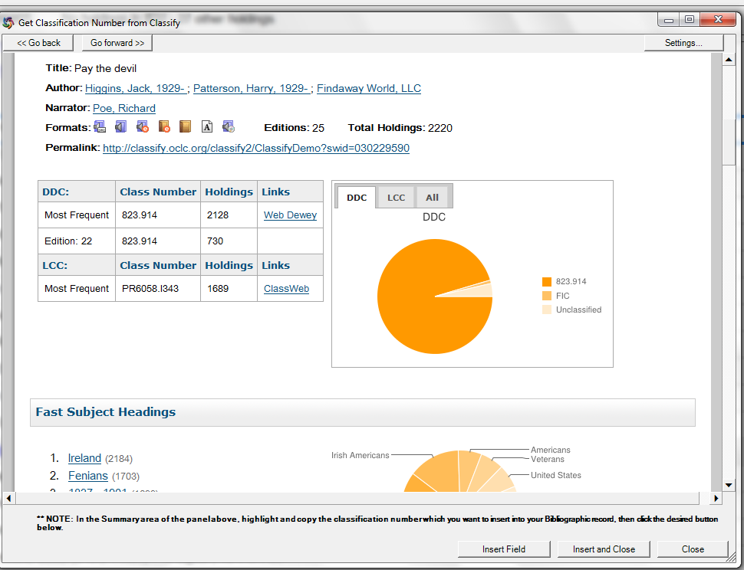

If no results are displayed, you can edit the search criteria or you can search a subject by typing the subject you wish to search. Click Search, and select a heading from the results.
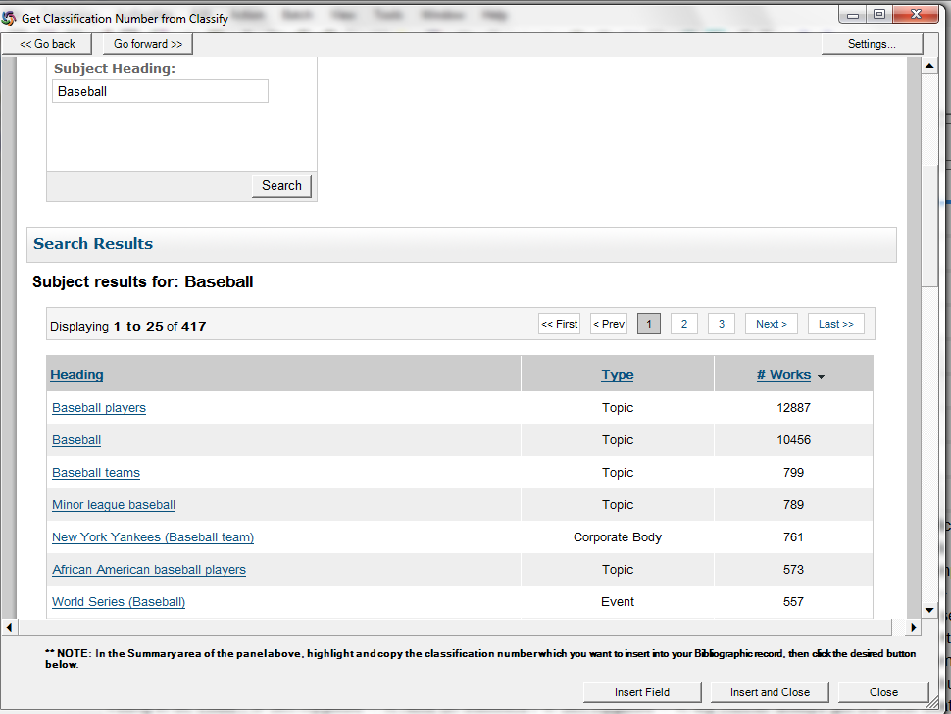
Scroll down to the subject results, choosing the one that best meets your item.

Click on the subject to open a list of titles with that subject. Scroll down to the search results (in this example, Search Criteria Fast Heading = Baseball).
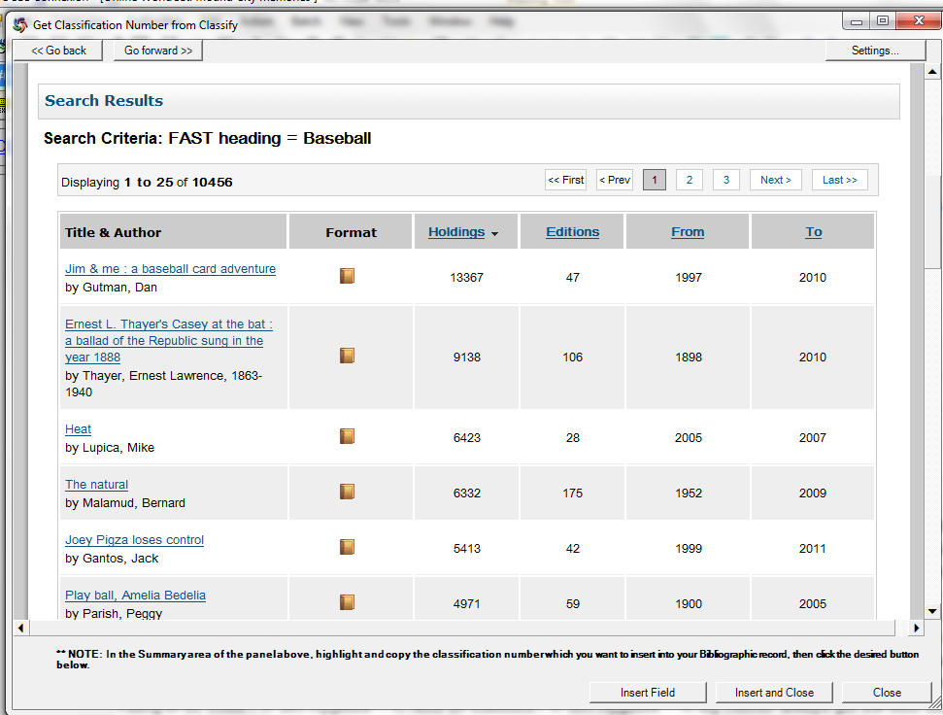
Click on a title, scroll down to the Dewey number, copy the number and click on Insert and Close to insert the class number in the bibliographic record.

You can also use the Classify function without being in a bibliographic record. On the menu bar, click Help>Useful Web Links>OCLC Classify Web Service.

The Classify screen will open in a web browser.
