Marshall Public Library Oral History Project Upload Process - A step-by-step guide

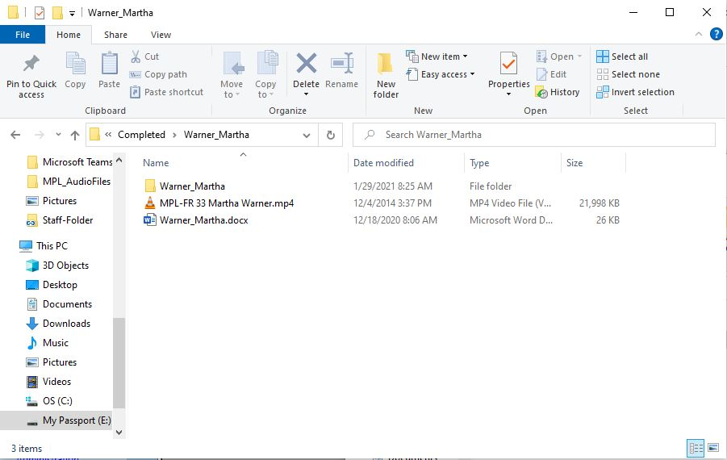
The folder for the interview contains the following: Interview (mp4 is the required upload filetype for CONTENTdm/IDA), transcript in a Word document, and if applicable, a folder of digitized images

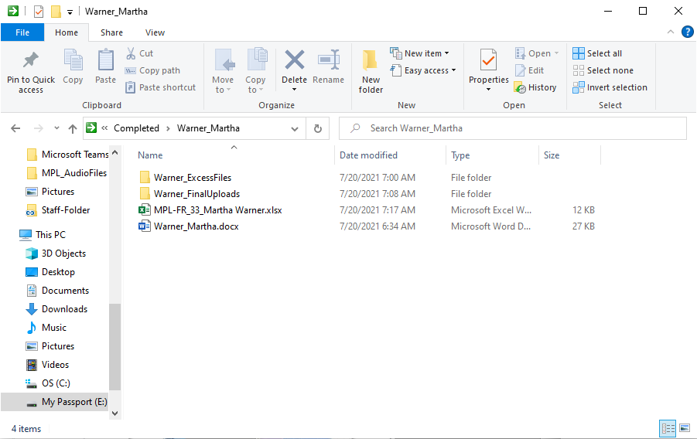
You will create a metadata template with the information that will need to go into CONTENTdm, and I put my files that will be uploaded into a specific folder titled lastname_FinalUploads (this is to give CONTENTdm a filepath to grab just the uploads from)

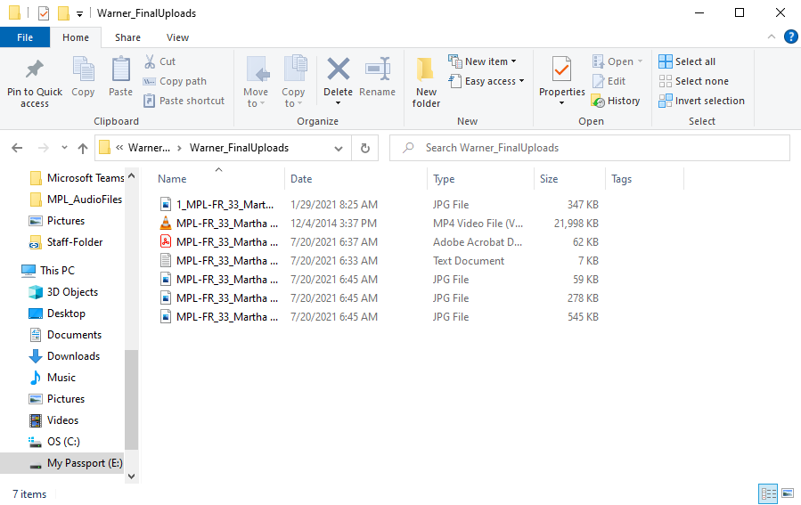
The lastname_FinalUploads folder will contain the following: a PDF file of the transcript, a .txt file of the transcript, the audio file (as an mp4), and any applicable image files. All should have the same “base” filename except the photos, which can have a -1, -2, etc. appended to the end to differentiate. The other files are different filetypes so the additional number isn’t necessary. CONTENTdm likes to upload files in the order in which they appear in the folder, so if there’s a particular image that I want to come first, I append a 1_ to the front of it. Since anything before the underscore doesn’t go into consideration by CONTENTdm, this isn’t a problem.

Filetype Conversions: mp3 to mp4

You will need your audio files to be in mp4 format, and image files to be in .jpg format (not .jpeg).

I used VLC Media player to convert mp3 to mp4.

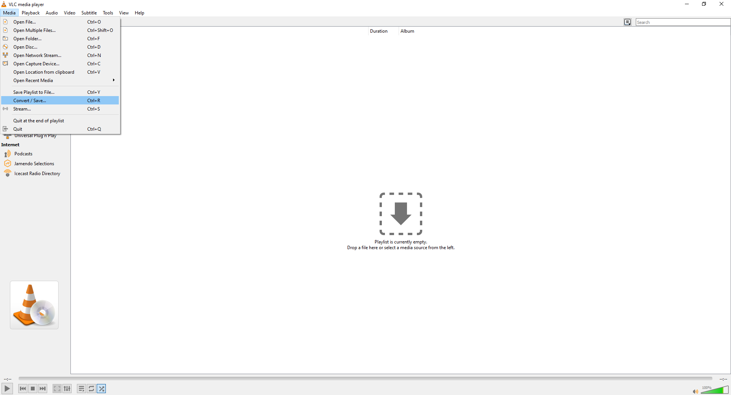
I start by navigating to and clicking “Convert/Save” under the Media dropdown.

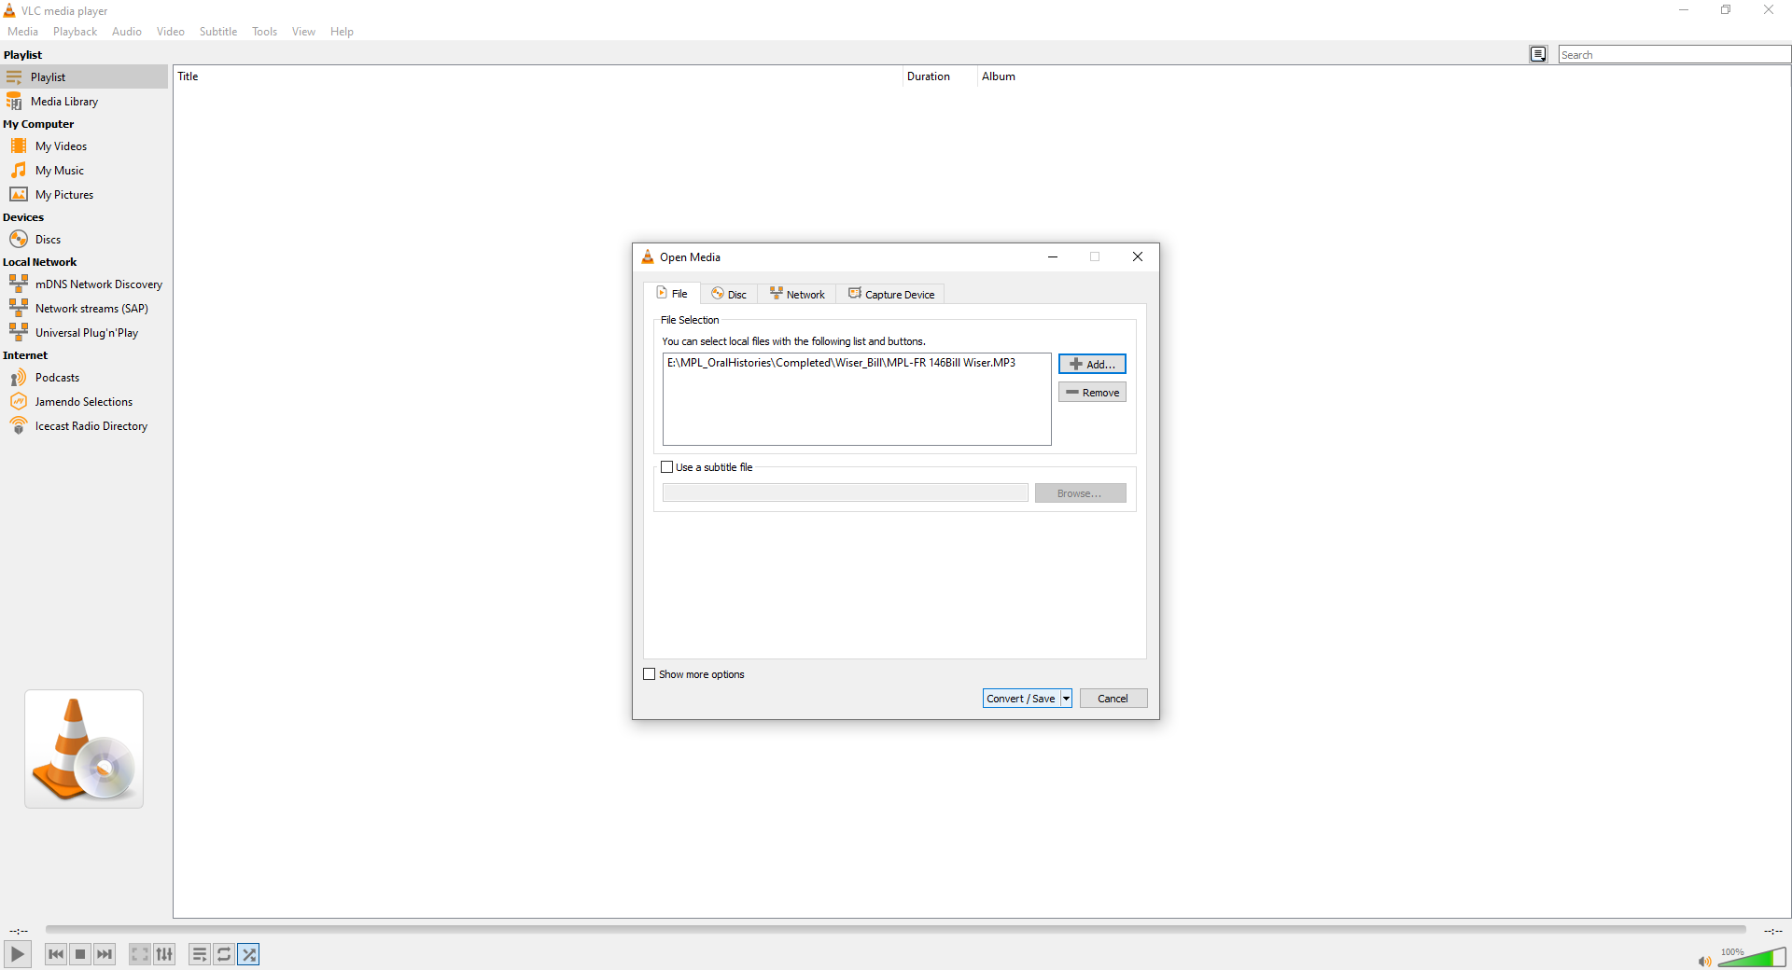
I “add” the file that I want to convert...

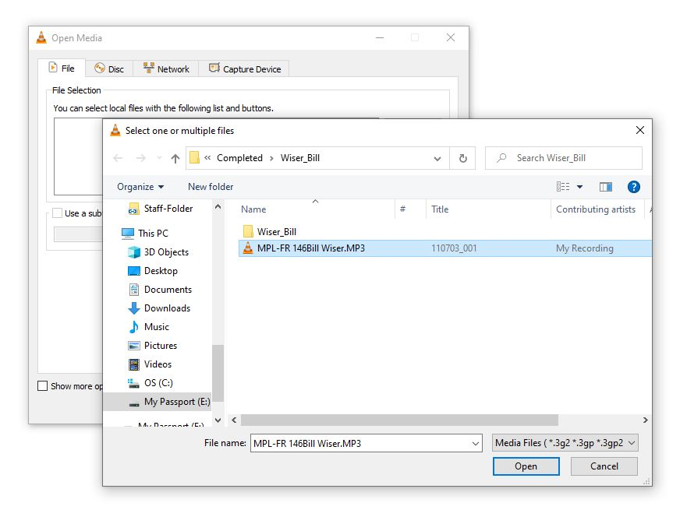
Select the file...

Once added, you can click on “Convert/Save” at the bottom...

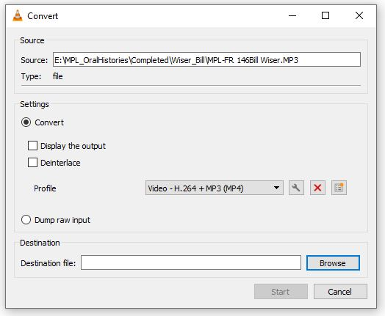
A new window will pop up, and under profile you will want to choose “Video - H.264 + MP3 (MP4)” and then in the Destination section click “Browse” to choose where the file will go...

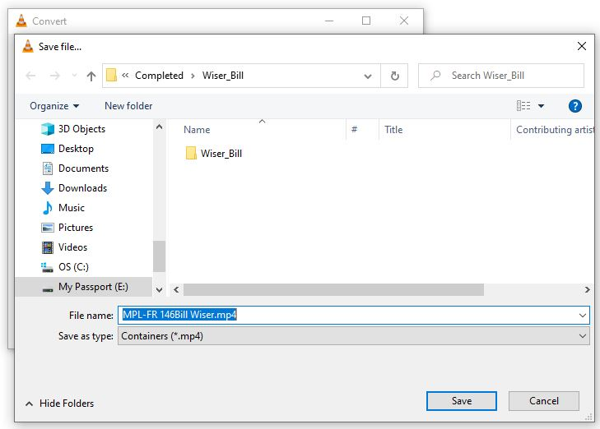

Navigate to where you want to save the file, and under “File name:” you will change the extension of .MP3 to .mp4 (upper/lower case don’t matter, I just prefer lower case), and then click “Save”...

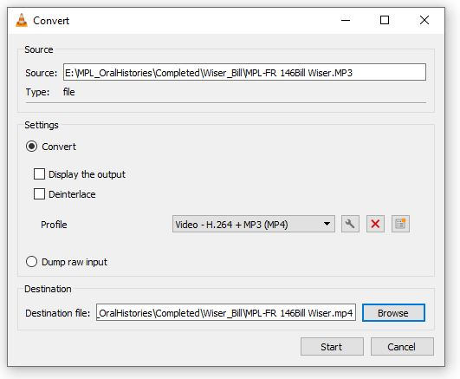
Now you can click “Start” and the window will automatically close and the process will begin...

You can see that it’s working by looking at the bottom of VLC Media Player where you will see the progress bar (blue) moving. Once it moves across the bottom all the way to the end of the bar, that means it will be done, and you will find the .mp4 file along with the .mp3 file in your folder.

Filetype Conversions: JPEG to JPG

There are multiple ways to change your JPEGs to JPGs. You can do it manually, one at a time, or you can run a script to change a batch of them.

One at a time:

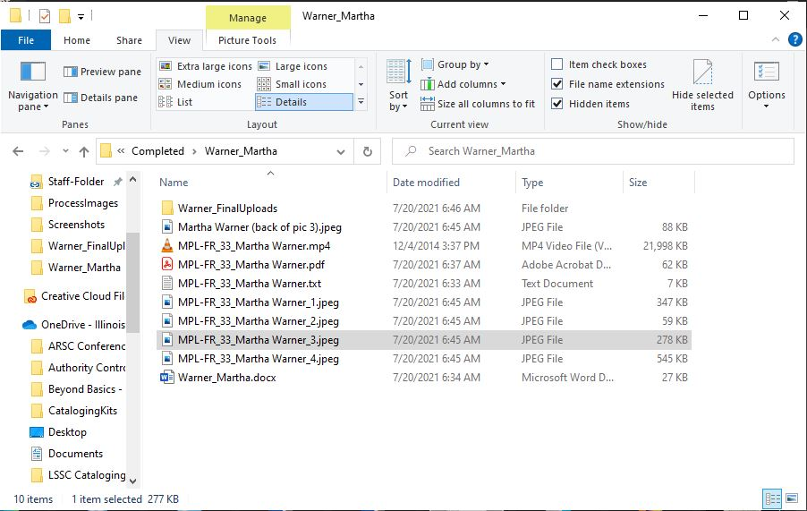
All you have to do is click on the file to edit the filename, and then change the extension. This will change the image format.

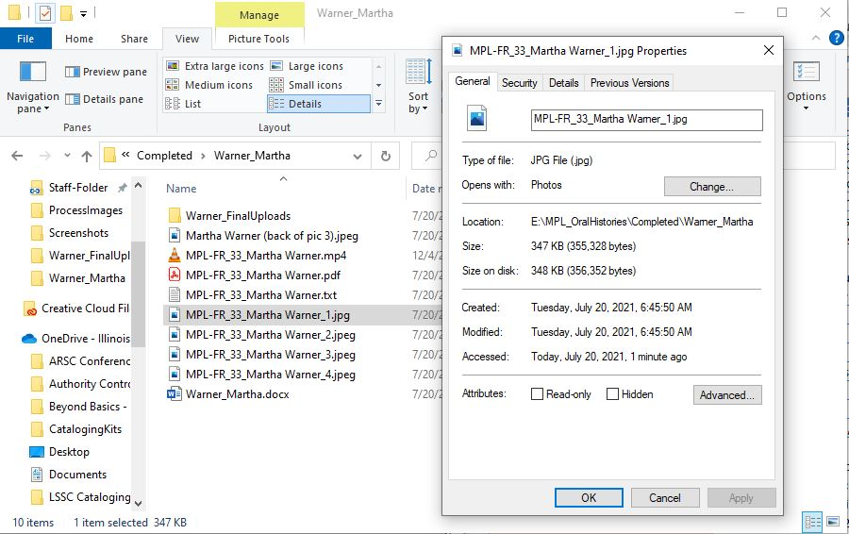

Batch change:

There is also a Command Line script that you can run to change a large batch of them. I follow the instructions here: https://fileinfo.com/help/windows_batch_rename_file_extensions
You will need the files to be on your desktop for this to work (at least I did).

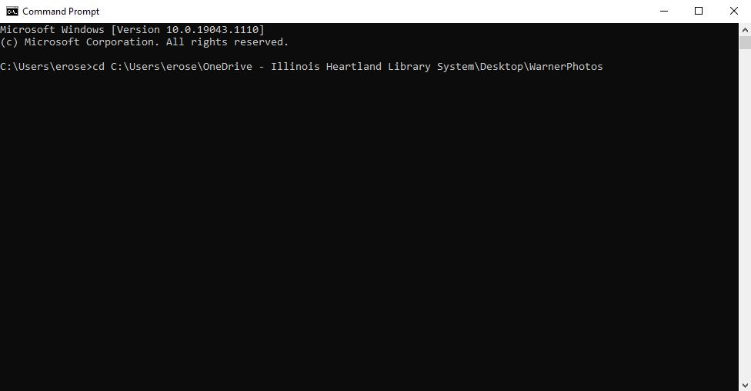
Open Command line, type in cd and then copy/paste the filepath into Command Line, then hit enter...

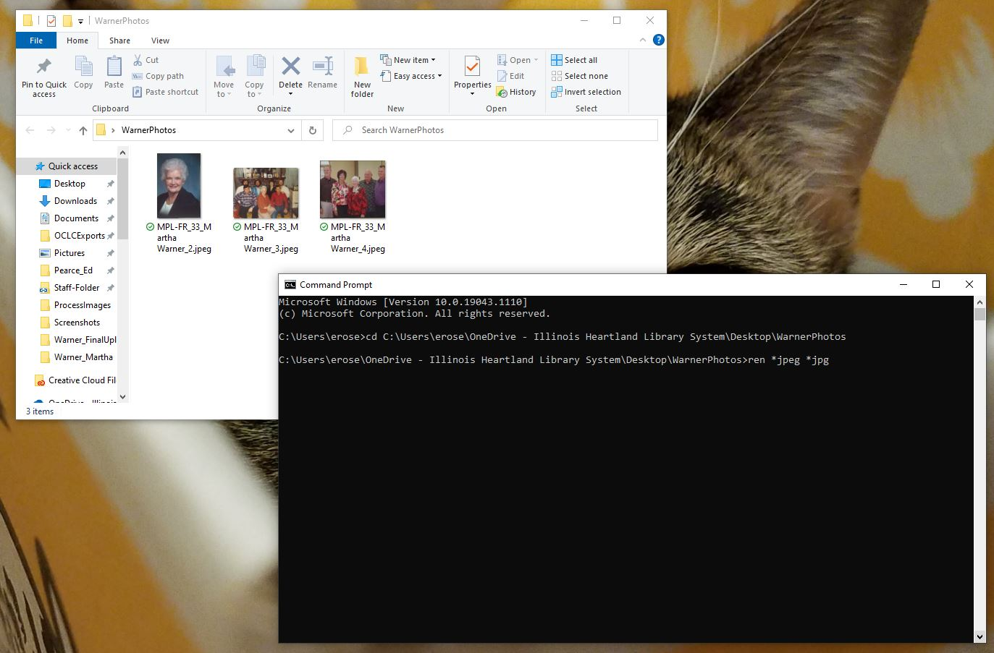
Next, type in ren *jpeg *jpg and hit enter...

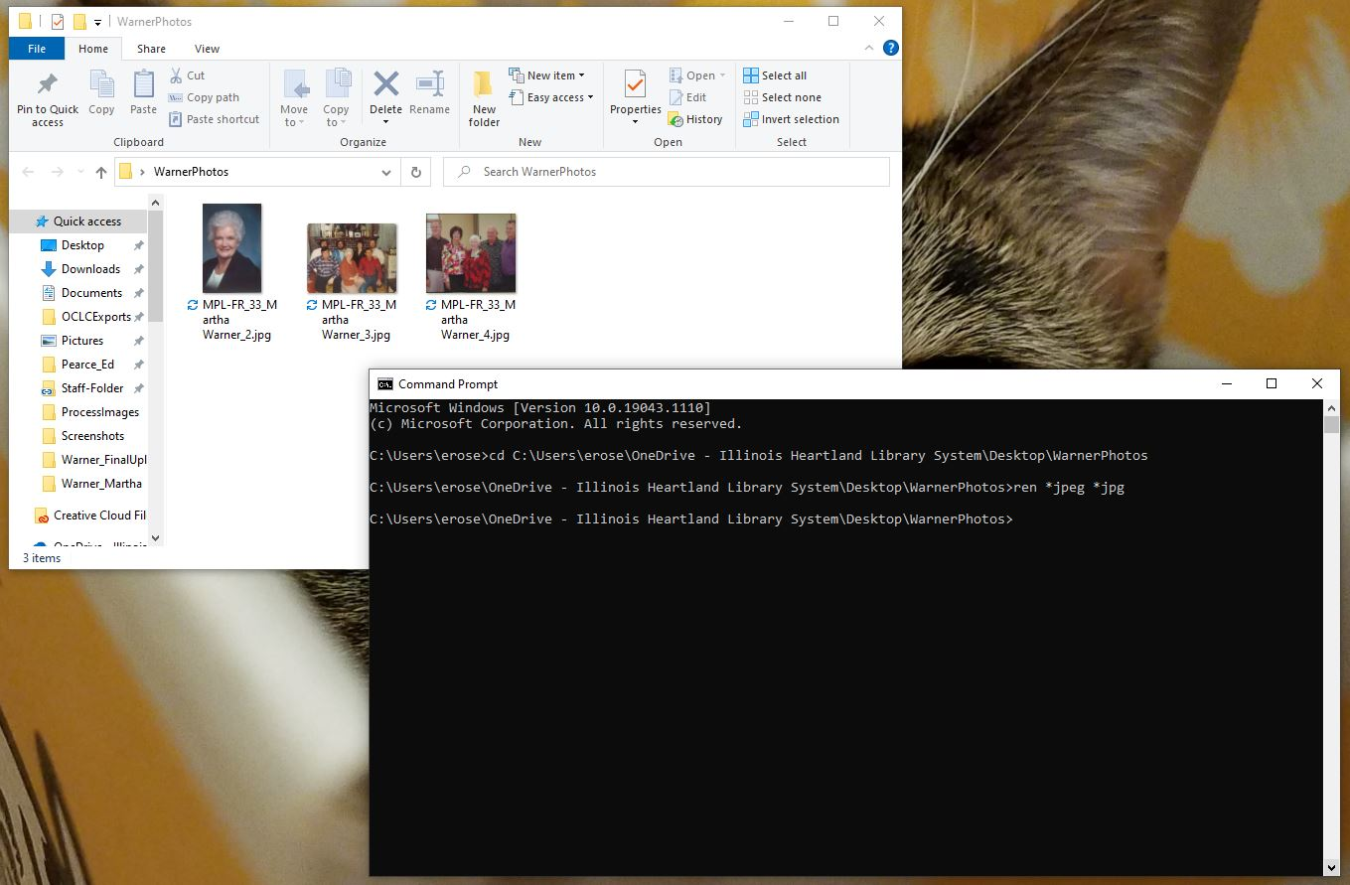
After you hit enter, nothing really happens in Command Line that you can see, but if you look at the image files in the File Explorer, they now have the .jpg extension instead of .jpeg.

Photos in Bridge and Photoshop

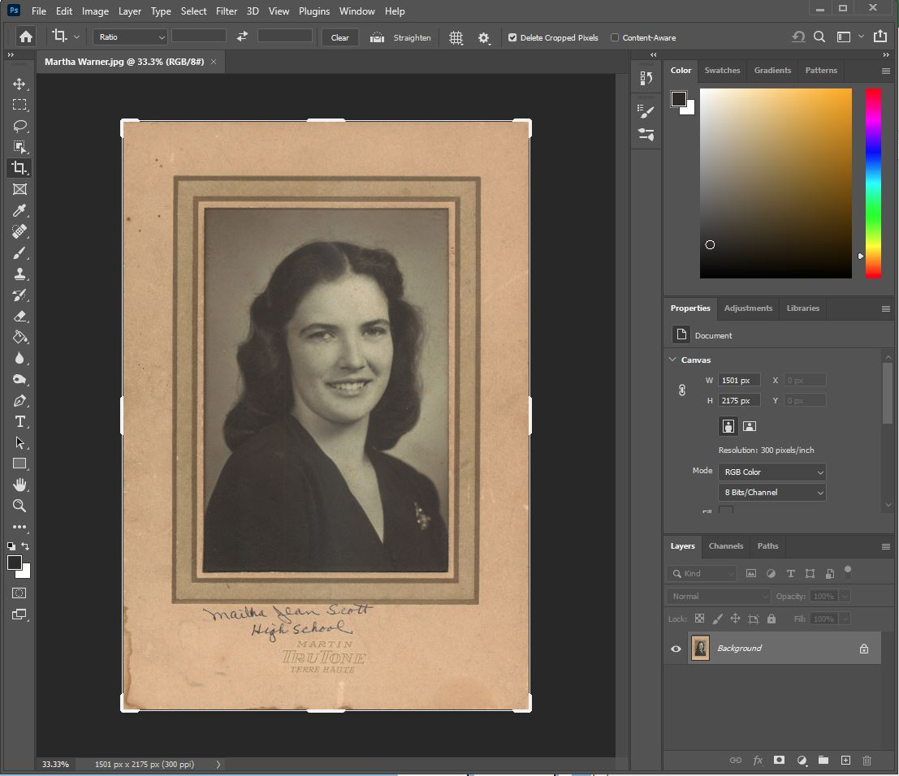
I use Adobe Photoshop to crop the photos because it’s just what I’m comfortable with. If you have a preferred program to use for this, feel free to use it. Just make sure that you save the file as a .jpg.

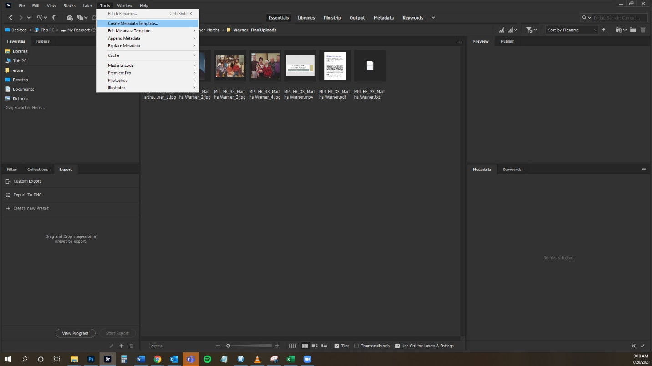
I created a Template for this project that has metadata that I want to append to all photos across the board. You can do this by going into Adobe Bridge, navigating to the Tools dropdown, and clicking on “Create Template.”
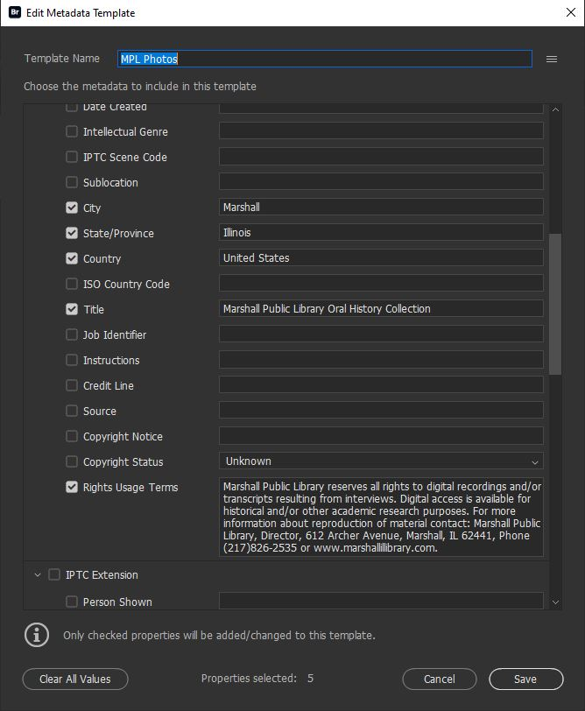
Next, type in the data that you want to be in the template and when you’re done click “Save.”

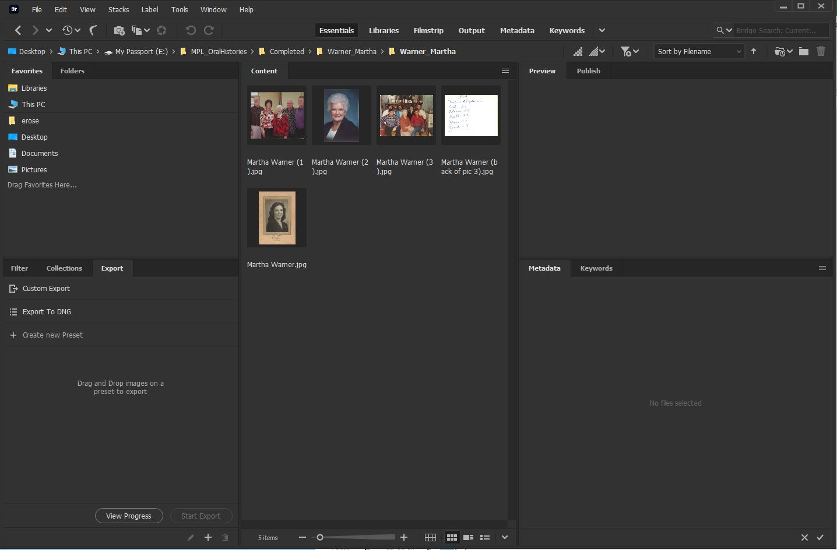 Now, navigate to your photos folder.

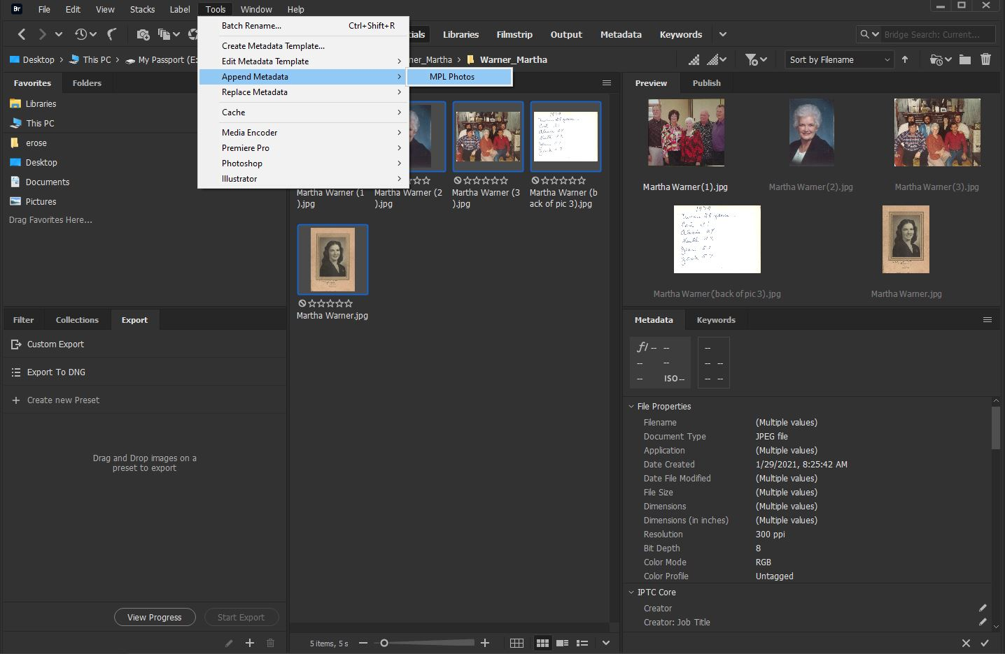Select the photos that you want to append the template data to, then navigate to the Tools dropdown, click on Append Metadata, and choose the template that you want to use.

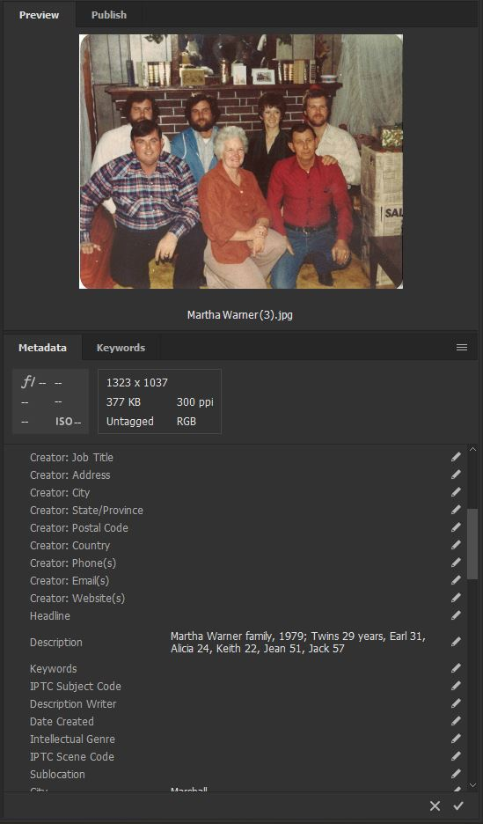
Now, click on each individual photo to add particular data, such as a description, to the photos.

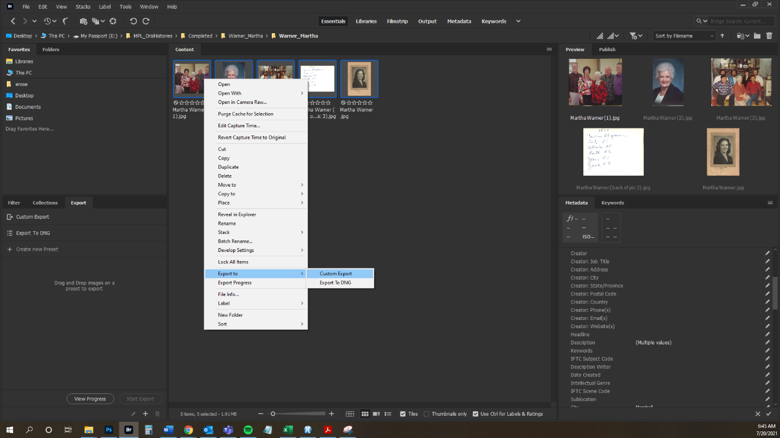
Once you have appended all of your metadata to all of your photos, you will want to “Export” the photos with their new metadata. Do this by selecting all of the photos, right click to bring up the dropdown, click on “Export to” and choose “Custom Export.”

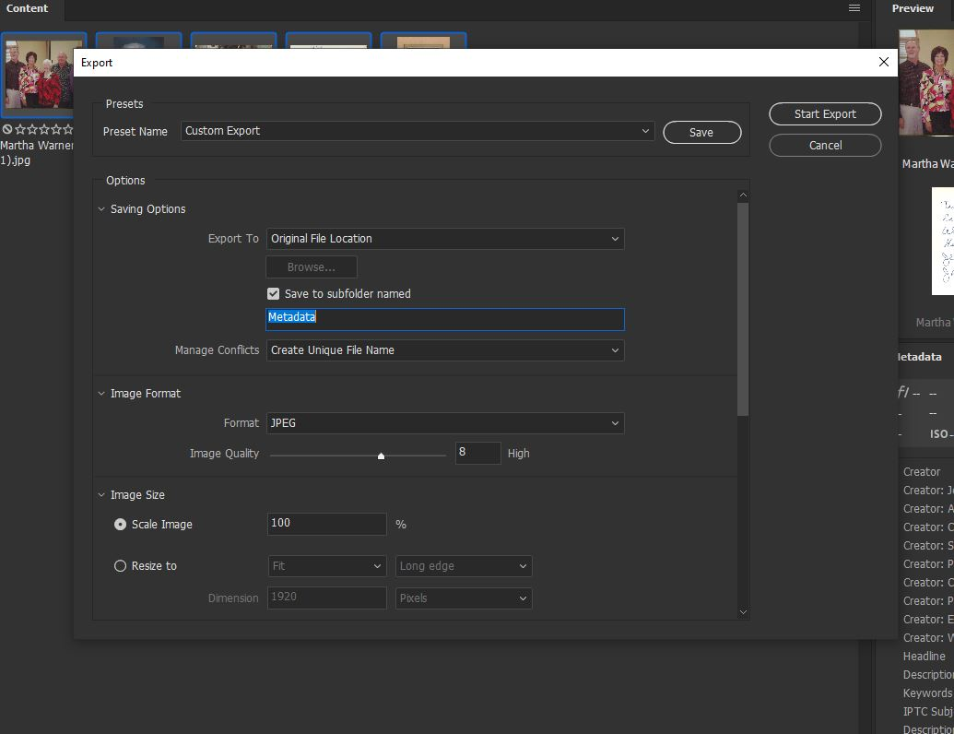
I always click into “Save to subfolder named” and create a title (I use metadata). I’ve tried to replace the original photos (the ones that don’t have metadata), but this doesn’t always work and instead all of the photos get mingled together. Exporting this way puts them into a folder nested within the folder that holds the originals. Once you’ve done this, you can click on “Start Export.”

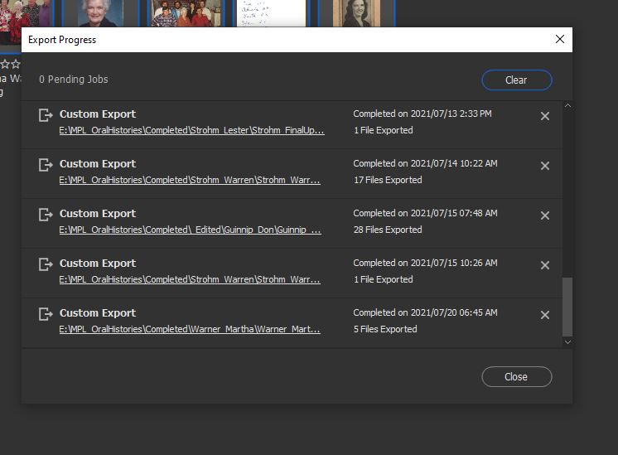
This window will pop up to show you the progress (it goes fast, if you have a small number of photos, you might miss it!), and once it’s Completed, you can close and you’re done with Bridge.

At this point I go to File Explorer where I delete the photos that don’t have metadata, then move the photos with the metadata from the Metadata folder into the old ones’ place.

Interview Files

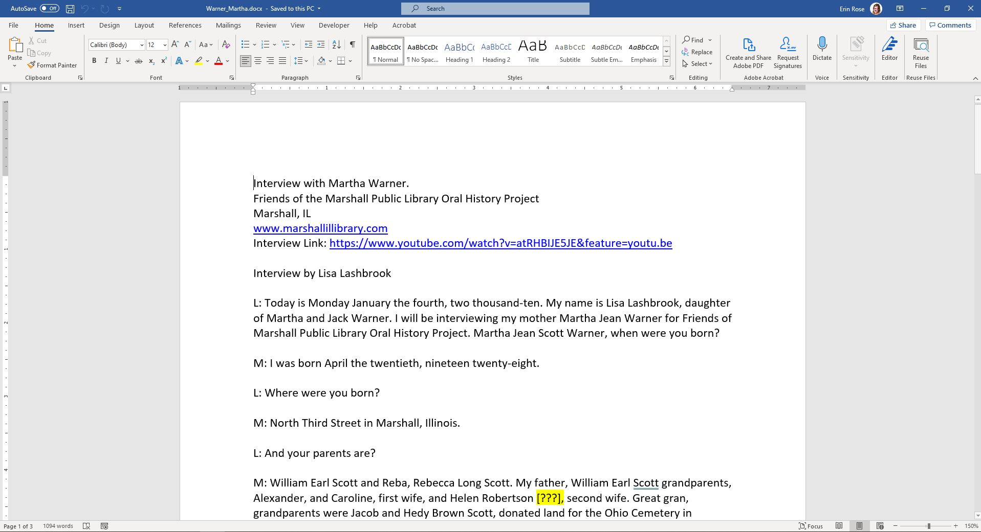
All interviews were typed up in Microsoft Word; however, we don’t upload .docx files to CONTENTdm, we upload .txt and .pdf files. The first step is to edit the transcriptions one last time before uploading.

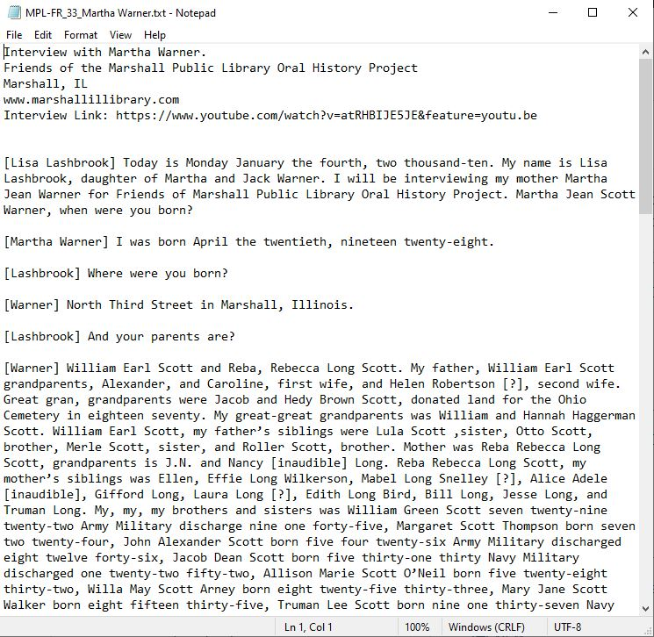
Once edited, copy and paste a copy of the interview from Word into NotePad. Save to the folder and close the .txt file.

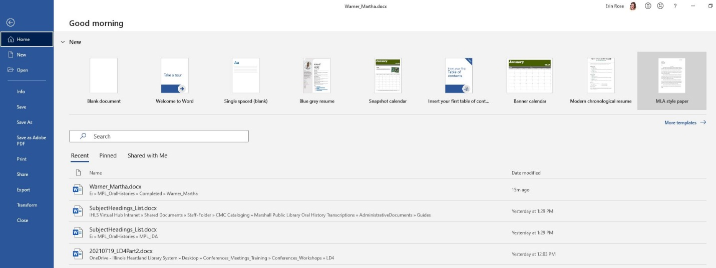
Next, save the file as a PDF by navigating to File and clicking on “Save as Adobe PDF.”

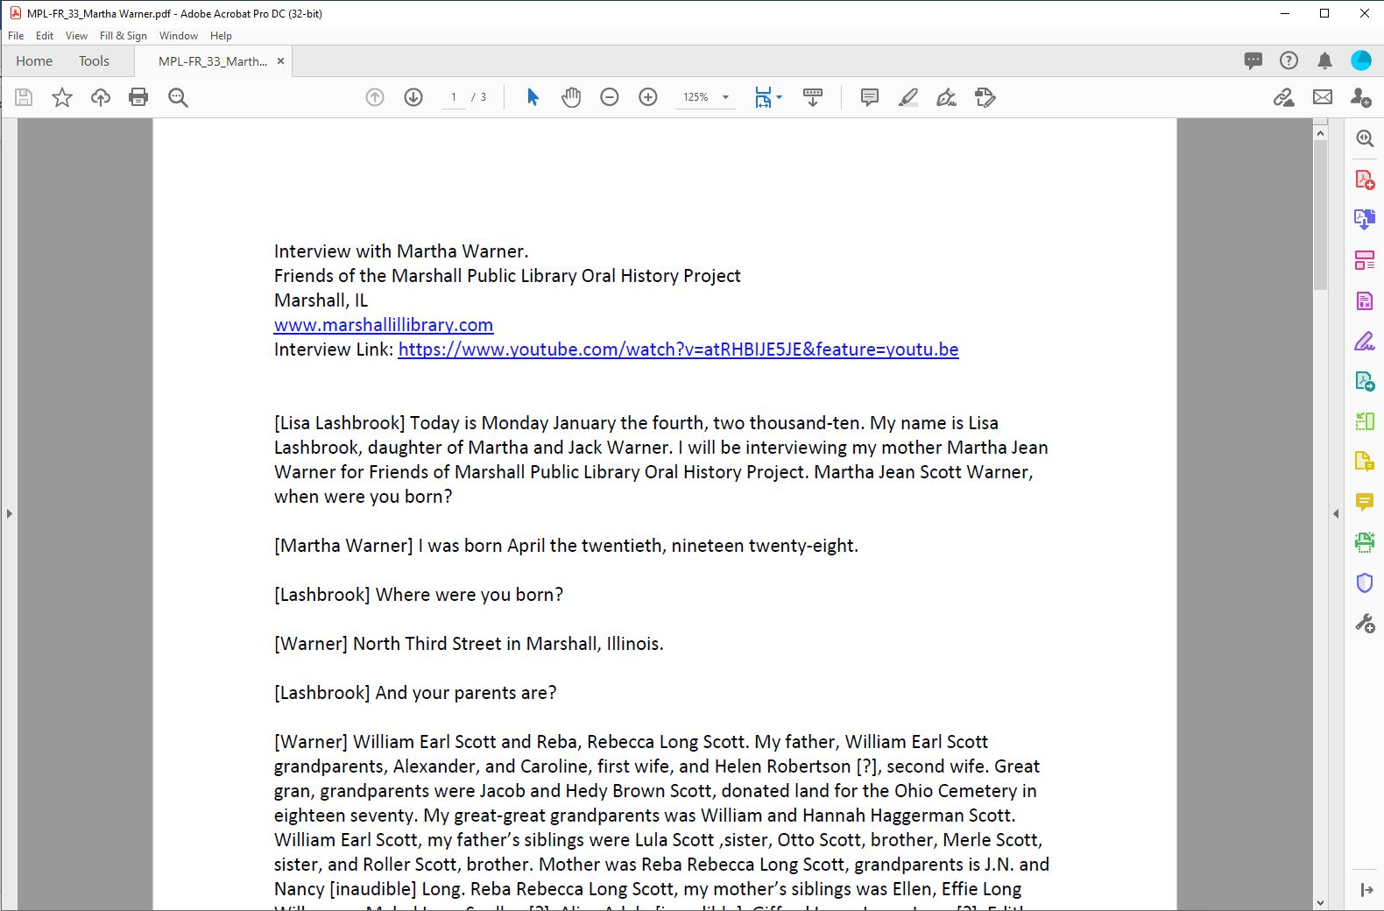
Once the PDF file has been created, you’ll want to make sure that OCR has been applied. I do this in Adobe Acrobat Pro DC.

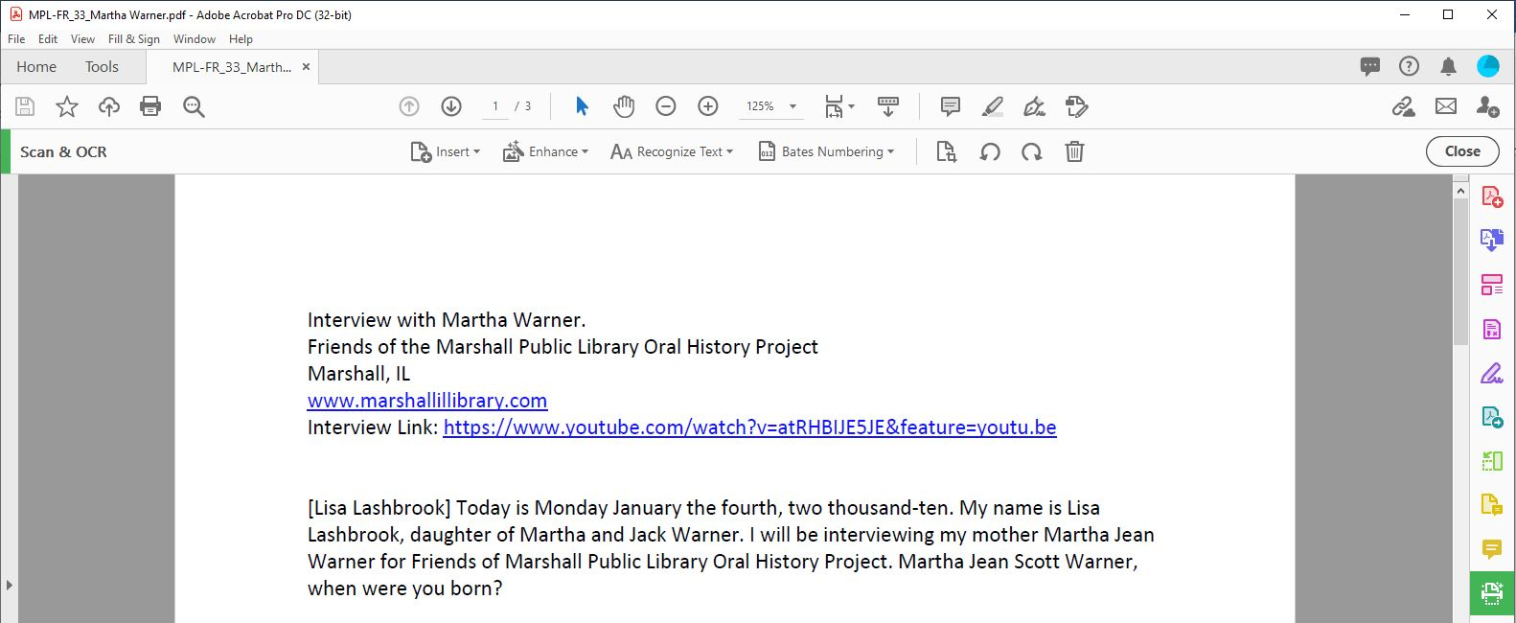
You can either navigate to Tools and then choose “Scan & OCR,” or you can click on the little icon on the right toolbar that is green and looks like a little printer.

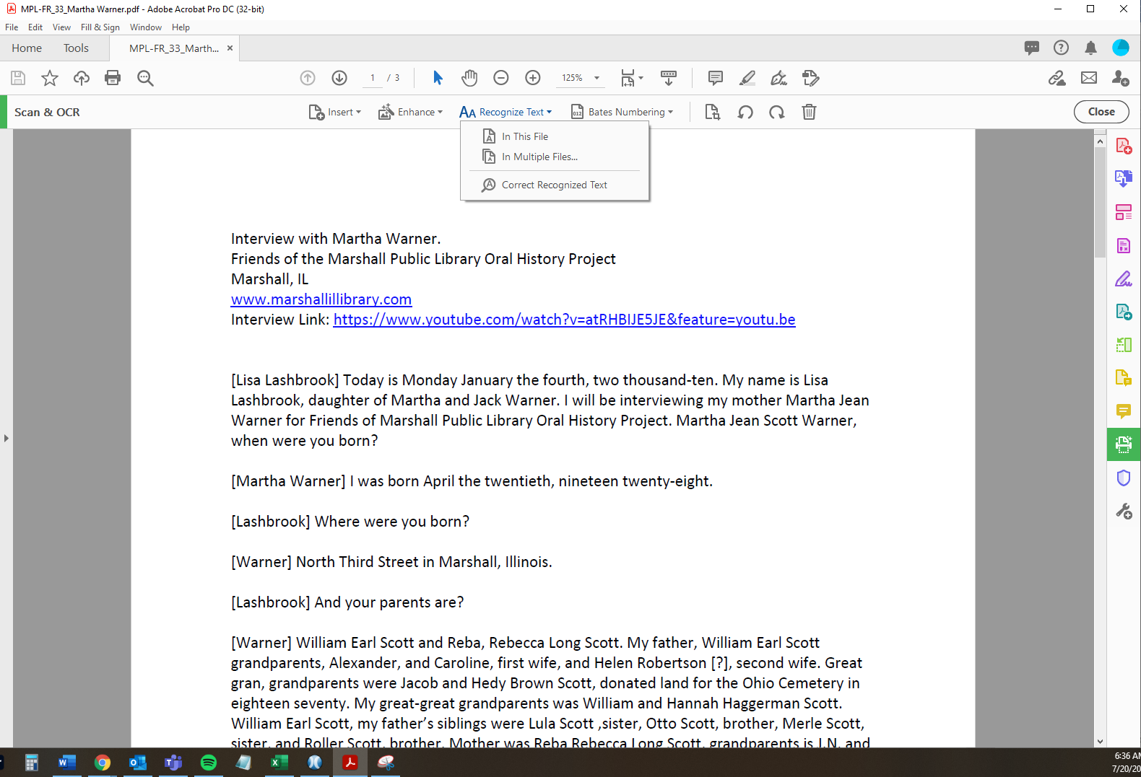
A new top toolbar will show up, click on “Recognize text” and choose “In this file” from the dropdown menu.

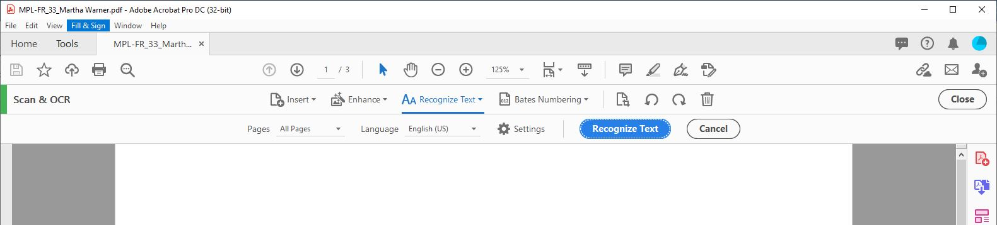
Yet another top toolbar will appear, click on the blue “Recognize Text” button, and the process will run. Once it’s done, your OCR will be applied, and you can save and close the file.

Metadata Template
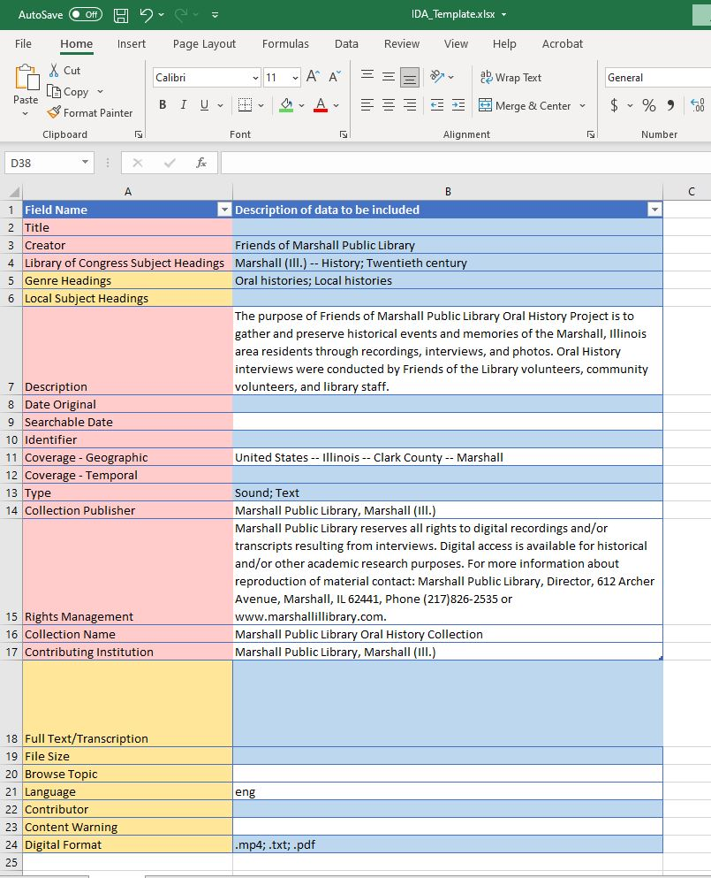 You will create an Excel metadata template based on the fields you’ll see in your CONTENTdm project.

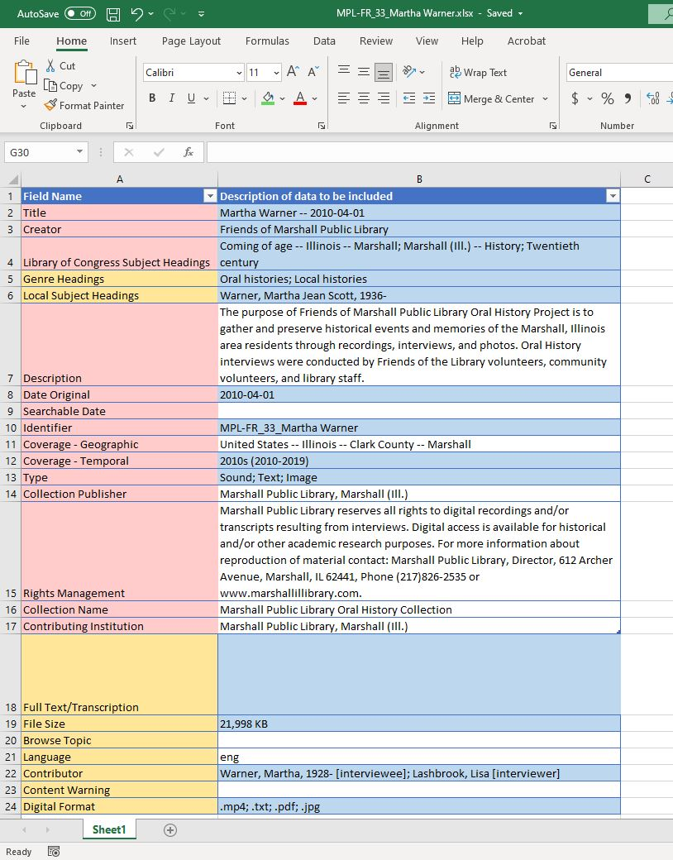
Enter the data about your interview into the appropriate fields. The highlights are for me to remember which fields may change in the CONTENTdm Metadata Template.

CONTENTdm Uploads

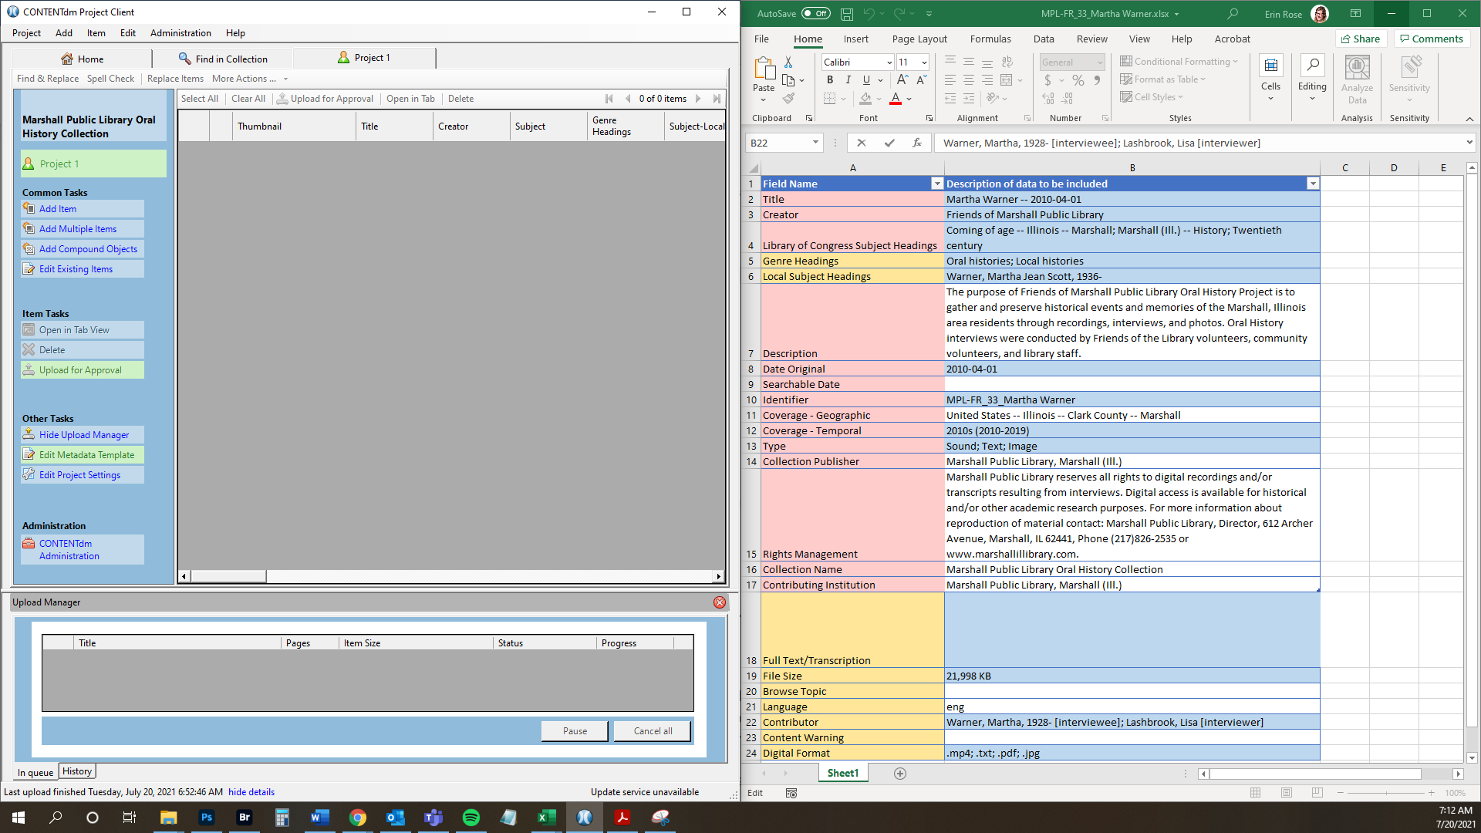
I open the Excel file template at the same time as the CONTENTdm one to copy and paste information over easily. To open the template in CONTENTdm, click on “Edit Metadata Template” on the left toolbar.

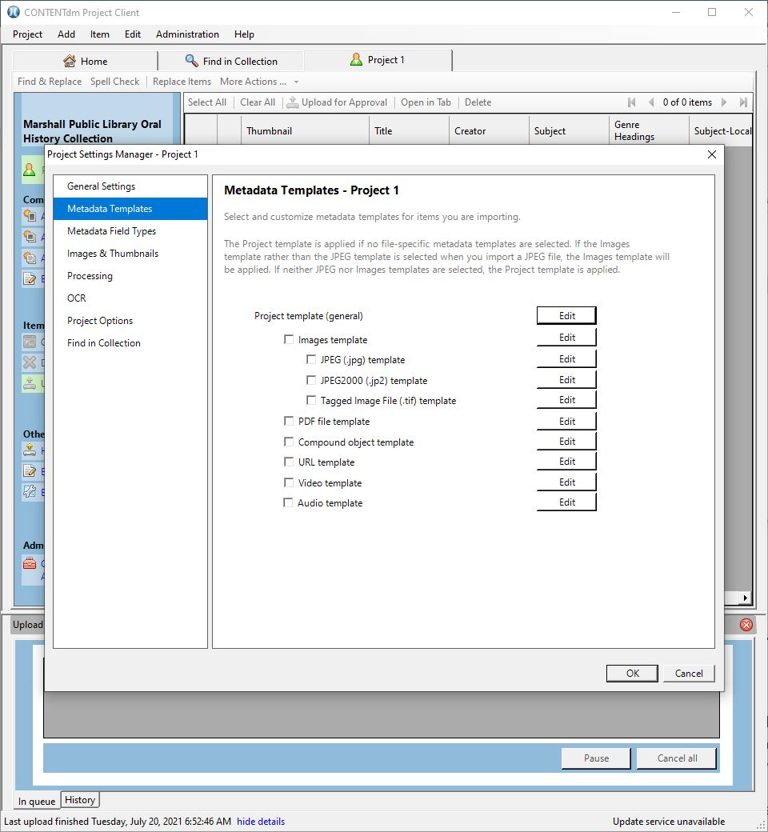
Since we had Illinois Digital Archives create our project template custom to this project, I can click on the Edit button next to “Project template (general).”

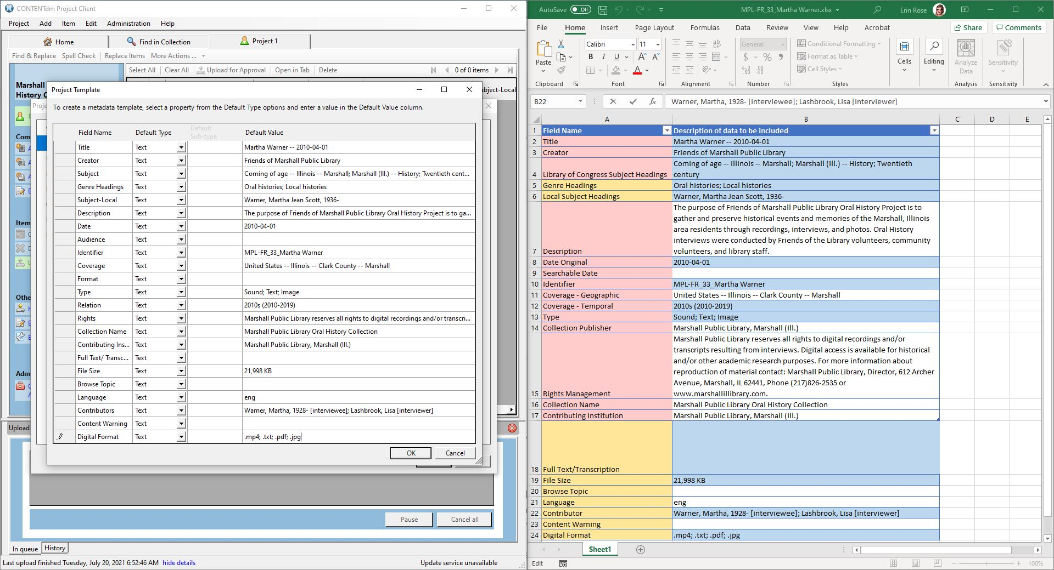
Copy and paste the appropriate information from Excel to CONTENTdm and when you’re done click the “OK” button.

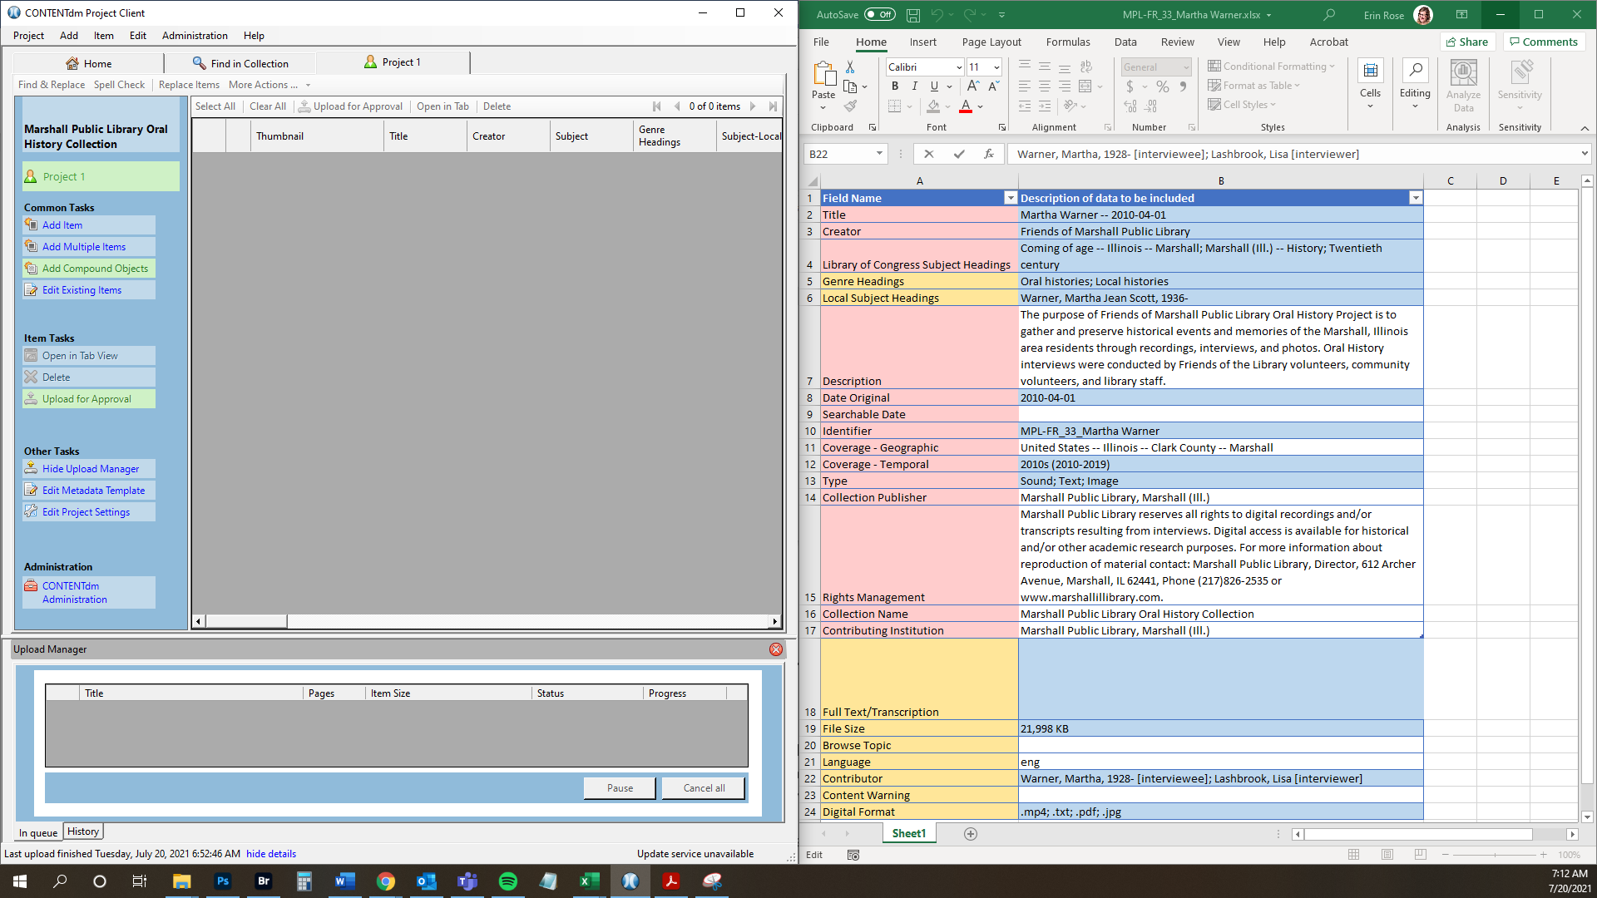
Next, you will want to add the files as a compound object, and you can do this by clicking on “Add Compound Objects” on the left toolbar.

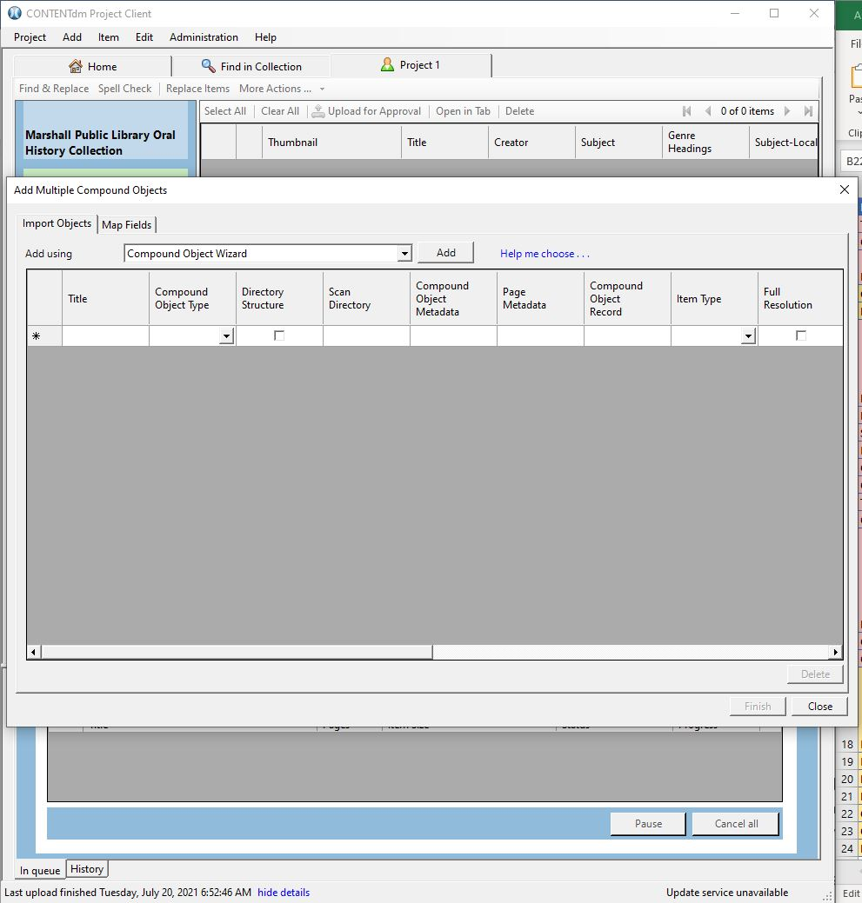
This window will open, click on the “Add” button...

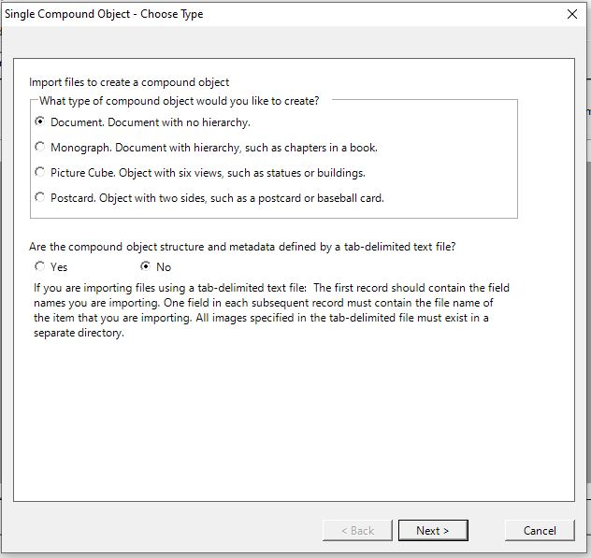
Make sure that “Document.” is chosen...

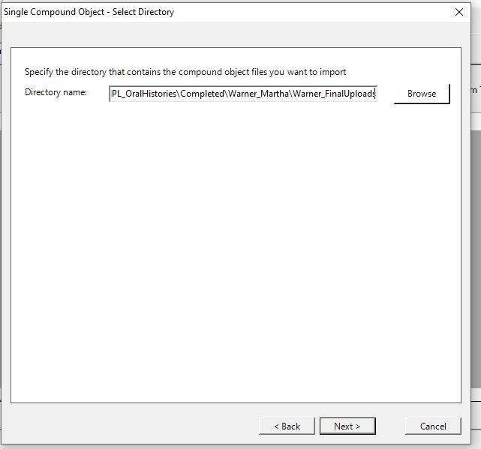
Enter the filepath to what you want uploaded (it should be your lastname_FinalUploads folder); you can do this by either copying and pasting the filepath into the field, or by navigating to it through the “Browse” button...

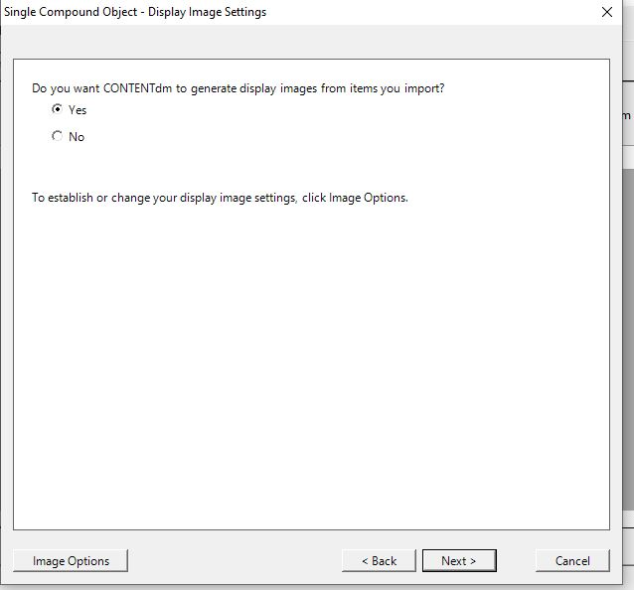
Leave “Yes” selected...

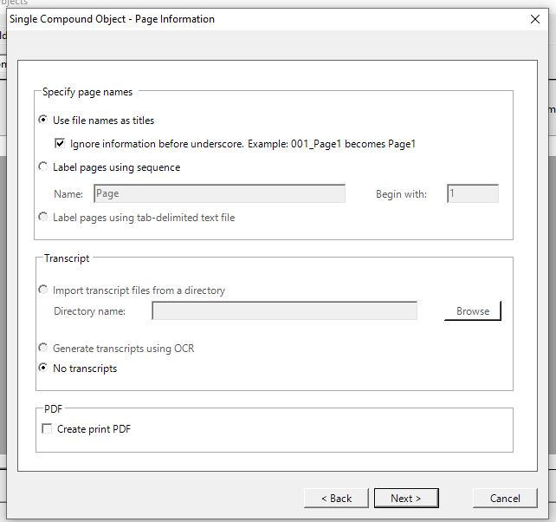
Leave “Use file names as titles” selected and click “Next”...

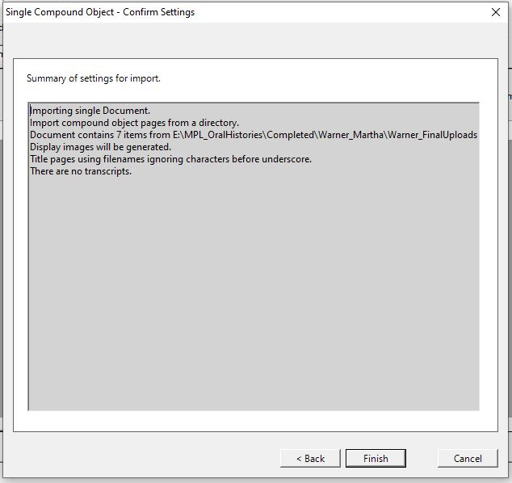
You will have a summary here, click the “Finish” button...

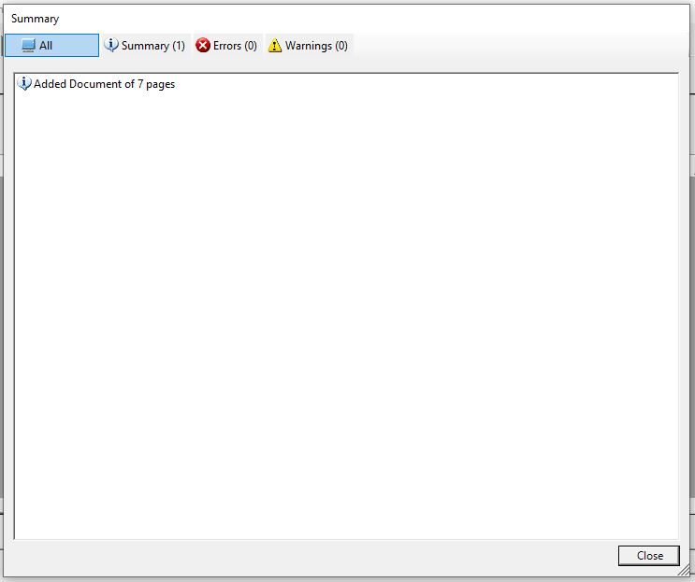
This window will pop up showing how many items have been uploaded for your Compound Object, it should match the number of files in the folder you uploaded. Click “Close”...

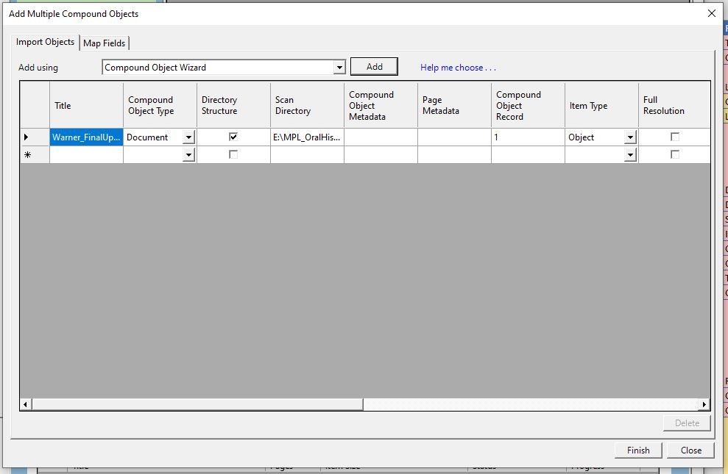
This window will show up, you can scroll across the fields if you want with the bottom bar, and once satisfied, click the “Finish” button.

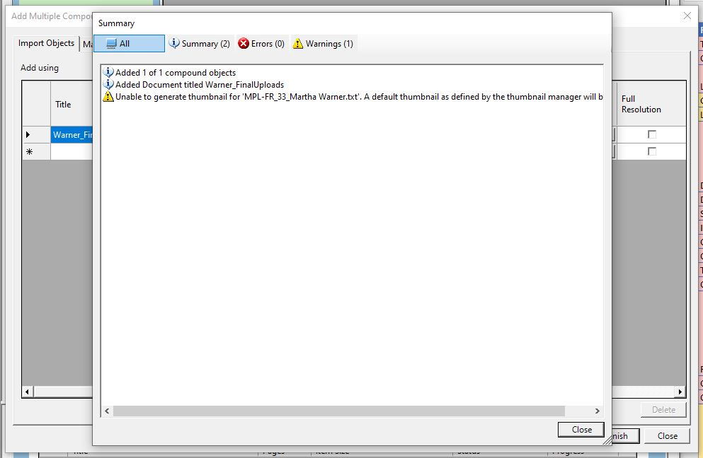
You might get warnings - this should be okay, typically it refers to issues with generating thumbnails for files that aren’t image files. If everything looks okay, click the “Close” button.

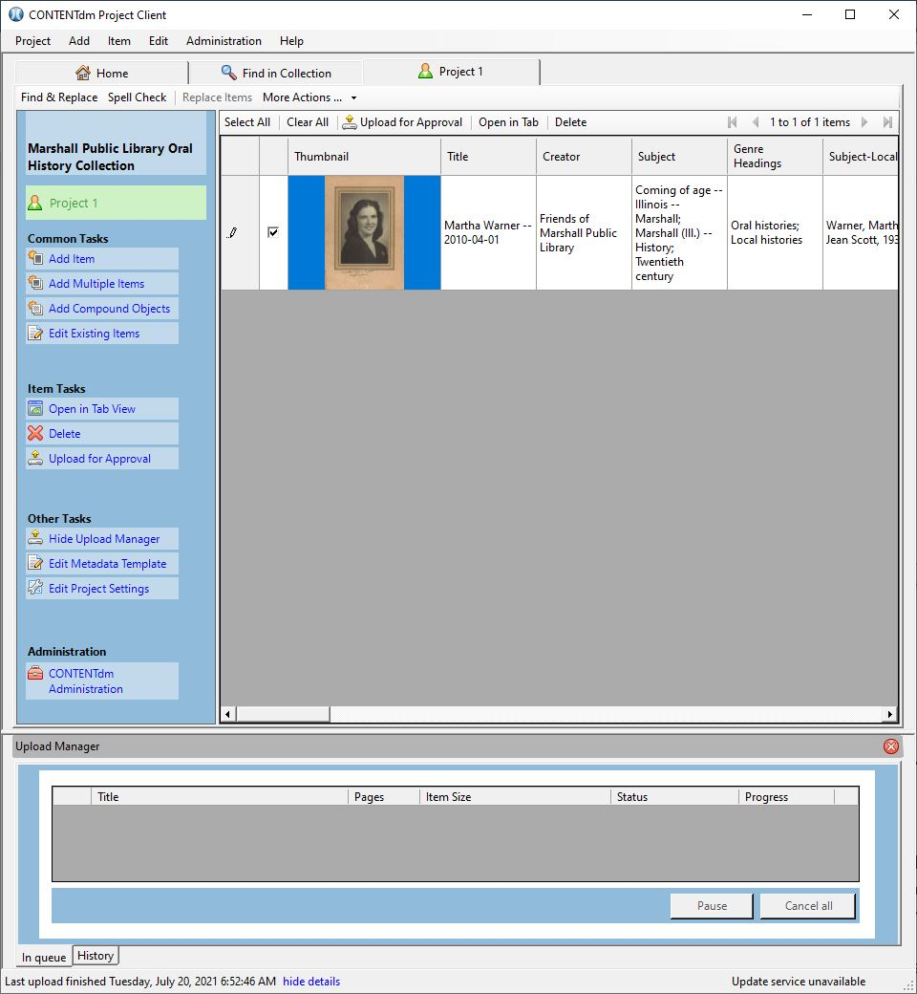
You will see your compound object show up, it is recommended that you verify the information in your metadata template still looks right and that all of the items within your object look correct.

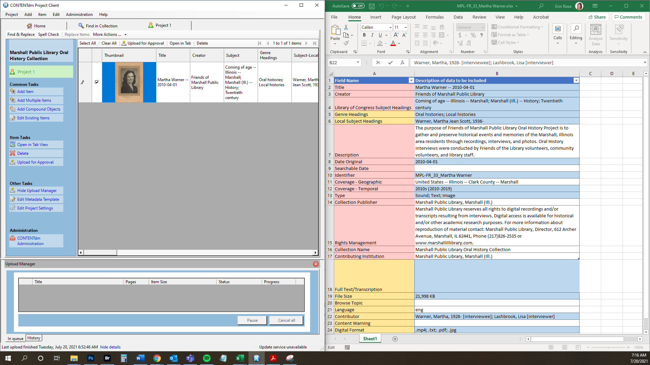
You can open the template panel by double clicking on the compound object (usually I just double click on the Thumbnail).

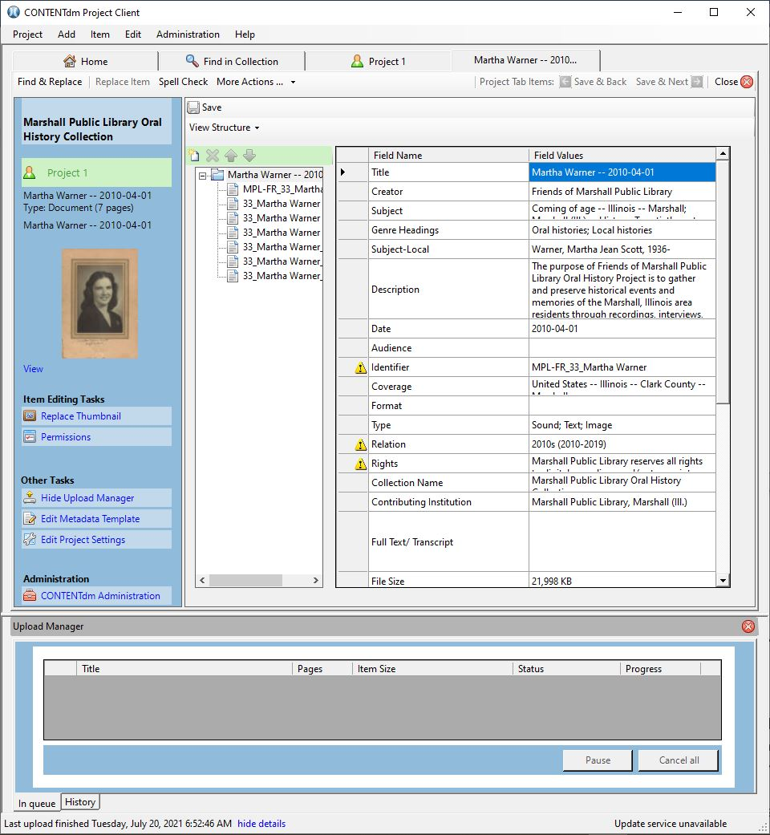
Compare this to the Excel file. If everything is fine, you can click on “Close” at the top right. If there are edits to be made, you’ll have to edit the information for each item, as seen in the hierarchical “structure” list.

Once verified, make sure that the checkbox next to your compound object is checked, and then click on “Upload for Approval” on the left toolbar.

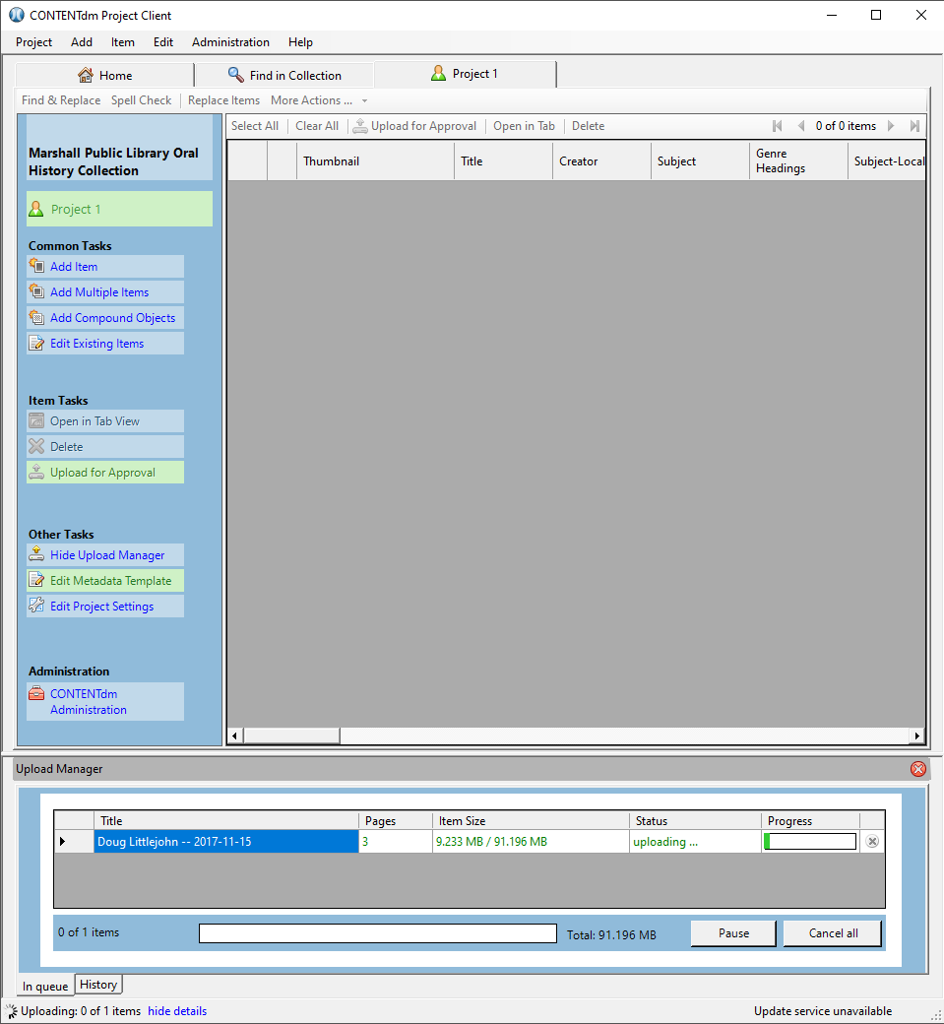
While it uploads, you can view the progress by clicking on “view details” at the very bottom of the screen and then selecting the “In queue” tab.

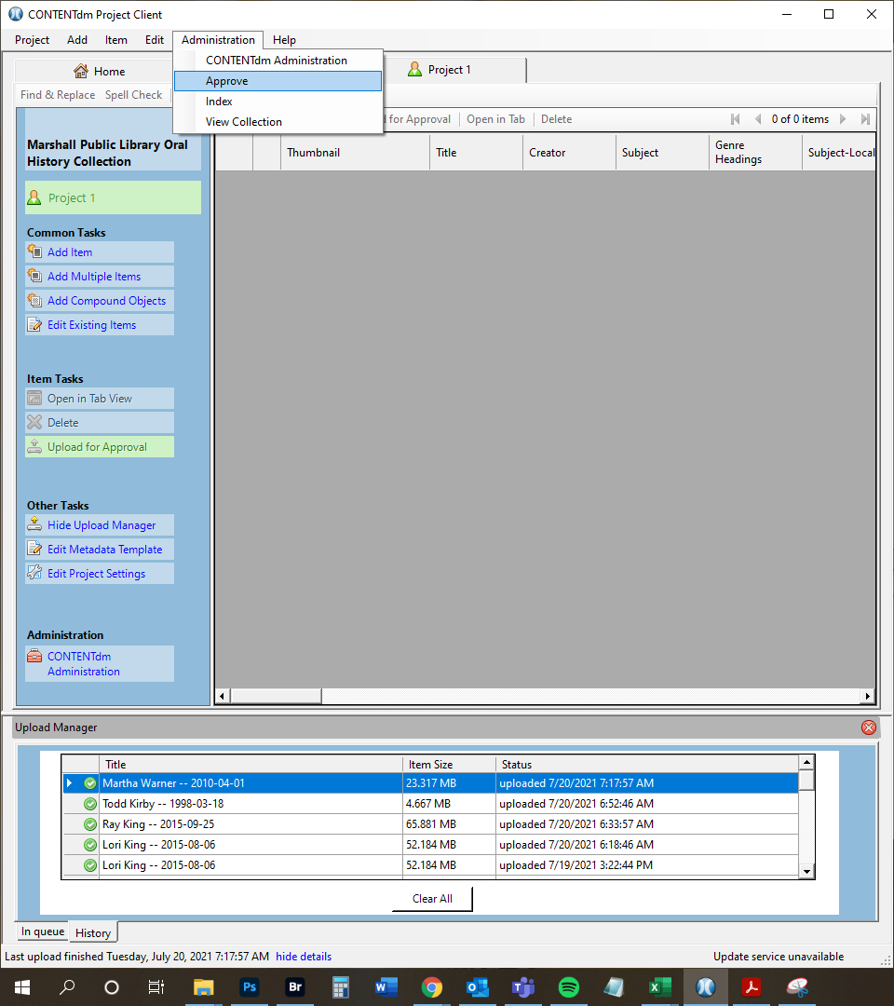
Once it’s done uploading from the Project Client program, it will show up in the “History” tab with a green checkmark. Next, you will navigate to the web interface. Do this by clicking on “Administration” dropdown and clicking on “Approve.” This will automatically open the web interface...

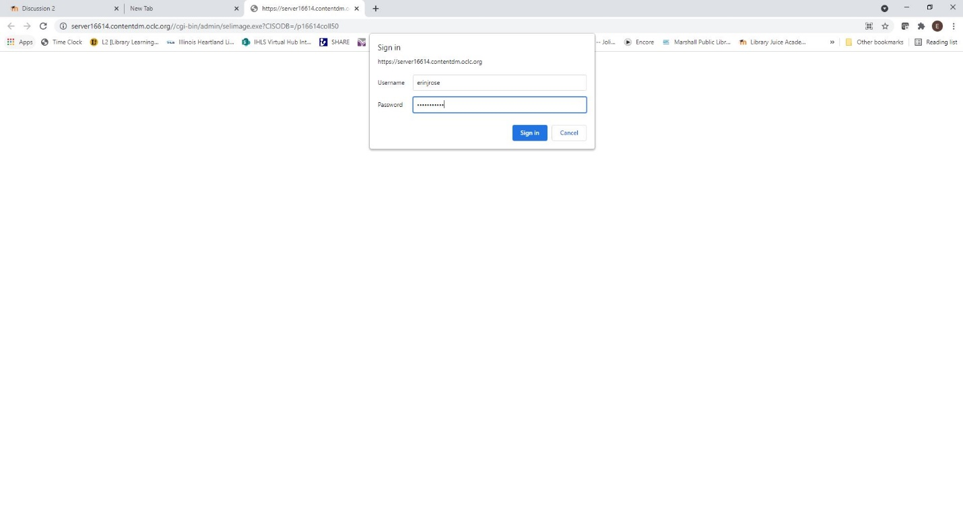
You will be asked to log in with your CONTENTdm username and password...

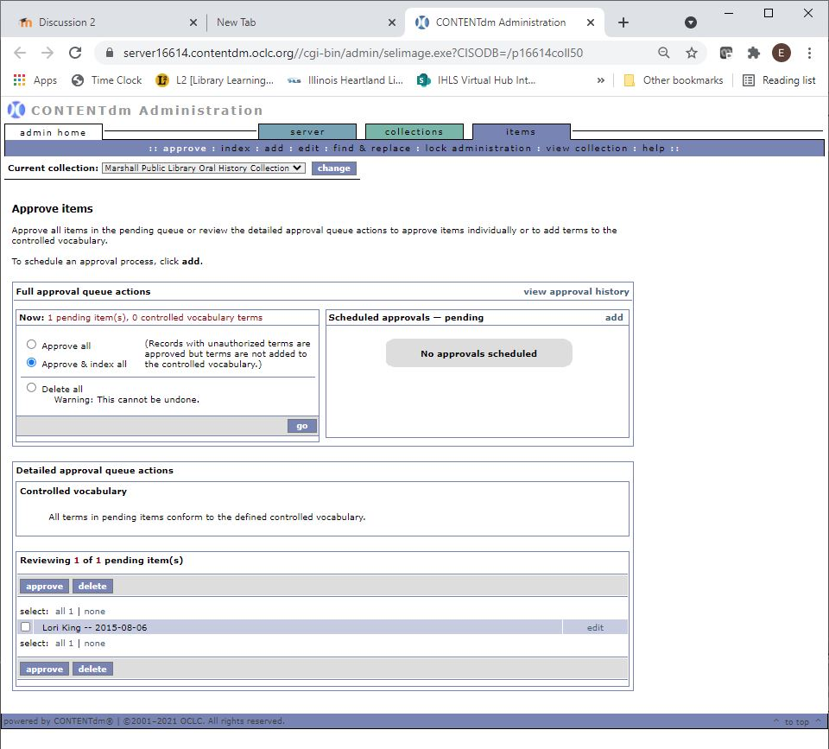Click on the “approve” option in the purple toolbar, and you will see that there is an item pending for approval. Click on the radio button next to “Approve & index all” then click on the purple “go” button.

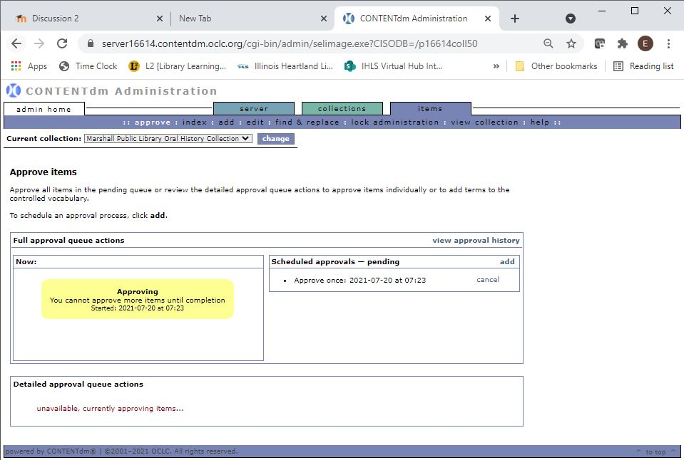
You will get the yellow “Approving” rectangle, which is the first step of the Approve and index process. Once it’s done approving, it will begin to index, and you can track that progress by clicking on “index” in the purple toolbar.

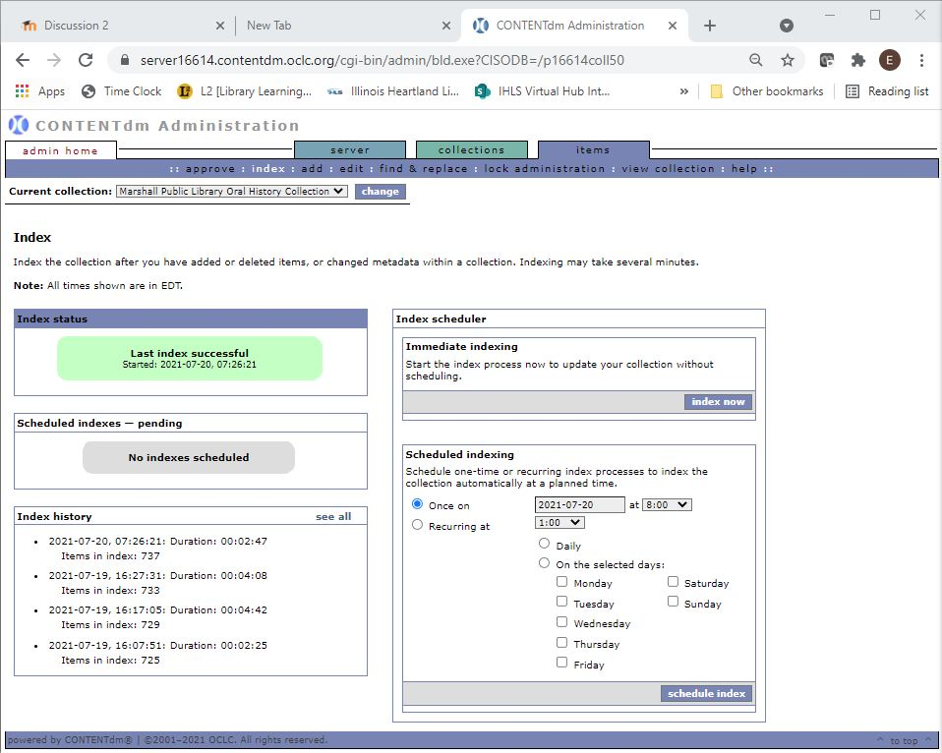
Once the index is complete, you will get a green rectangle stating that index was successful. You can view the compound object on the website by clicking on “view collection” and it will open your collection page.

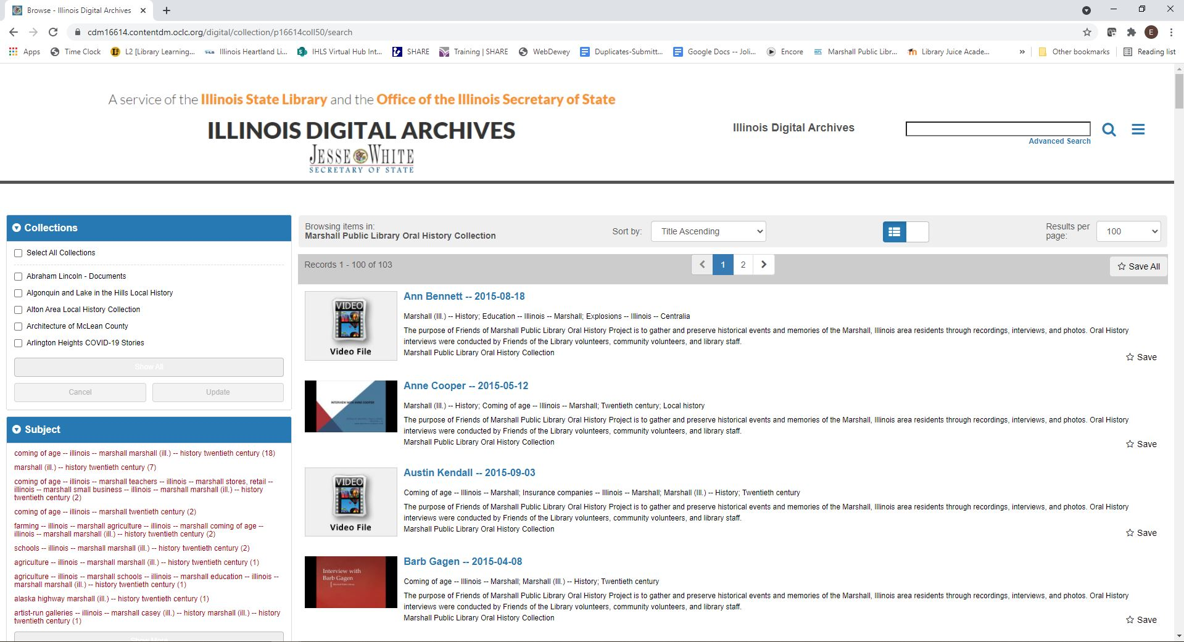
Once you are on your collection page, navigate through to find your compound object...

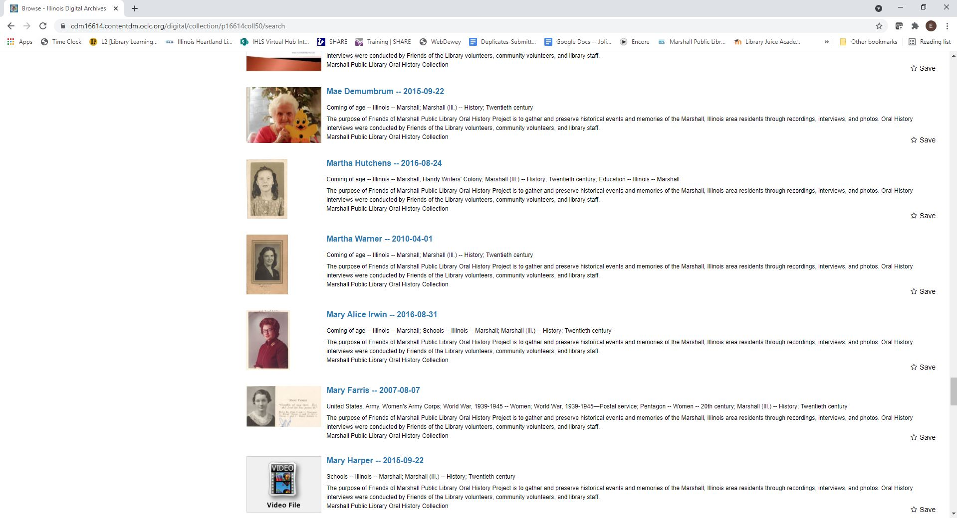
And click on it to open it up and make sure that everything looks right. You’ve done it!

