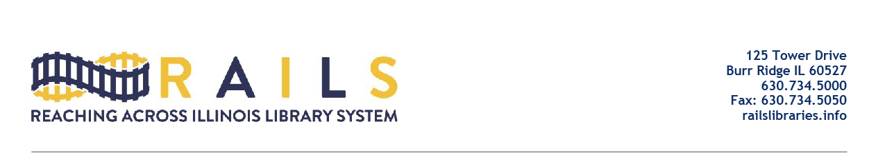

RAILS City Library Directors Networking Group
Friday, May 13, 2022
10:00-11:00am

Agenda

- Welcome (5 mins)

- Introductions (20 mins)

- Please give one thing you want to take away from the networking meetings

- Why This Group Was Formed (5 mins)

- Open Discussion (25 mins)

- Next Meeting (5 mins)

- Adjourn

