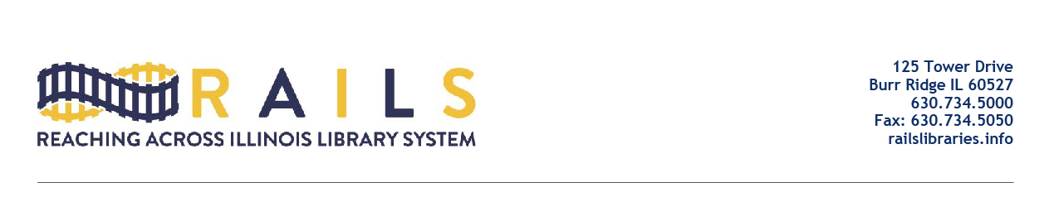

Chicago Area Solo Librarians Networking Group
Friday, July 24
12:00-1:00pm

Agenda

- Welcome (5 mins)

- Group History (5 mins)

- Introductions (20 mins)

- Please give one thing you want to take away from the networking meetings

- Open Discussion (25 mins)

- Next Meeting (5 mins)

- Adjourn

