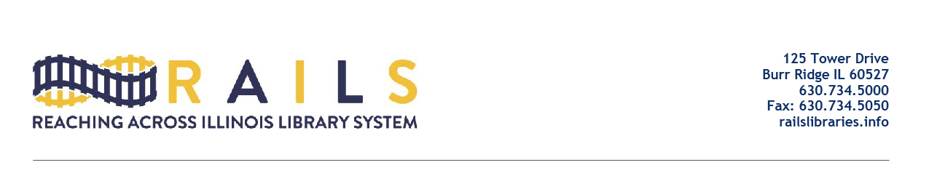

RAILS City Library Directors Networking Group
Friday, June 17, 2022
10:00-11:00am

Agenda

- Welcome (5 mins)

- Responses from Julie Tappendorf (25 mins)

  - See separate document
  - Boilerplate from RAILS:

Feel free to share this document with your boards as you evaluate the best course of action for your library. It is our recommendation that you also review this with your library’s attorney before taking any action.

- Other questions (25 mins)

- Residency requirements: I am wondering how many other libraries follow their city's residency requirement. Our city has a residency requirement within 10 miles of within the city.

- Next Meeting (5 mins)

- Adjourn

