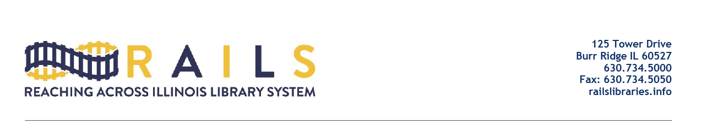

RAILS Date in Libraries Networking Group
Tuesday, June 21, 2022
2:00-3:00pm

Agenda

- Welcome (5 mins)

- Why This Group Was Formed (5 mins)

- Poll questions:
  - How often do you work with data?
  - How often would you like to work with data?
  - What are you hoping to get out of this group?
- Padlet questions:
  - What kind of data that RAILS could get would be useful for you?
  - What is your job title?
  - Do you have some data or project to share with the group?

- Introductions (20 mins)

- Please give one thing you want to take away from the networking meetings

- Open Discussion (25 mins)

- Next Meeting (5 mins)

- Adjourn

