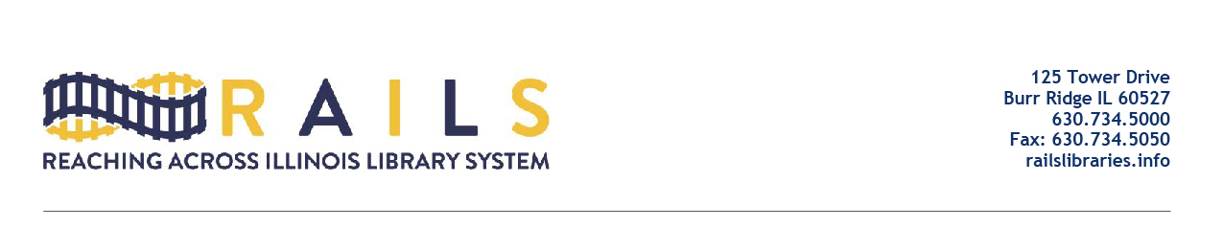

RAILS City Library Directors Networking Group
Friday, July 15, 2022
10:00-11:00am

Agenda

- Welcome

- Ryan Livergood, ILA PPC

  - Funding for cards for kids (L. Stainbrook)
  - More clarify on state law and levy related to budgeting and capital (C. Brown)
  - Others

- Responses from Julie Tappendorf, continued

- Other issues

- Next meeting

- Adjourn

