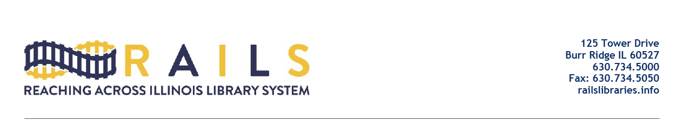

RAILS City Library Directors Networking Group
Friday, August 19, 2022
10:00-11:00am

Agenda

- Welcome

- RAILS memorandum addressing the relationship between municipalities and municipal libraries from Julie Tappendorf

- Discuss survey of needs and issues

- Other issues

- Next meeting

- Adjourn

