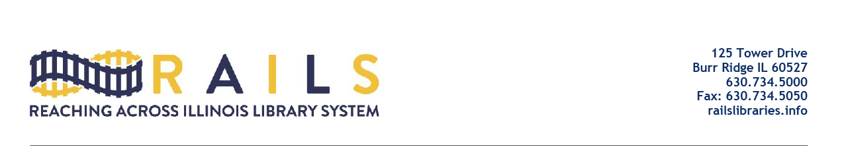

RAILS City Library Directors Networking Group
Friday, November 18, 2022
10:00-11:00am

Agenda

- Welcome

- Initial results from the RAILS City Library Directors Survey with Grant Halter

- Memo from Ancel Glink concerning board of director vacancies with Joe Filapek

- Other issues

- Next meeting

- Adjourn

