**SimplyReports Users Guide**

**What is SimplyReports?**

SimplyReports is a Polaris product that gathers data from the Polaris database, allowing you to create custom reports about your patrons, patron account transactions, holds, and items. SimplyReports provides you with information you would expect to find in Reports and Notices yet is more robust and gives you control over the content, order, and parameters.

**Accessing SimplyReports**

First, you’ll need to request access to SimplyReports by submitting a Help Desk ticket on the SHARE website (share.illinoisheartland.org).

SimplyReports can be accessed from any computer with any browser.

Log in to SimplyReports, by going to: <http://ihlsrpts.illinoisheartland.org/SimplyReports>

To log in, enter your Polaris username and password, then click the [Log in] button.

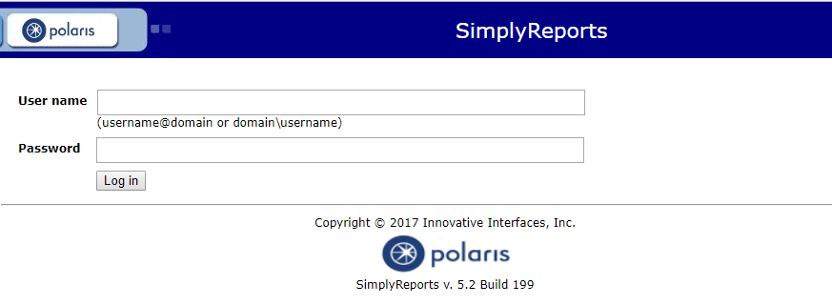

After logging in, you will see the following window:

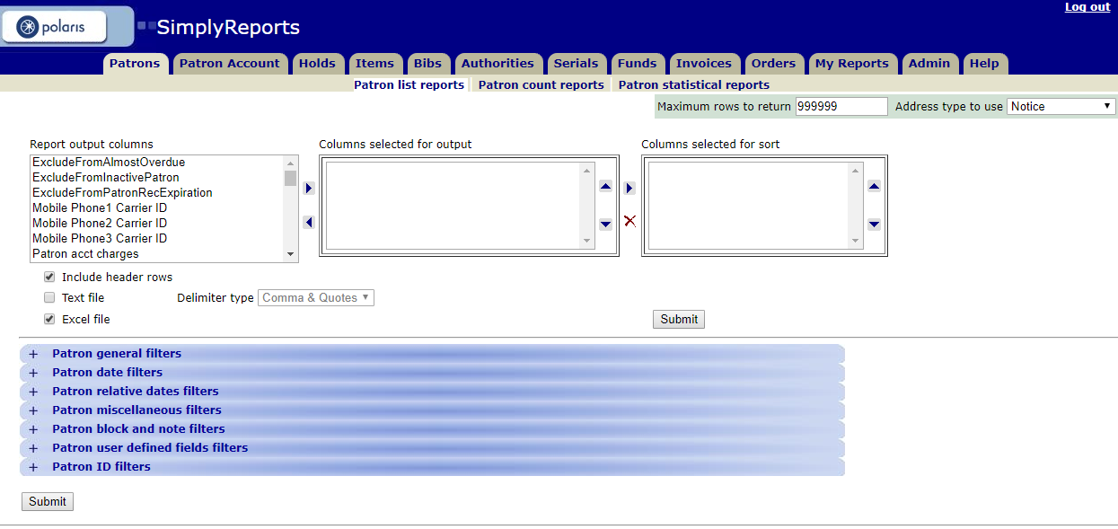

**Steps for Creating a Report**

1. Select the category of the report.

The tabs across the top allow you to select the category of the report. Some of the tabs are blocked because running reports in this area slows down the performance of Polaris.

* **Patron** – use for information based on data in Patron Registration and Patron Status.
* **Patron Account** – use for information based on data in Patron Status, such as financial information and patron activity.
* **Holds** – use for information on hold requests including hold activity, item records, bib information and patron activity.
* **Items** – use for information on item records, linked bib records and linked patron records.
* **Bibs** – use for information on bibliographic records, linked item records and linked holds.
* **Authorities** – (NOT AVAILABLE)
* **Serials** – use for information on serials, holds and issue information.
* **Funds** – use for information on acquisition fund records.
* **Invoices** – use for information on acquisition purchase order records.
* **Orders** – use for information on acquisition purchase order records.
* **My Reports** – this option allows you to access any saved reports.
* **Admin** – (NOT AVAILABLE)
* **Help tab** – access the SimplyReports online help index.

1. Select whether the report should be a list report or a count report.
   * **List** – this type of report will list detailed information according to the columns you have chosen to display.
   * **Count** – this type of report will only display counts for the columns you have selected.
   * **Statistical** – (NOT AVAILABLE)
2. Check your default settings such as “Include header rows” or “Excel file”.

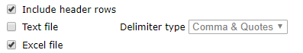

1. Select the Columns (fields) you want included in your report.  
     
   The “Report output columns” list contains the columns (fields) in Polaris related to the category you have selected. Highlight the output column fields you want included in your report and click on the arrow to add it to the second column, “Columns selected for output” list.

The up and down arrows allow you to move the output column up and down the list. This is the order the columns will display on your report. To remove a column from your output list, highlight the line, click the left arrow, the column will be moved back to the end of the first column, “Report output columns” list.

1. Select the Sort Order (optional).  
     
   In the “Columns selected for output” list, highlight the fields that you want to sort the report by and then click the arrow key to move them to the “Columns selected for sort” list. You can include multiple fields to sort and you can change the order of the fields by clicking on the up and down arrows. You can delete a column from sort by clicking on the **X** button.
2. Select your filters.   
     
   Filter choices change depending on the category but there will be several filters to choose from. Selecting the right filters allows you to limit your report to the correct results. To see what is under each filter section, click the + sign to expand the list. Clicking the – sign will close the list.

To select a filter, you must check the left box, and then type your selection in the field or pick a selection in the dropdown menu.

1. Click the [submit] button.

A preview of your report will appear in another window.

1. Review the data.

If the output is not what you want, close the window and make any necessary changes to selected settings, and submit again. When you get the desired output, select a method for saving the report:

* 1. Download report output. When checking this option, a download button will appear. Click the download button. Once the file has finished downloading, double-click on it to open. You can then save the file to your computer.
  2. Save report parameters for later use. When checking this option, two blanks give you an opportunity to name the report and describe the report. Click Save report parameters.
  3. Create patron (item) record set from report results. When checking this option, two blanks give you an opportunity to name the record set and describe the record set. Click Save record set.

1. Accessing your reports.  
   1. If you downloaded the report, after opening and saving it, you can access the report on your computer.
   2. If you saved the report for later use:

Go to the “My Reports”. Click the dropdown menu to the type of report that you created. Saved reports for that type will appear in a list.   
  
For each report you can:

1. Delete the report.
2. Edit the report.
3. Run the report (this gives you the opportunity to see the report in Excel).
4. Publish the report (this saves the report in your custom folder so that it can be generated on an as-needed basis).

Note: If deleting or editing the report, be sure you click on the correct button before answering OK when prompted. The prompt for both appears identical in size and color except for the words “delete” and “edit”.

1. If you created a Patron Record Set, go to the main Polaris toolbar and click Patron Services / Record Sets. Search for your record set. If you created an Item Record Set, go to the main Polaris toolbar and click Cataloging / Record Sets. Search for your record set. In Leap, at the main screen, click Find, then click Record set in the Find Tool dropdown menu.

**To Edit a Saved Report**

You can edit all column and filter settings for saved Patron, Patron Account, Bib, Item, and Holds list and count reports.

To edit a saved report:

1. Select the My Reports tab and select the My reports subtab.
2. Select the type of report you want to edit in the Select one or more report types box. The saved reports of this type are listed.
3. Select the check box next to a report in the list of saved reports.
4. Click “Edit” under Actions. A message asks if you are sure you want to edit this report. If you want to continue, click OK.
5. The tabbed page for the selected report type opens. The report information at the top of the page is blue to indicate that you are editing a saved report. The filter options are expanded, and the column and filter options are displayed with the options set as they were when the report was saved. Note: Saved reports preserve the column selections but do not preserve the column order.
6. Change the column and filter selections as desired.
7. Click Continue. The report Preview window opens.
8. Leave the report name unchanged to overwrite the previous version of the report or type a new name for the edited report.
9. Click the Save report parameters icon to save your edited report.

**Steps for Publishing a Report**

When you publish reports created in SimplyReports, they appear in the Custom folder when you select Utilities/Reports and Notices/Custom/Your Library on the Polaris Tool bar.

To publish a report to the Custom folder so that it is available from the Polaris Tool bar:

1. Select the My Reports tab and select the My reports subtab.
2. Select the report type. The list of saved reports of this type appears.  
     
   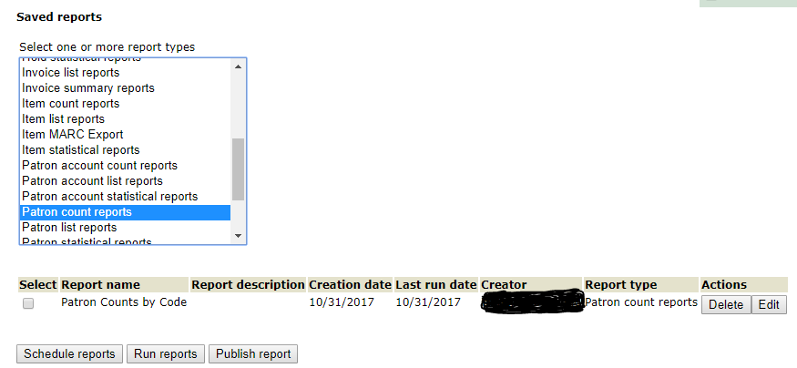
3. Select the report you want to publish.
4. Click Publish report. The Basic Publishing page opens.

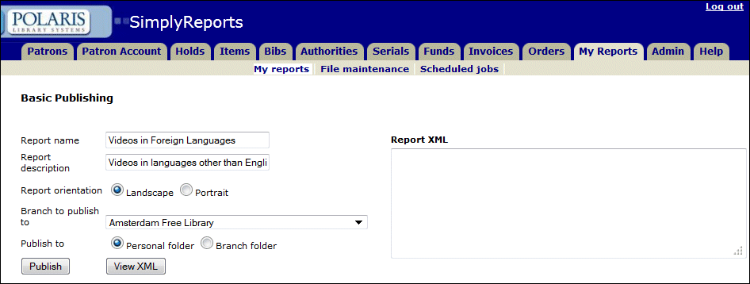

1. Select Landscape or Portrait to specify the report’s orientation on the page.
2. Select a branch for the report in the Branch to publish to box.
3. Select Personal folder or Branch folder to indicate the customer folder in which to save the report. The personal folder will be a subfolder under your library’s Custom folder labeled with your user name and will only be accessible by you. The branch folder will put the report under your Custom folder and accessible by other staff at your library.
4. Click Publish to save the report.

The report will now be available for you to generate from your library’s Custom report folder on an as-needed basis (Polaris Tool Bar / Utilities / Reports and Notices / Custom / My Library).

Note: After a report is published to the Customer folder in Polaris Reports and you edit it in SimplyReports, the changes do not affect the version in the Custom folder. To change the Custom report, you must edit the report in SimplyReports and publish it with the same name so that it overwrites the old one in the Custom folder.

Note: Once you have published a report, only SHARE staff can remove it from your folder.

**Running a Report on a Record Set**

Sometimes you may want to run a report based on a Record Set that has already been created. In SimplyReports this is easy to do.

After selecting your options from Steps 1-5 listed in “Steps to Creating a Report”, you must then point SimplyReports to the Record Set. This happens in Step 6 when you are adding your filters.

For a Patron Record Set, the option will be listed on Patron General Filters.



For an Item Record Set, the option will be listed on Item General Filters.



Add other filters as desired. The filters will only be applied to any patron or item that you have in the Record Set.

**SimplyReports Tips**

* If you select a filter by checking the check box and *do not* select a value by highlighting it, SimplyReports will use *all* the values, e.g., if you check Collection in the Item general filters but do not highlight a specific collection or collections, the report will gather data and show *all* the collections.
* Some filters also have the option of checking **not present**, e.g., patron expiration date. In this example, checking **not present** limits output to those records where there is no expiration date in the patron record.
* To select more than one value in a menu, hold down the **CTRL** key and click on the values you want. To deselect one value when many are selected, hold down the **CTRL** key and click on the value you want to deselect.
* To select a block of values, click on the value at the top of the list of values you want to select, and then hold down the **SHIFT** key and select the value at the bottom of the list of values you want to select. This will highlight all the values in that range.
* When filtering by date (a specific date range), you must select *from* and *to* dates using the calendar icons.
* For those filters where you are prompted to type specific information, you may truncate with an * at any point, e.g.:

1. Patron block and note filters: Blocking notes - *needs to sign*
2. Patron user defined fields filters: (User 2) Homeroom/Location - *Henderson*
3. Item block, note, and funding filters: Physical condition - *
4. Item call number filters: Classification number - 000.*-099.*

* If you do not move one or more of the values from the **“Columns selected for output”** list into the **“Columns selected for sort”** list, the report you create will be sorted by the order they appear in the **“Columns selected for output”** list.
* You can safely maximize (+) and minimize (-) the filter lists while creating a report without losing the information you select.

If you create a list report (patron or item) and some fields are blank, that indicates the information asked for is not in the database for those specific patron or item records, e.g., the expiration date may be blank for some patrons, or the item assigned collection name may be blank for some items.