In Polaris, an item record is linked to a bibliographic record to describe an individual copy of a work owned by a library. Each copy must have a separate item record.

General Cataloging Steps
- Search the Polaris database first for a matching record
- If a record is found, use match points to determine if the record matches your item
- If the record is a match, attach your item
- If a match is not found in the database, a record will need to be brought in
- For cataloging libraries, search OCLC
  - If a match is found in OCLC, upgrade or edit as needed and export record into the database
  - If no match is found in OCLC, the item will require original cataloging
    - Create an original record in OCLC and export into the database
or
    - Send to IHLS cataloging center at your hub for original cataloging
- For barcoding libraries, hold item and search again later, or send to IHLS cataloging center at your hub

Matching
- Determine if the item in hand matches the record you have found
- Often you will find more than one record that may be a match
  - In that case, try to determine the best record
  - Report duplicate records through the SHARE help desk or website form

General match points
- Numbers--i.e., ISBN, publisher number, UPC, ISSN, etc.
- Title
- Responsibility—i.e. authors, illustrators, editors, translators, directors, performers, etc.
- Publication information
- Physical description
- Language
- Series

Creating Item Records

Once a bibliographic record is identified, you can create item records in these ways:

- Create a new item record from a blank workform without using a template
- Create a new item record using a template.
- Create multiple item records using a template. Creating item records with a template will be discussed today.

Creating Item Records from a Template

Item record templates contain pre-defined information that will automatically populate selected fields in the item record. Follow these steps to create an item record from a template:

- Using the bibliographic search tool [F12], find the correct bibliographic record.

- Open the Item Record workform by selecting Tools, Create Item Records, or click 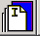. The New Item Record workform appears. The Item information section contains the title, author, and control number information from the bibliographic record.

- Click in the white box below the Template column header to bring up a list of your library’s
templates.
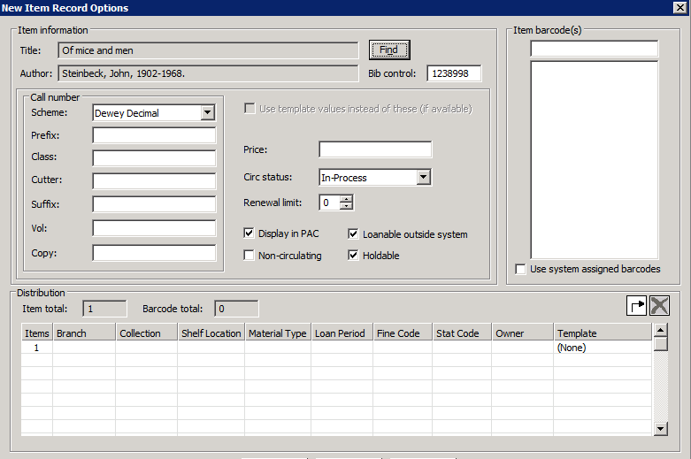
- Select a template from the list. Fields on the bottom fill in based on the template selected.

- Click [OK]. The Item Record view will appear.

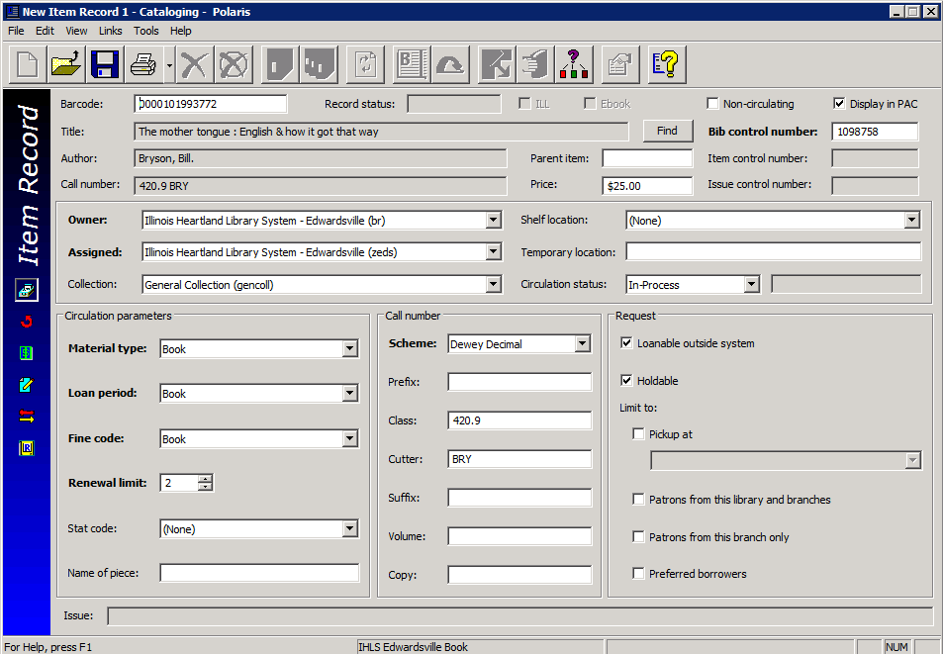

- Scan in the barcode and enter information in other boxes as needed—some may fill in from the template.
- Fill in the call number information:
  - Scheme – This will default to the classification scheme set up in your library’s profile. Most will be Dewey Decimal, but in some cases will default to Library of Congress (LC) or Other (for libraries that use a local classification scheme).
  - Prefix – The start of a call number. REF, R, J, DVD are examples. This helps define the type of material or location. Not every call number will have a prefix. Library defined. This is usually already filled in from the template.
  - Class – Dewey classification number, such as 364.1532. LC classification will begin with letters.
  - Cutter – A combination of letters and/or numbers to arrange the items for location on the shelf. This is often the first three letters of the title or author’s name, but this is determined by the individual library.
  - Suffix – Other identifying information that determines location or type of material. Library defined. Use this field to showing series numbering, if you want to provide this information to your patrons. Displays at the end of the call number.

- Add a Price if desired. Type in the amount only—the system will supply the $.

- Leave the Circ Status in its default form “In Process.” This status allows holds to be placed at the title level while the item is being processed.

The Holdable option can be limited by:

- Pickup at this branch – this limits the item to filling hold requests only where the item’s assigned branch is the pick-up library.
- Patron from this library and branches – this limits the item to filling hold requests from patrons registered at the item’s assigned branch and other branches associated with the same parent library.
- Patrons from this branch only – this limits the item to filling hold requests only from patrons registered at the item’s assigned branch.
- Preferred borrowers – this limits the item to filling hold requests only where the patron’s pick-up library is on the Preferred borrowers list in the Holds options dialog box in Polaris Administration. This functionality is not being used at this time.

- Double-check your entry. Make any desired changes, and then click File>Save on the Shortcut Bar, or , or press CTRL+S to save this item.

- When the record has been saved, an item record control number will appear in the Item control number field and the Record status field will indicate Final. Also, icons for various functions will be available on the record’s tool bar.

- The final step to make an item ready to circulate is to check it in. This changes the Circulation status from In-Process to In and allows the item to fill holds. The item may be checked in through the circulation module, or from the item record by clicking the Check In icon:

Item Record Views

In the individual Item Record, there are 6 different views: Cataloging, Circulation, Source and Acquisition, Notes and Notices, Circulation History, and Reserves.

The default view when creating or opening an item record is the Cataloging view.

.

Circulation View

The circulation view allows you to see information such as a current due date, current borrower, check out date, renewal history, in-transit information, etc.

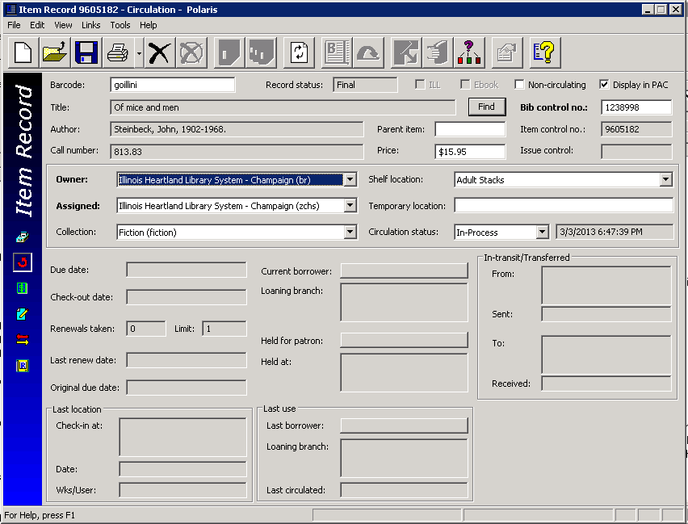

Source and Acquisitions View

The source and acquisitions view displays information regarding acquisitions, such as purchase order and/or invoice information. Even if you are not an acquisitions library, you can add donor information if you feel that this would be helpful data to gather.
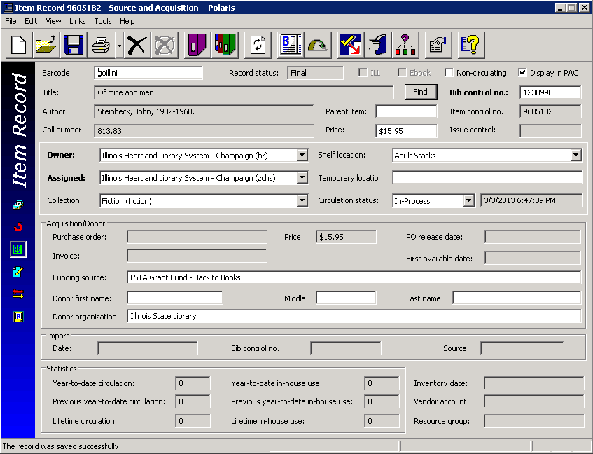

Notes and Notices View

The notes and notices view displays information about notices and allows you to enter notes on a particular item. The following notes are available:

- Public – notes that will display in the PAC
- Non-public – notes intended for library staff only
- Physical condition – describes the physical condition of the item. Example: Torn cover

At the bottom of the screen, you can add blocks to an item that will display when an item is checked in or out:

- Library Assigned – available choices include Check Contents, See Note, Damaged, Send to Cataloging, Check for Disk, Check for Cassette, Check for Book, Check for Map
- Free-text – allows you to type in any note. Example: Check for 10 CDs.

You can use Library Assigned and Free-text blocks together if desired.

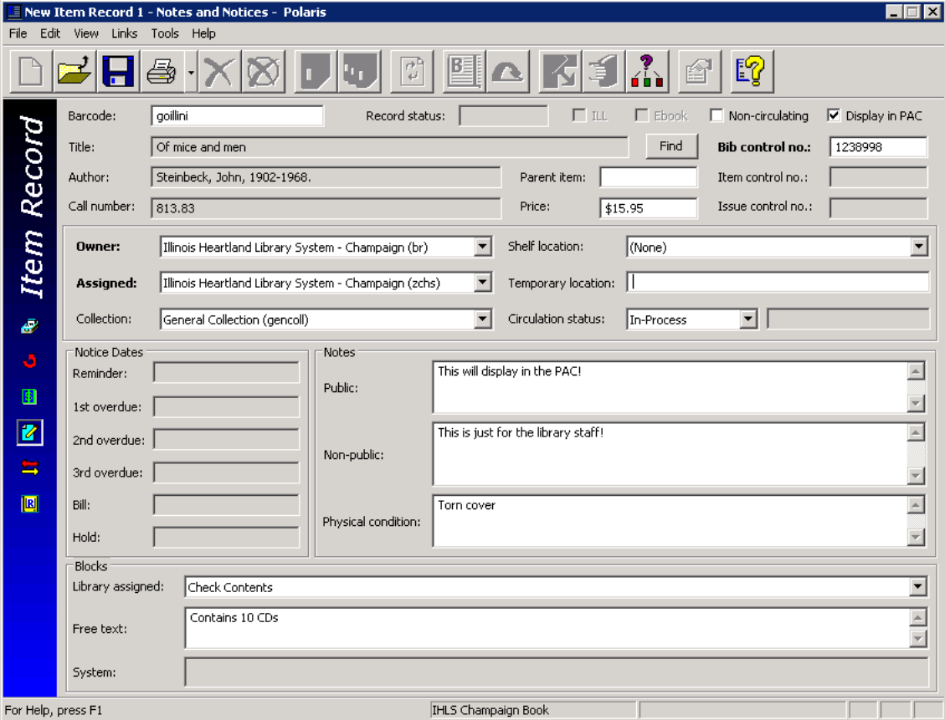
Circulation History View

The circulation history view displays information about what has happened to this item, including the date and time, and the login that performed the action.
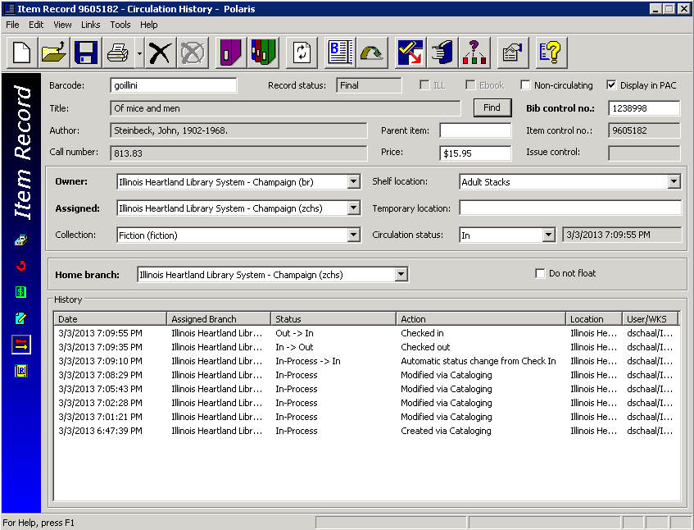

Reserves View
The reserves view displays information about course reserves, which is not discussed in this manual.

Searching for Item Records

If you need to find an item record that has already been created, there are three ways to bring up the Item Record Find Tool:

- Select the item record icon in the cataloging module on the tool bar

- Choose Cataloging>Item records from the menu bar

- Press CTRL+ALT+F9 on the keyboard

The Item Record Find Tool defaults to searching by Barcode (your login may be different if you have changed your user defaults). Scan or type in the barcode to bring up the item record. You may also search by any of the other indexes available in the Search by: dropdown menu.

From an open bibliographic record, you can bring up a list of all attached item records by clicking the Linked Item Records icon . From the list, highlight and double-click the desired item record to open it.

Editing Item Records

Edit from an open record
- Retrieve an individual item records by one of the search methods above.

- Open the item record and make changes as desired. Save your changes.

Transferring Item Records

It is very easy to move an item record from one bibliographic record to another (for example, if the record was mistakenly attached to a bibliographic record that does not match your item). Follow these instructions:

1.In the item record, delete the bibliographic record control number in the Bib control number
field and replace it with the control number of the bibliographic record you will be using.
Recommend copying the control number from the bibliographic record you will be using and
pasting it in to prevent the possibility of typing in the wrong number.

2.Save the record.

Deleting Item Records

There are 4 ways to delete item records in Polaris:

- If you are in the Item Record workform, click File, Delete, or , or CTRL-D.

- If you are in an [F12] search results list, right-click the record, select Delete from the submenu.
- From a search results list, you can highlight multiple records for deletion. The Multiple Object Deletion dialog box appears; click [Yes] to continue with the deletion. If you made a mistake, click [No] to cancel the deletion process.

- You can also delete items using the Record Set function. This will be discussed in a different session.

- You may see a warning like this. Click [Yes] to continue.

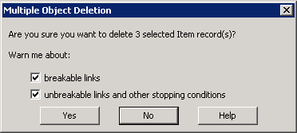

- If any item record you are deleting is the last item attached to a bibliographic record, the bibliographic record will automatically be added to a record set and you will get a message like the one below. Click [Delete] to continue. No further action is required--the bibliographic records will be purged from the database by SHARE staff.
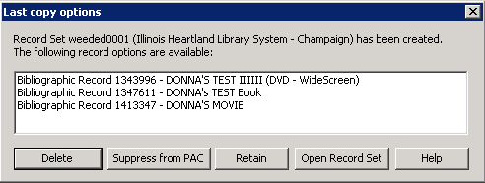

Undeleting Item Records
Deleting item records is a two-step process. The first step is done by the library, following the instructions above. This puts the item record in a Record status of Deleted. In this status, the item record cannot be edited, it will not fill holds, and it does not display in the PAC. However, the item record is still in the database.

The second step is called purging and is done by SHARE staff on a periodic basis. Purging permanently removes the record from the database.

While an item record is in Deleted status, but before it has been purged, it is possible to “undelete” the record (for example, if it was deleted by mistake, or a lost item is returned)
To undelete an item record:
- If you are in the item record, click File>Undelete, or , or CTRL-U.

- If you are in an [F12] search results list, right-click the record and select Undelete from the submenu.
A message box tells you the Record status has been changed to Final, and if there were links to other records, they need to be reestablished. The item record will now once again fill holds, it will display in the PAC, and it may be edited.

Item Record Templates

Item record templates contain pre-defined information that will automatically populate selected fields in the item record. Each library may create as many item record templates as desired.

Searching for Existing Templates

- Using the [F12] Find Tool, change Object to Item Templates. You may also click Cataloging on the menu bar, then select Templates>Item.

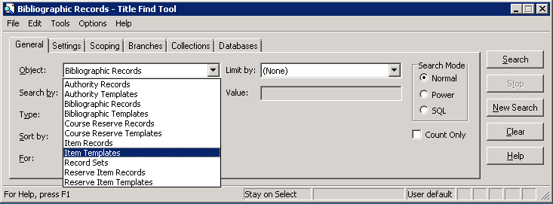

- The Item Templates Find Tool defaults to searching by Name (your login may be different if you have changed your user defaults). In the For: box, enter the name of the template you’re looking for, or enter a wildcard character (you can use either an asterisk (*) or a question mark (?)). This will find all of your library’s templates.

- Highlight the desired template and double-click to open it up.

- From here, you can either edit the existing template (don’t forget to save your changes) or copy the template to create a new one.
Note: do not edit or change the name of your library’s On the Fly template, or the template will not work correctly in the circulation module. Also, template names for item records created through the serials module must begin with the word Serial.

Creating a New Template
- From inside an existing template, Click File>New, or , or CTRL+N to create a new template. The Copy the existing workform radio button should be checked. Click [OK].

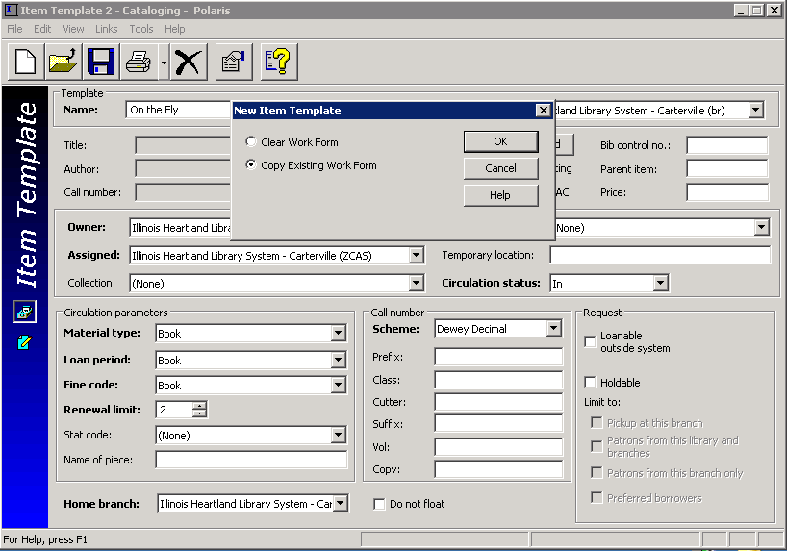

- Rename the template.
- Make any desired changes, and then click File>Save on the Shortcut Bar, or , or press CTRL+S to save this template.
- The template will now be available for use in the template dropdown menu on the New Item Record workform.

Deleting a template

There are 2 ways to delete item record templates:

- If you are in the template workform, click File, Delete, or , or CTRL-D.

- If you are in an [F12] search results list, right-click the template(s), and select Delete from the submenu.

Note: There is no “undelete” option for templates. Deleting a template removes it permanently from the database.

