Machine Readable Cataloging (MARC)

An Introduction to MARC Records
Machine Readable Cataloging (MARC) is the computer framework that is used to create the bibliographic records that are the foundation of an online catalog. Coding in MARC records creates the display in the Public Access Catalog (PAC) and makes information in the records searchable so that users can discover your library’s resources.

What is MARC?
- A framework for creating bibliographic records in a form that can be read by a computer
- Developed in the 1960s to print catalog cards; evolved to become the basis of online catalogs
- Allows bibliographic information to be searched and edited
- Generates the display the patron sees in the online Public Access Catalog (PAC)
- Maintained by the Library of Congress (LC)
  - Updated and revised as needed to accommodate changing cataloging rules and the online environment

Why is it Important to Understand MARC Coding?
- Library catalogs are made up of bibliographic records that describe the items in the collection
- Bibliographic records are created using MARC
- Many functions such as cataloging, circulation, acquisitions, and interlibrary loan make use of MARC records
- Understanding MARC helps you navigate the catalog and better help your patrons find the resources they need

What is a Bibliographic Record?
- A record created by catalogers to provide information about resources in a consistent, accurate, and searchable form
- Bibliographic records include:
  - Title
  - Responsibility
  - Publication information
  - Physical description
  - Other general information—summary, contents, system requirements, etc.
  - Subjects

What is a Public Access Catalog (PAC)?
- An online database of materials held by a library or group of libraries
- May be called PAC, OPAC, catalog, etc.
- What the patron sees when they do an online search for library resources
- The database includes:
  - Bibliographic records in MARC format describing resources
  - Holdings information for libraries that own copies

What Does the PAC Do?
- Allows users to search for resources that meet their needs
- Lets users see what resources are available and provides information about those resources
- Allows users to obtain the resources (place a request)

PAC Displays
- Displays are generated by MARC coding
- How the bibliographic data is displayed and searched depends on:
  - The ILS (Integrated Library System) being used
  - Capabilities of the ILS
  - Customization

Input Standard vs Content Standard

MARC is an input standard that uses coding to make bibliographic data visible and searchable for users of an online catalog. MARC makes the information readable by a computer but doesn’t tell the cataloger what that information should be.

The information that goes into a record is entered according to a content standard—a set of rules for what information is entered and how it is formatted.

The content standard currently being used by the Library of Congress and many other institutions is Resource Description and Access (RDA).

Before RDA, the most commonly used content standard was Anglo-American Cataloging Rules (AACR). This standard is still in limited use.

Catalogs often contain records created using AACR, records created using RDA, and hybrid records that are a combination of both. The formatting and coding will differ somewhat between these records.

Structure of MARC Records

Parts of a MARC Record
A MARC record consists of fields.

MARC records contain three types of fields: the variable fields, the leader, and the fixed field.

Variable Fields
- The body of the bibliographic record
- Called variable because a particular field may or may not be present in a record, depending on the resource being cataloged
- Some fields may be repeated; some may be used only once
- Data is transcribed or recorded from the item in hand

Variable fields consist of three parts: a MARC tag, indicators, and subfields

MARC Tag
- A three-digit number that denotes the type of information contained in the field
- The first digit indicates the general category of information (i.e., title, subject, note, etc.)
  - Example: MARC tags that start with 3 contain physical description information
- The second and third digits indicate the specific information within that category
  - Example: MARC tag 347 contains digital file characteristics
  - X in the second and/or third position stands for any number in that position
    - Example: 3XX denotes any MARC tag that starts with 3 (i.e., 300, 337, 344, 380, etc.)
- In Polaris, MARC tags are in blue

Indicators
- Two positions in every field
- Will be blank or contain a number from 0-9
- Positions are independent (i.e., 1st indicator 1 and 2nd indicator 4 are separate numbers, not 14)
- Some fields have two indicators, some have only one, and some have none
- Serve different functions depending on the field
  - Some generate PAC display
  - Some are used to limit searching
- In Polaris, indicators are in pink

Subfields
- Divide a field into smaller parts
- A lowercase letter or number, preceded by a delimiter symbol (‡)
  - Note: Different systems use different delimiter symbols (will sometimes see $, |, ǂ, etc.)
- Each MARC tag has subfields valid for that field
- Contain information specific to the field
  - Example: Subfield b in MARC tag 245 contains different information than subfield b in MARC tag 264
- In Polaris, delimiter symbols and subfields are in green

Field
Indicators

MARC tag Subfields

Some Commonly Used Variable Fields

This is not an exhaustive list but shows some of the MARC tags commonly used in bibliographic records.

See OCLC Bibliographic Formats and Standards for complete information on each tag, including an explanation of the purpose of the tag, whether the tag is repeatable, and valid indicators and subfields with examples.

0XX Fields--Numbers and Other Coded Information

000 – Leader
006 – Additional fixed field information
007 – Coded physical description information
008 – Fixed field
010 -- Library of Congress Control Number (LCCN)
020 – International Standard Book Number (ISBN)
022 – International Standard Serial Number (ISSN)
024 – Other standard identifier
028 – Publisher or distributor number
041 – Language code
043 – Geographic area code
092 – Dewey Decimal Classification number

1XX Fields—Main Entry Fields

Main entry is an outdated term but is still used to refer to the access point for the entity principally responsible for the work.

This is usually a name, either of an individual or a group.

100 – Personal name main entry
110 – Corporate body main entry
111 – Conference main entry

In cases where no name can be associated with the work, a uniform title may be designated as the main entry in cases such as works with many translations, or serials that change titles during the run of the publication. A uniform title brings together different manifestations of the same work.

130 – Uniform title main entry

2XX Fields—Title, Edition, and Publication Information

240 – Uniform title (used to bring together different manifestations of the same work when the author is known)
245 – Title proper
246 – Variant titles
250 -- Edition
260 – Production, publication, distribution, manufacture, and copyright information (AACR records)
264 – Production, publication, distribution, manufacture, and copyright information (RDA records)

3XX Fields—Physical Description

There are many fields used to record various aspects of a resource’s physical description. These are just a few.

300 – Physical description
310 – Current publication frequency
321 – Former publication frequency
336 – Content type
337 – Media type
338 – Carrier type
340 – Physical medium
341 – Accessibility content
344 – Sound characteristics
345 – Projection characteristics of moving image
347 – Digital file characteristics
380 – Format of work
382 – Medium of performance

4XX Fields—Series Information

440 – Series statement (This tag is obsolete, but is still present in older records)
490 – Series statement (Series statement as it appears on the resource—may be used in conjunction with 8XX entries)

5XX Fields—Notes

There are many fields used to record notes of various types. These are just a few.

500 – General note
504 – Bibliography note
505 – Contents note
508 – Creation/production credits note
511 – Participant or performer note
518 – Date/time and place of an event
520 – Summary note
521 – Target audience note
526 – Study program information note
532 – Accessibility note
538 – Systems detail note
546 – Translation note
588 – Source of description note

6XX Fields—Subjects

600 – Personal name subject heading
610 – Corporate body subject heading
611 – Conference subject heading
650 – Topical subject heading
651 – Geographic place subject heading
655 – Genre or form subject heading
690 – Local subject heading

7XX Fields—Added Entries

Added entries are used to record names of persons or groups other than the principal creator that contribute to the creation of a work. These fields are also used for related titles.

700 – Personal name added entry
710 – Corporate body added entry
711 – Conference added entry
730 – Uniform title added entry
740 – Title added entry
780 – Earlier title for serials
785 – Later title for serials
787 – Related title for serials

8XX Fields—Series Information and Other Miscellaneous Information

800 – Personal name series entry
830 – Uniform title series entry
856 – http address

The Leader and the Fixed Field

Leader
- The first 24 character positions of every record (00-23)
- Contained in MARC tag 000 with no indicators or subfields
- Character positions indicate individual elements
- Elements contain coded information
  - Each element will only accept codes that are valid for that element
- Tells the computer how to process the record
- Some elements are system-generated; some are supplied by the cataloger
- Cataloger-supplied elements include:
  - Format of material: book, sound recording, visual material, etc.
  - Publishing format: monograph (complete in one entity) or serial (published on a continuing basis)
  - Encoding level: Completeness of cataloging
  - Description: the content standard used to create the record

How the leader displays in a bibliographic record depends on the ILS being used

In Polaris, the leader is displayed in the LDR field, but may also be expanded

Polaris collapsed view
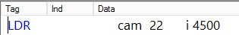

Polaris expanded view
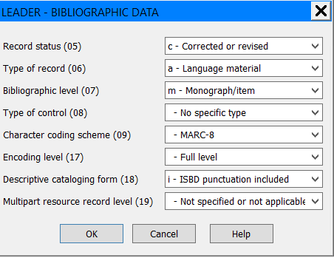

Fixed Field
- Present in every record
- Contained in MARC tag 008 with no indicators or subfields
- Consists of 40 character positions (00-39)
- Character positions indicate individual elements
- Elements contain coded or numerical information
  - Each element will only accept codes or data that are valid for that element
- Some elements are the same in every record; some differ depending on the format of material being cataloged
- Called fixed because all elements for a format are present in the record, but may or may not be coded, depending on the resource
- Some elements are system-generated; some are supplied by the cataloger
- Can be used to limit searches

How the leader displays in a bibliographic record depends on the ILS being used

In Polaris, the fixed field is displayed in MARC tag 008, but may also be expanded.

Polaris collapsed view (book record)

Polaris expanded view (book record)
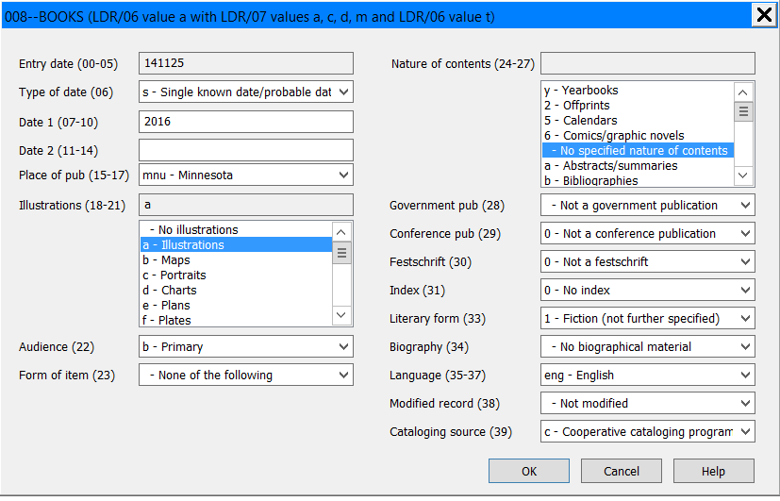

A MARC Record—What the Cataloger Sees (Polaris staff view)
Leader (collapsed view)

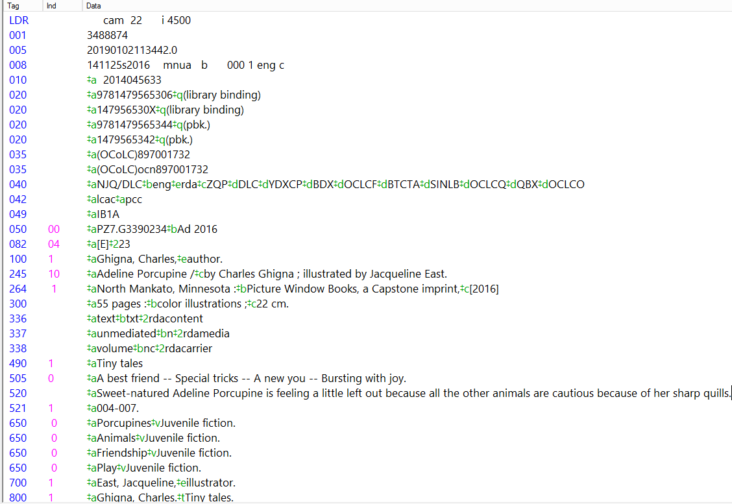
Fixed Field (collapsed view)
Variable Fields
Leader (collapsed view)

A MARC Record—What the Patron Sees (Polaris PAC view)

Access Points and Indexes

One of the main purposes of MARC coding is to make bibliographic information searchable so that users can find a library’s resources.

Searchable fields in a MARC record are called access points. When a record comes into the database, the fields are grouped into indexes. Indexes are categories of information that allow the user to focus their search. When a user chooses an index, the system looks only in the fields in the MARC record that contain that type of information.

For example, when a user chooses the Author index and enters a search, Polaris will search any MARC tag that contains a name access point: 100, 110, 111, 700, 710, 711, and 800, but will not search any other tags.

Some common indexes include:

Author
ISBN
Keyword
LCCN
Notes
Standard numbers
Series
Subjects
Title

Almost every field in a MARC record is included in the keyword index, which makes records retrievable in a keyword search. However, this type of search often returns very general results with many records that are not relevant. Indexes narrow a search to specific parts of the record and return more focused results.

The Future of MARC

MARC coding is becoming more incompatible with today’s online environment. The Library of Congress is currently studying a possible replacement for MARC, called BIBFRAME. There is no timeline for if and when BIBFRAME may be implemented, and if it is, there will be a long period of transition. Keep an eye on developments, but for the foreseeable future MARC is here to stay!

Resources

MARC21 Format for Bibliographic Data (Library of Congress): https://www.loc.gov/marc/bibliographic/
OCLC Bibliographic Formats and Standards: https://www.oclc.org/bibformats/en.html
For more information on BIBFRAME: https://www.loc.gov/bibframe/

