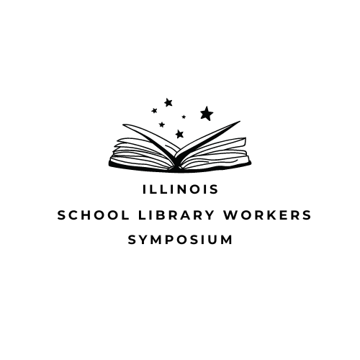

2023 ISLWS Report

Introduction

2023 was the first year for the Illinois School Library Workers Symposium (ISLWS). This event was designed for individuals who are working in school libraries with no formal library education, certified or non-certified, paraprofessionals, and those considering getting a school library endorsement.

Event Overview

This event took place on Wednesday, September 20, 2023. It was held entirely online via Zoom. It was co-hosted by the following organizations:

- Association of Illinois School Library Educators (AISLE)
- Illinois Library Association (ILA)
- Illinois Heartland Library System (IHLS)
- Illinois State Library (ISL)
- Reaching Across Illinois Library System (RAILS)

Over 300 people registered for this event and more than 250 people participated live.

Goals

One of the most important goals for this event was to offer a free training event for school library workers who didn’t otherwise have access to school library training. Organizers also wanted to offer school library workers a clearer path to understanding more about professional associations, library systems, standards, and other resources for support.

Keynotes

All attendees participated in four keynote sessions:

- School Libraries & Intellectual Freedom - Kristina Weber
- Standards & Advocacy for School Libraries - Megan Rasmussen & Sia Paganis
- Organization of Information in School Libraries - Barb Miller
- Leadership in School Libraries - Dan Bostrom

Education Sessions

In the education session portion of the event, participants were divided into three different tracks: high school library workers, middle school library workers, and elementary school library workers.

High School

- Material Selection for High School Libraries - Leah Gregory
- Programming for High School Libraries - Jenette Gonzalez
- Resource Sharing: Interlibrary Loan Basics - Gwen Harrison & Mary Jo Matousek
- Resources for High School Libraries - Aimee Miller

Middle School

- Material Selection for Middle School Libraries - Claire Greene
- Programming for High School Libraries - Jeanné Aken
- Working with Parents/Volunteers - Eden Crothers
- Resources for High School Libraries - Kimberly Dykstra

Elementary School

- Material Selection for Elementary School Libraries - Melanie Weigel & Renee Brown
- Programming for High School Libraries - Barbara O'Sullivan
- Working with Parents/Volunteers - Eden Crothers
- Resources for High School Libraries - LuAnn Grimm

Breakouts

There were three small group breakout sessions and one large group session. The small group breakout sessions were 15 minutes each and led by the individual members of the group. The large group discussion was 30 minutes long and led by the conference organizers.

PDH Credits

PDH credits were available to those who requested them. Illinois Heartland Library System (IHLS) issued more than 300 hours of credit.

Email List

As part of the follow up of the event, attendees were encouraged to sign up for a newly created email list. This email list is open to ISLWS any participant, presenter, or organizer.

Certificate of Participation

Each attendee received a certificate of participation. This certificate was emailed to them following the successful completion of the event.

Evaluation

All attendees were encouraged to fill out a short survey after the event. There were more than 80 total responses. A link to the survey results is shared below:

ISLWS Evaluation Survey results.

Based on the survey results, a few suggestions for 2024 become clear:

- More structure for the breakout sessions
- More focus on tangible skills for paraprofessionals, i.e. creating displays, weeding, adding new materials
- Create a “table talks” session where attendees can pick-and-choose breakout rooms based on interest
- Figure out a way to incorporate presenters and information from library education programs

Thank You!

A huge thank you to the 2023 ISLWS Planning Committee. Without your tireless work and effort, this event would not have been possible!

Jeanné Aken
Valerie Brunner
Leah Gregory
Jenna Griffith
Fiona Griswold
Gwen Harrison
Tracy Hubbard
Kate Kite
Ellen Lawrence
Becca Leslie
Mary Jo Matousek
Aimee Miller
Carol Naughton
Amanda O'Rourke
Sia Paganis
Stacy Palmisano
Kristin Pekoll
Megan Rasmussen
Deb Will

