Over the Garden Wall Blu-Ray example
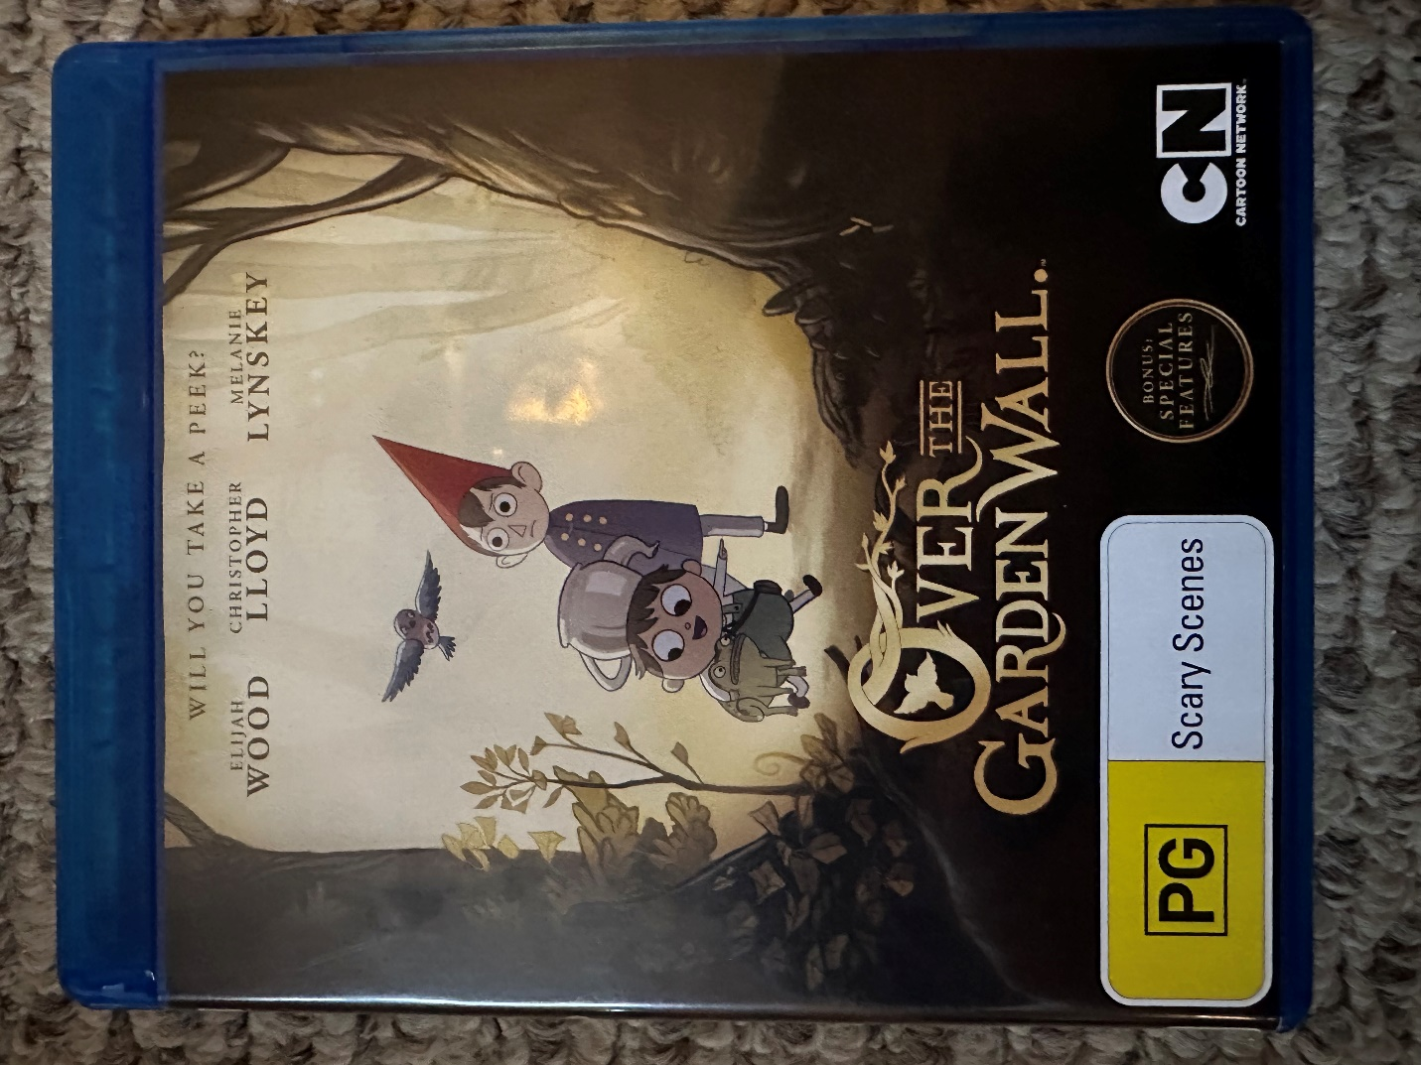
Container Front
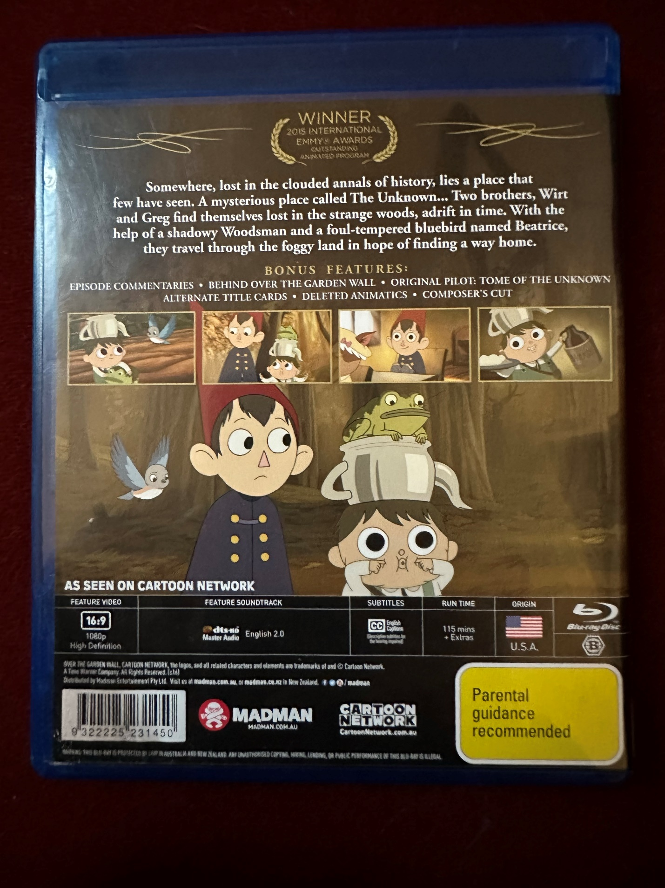
Container back
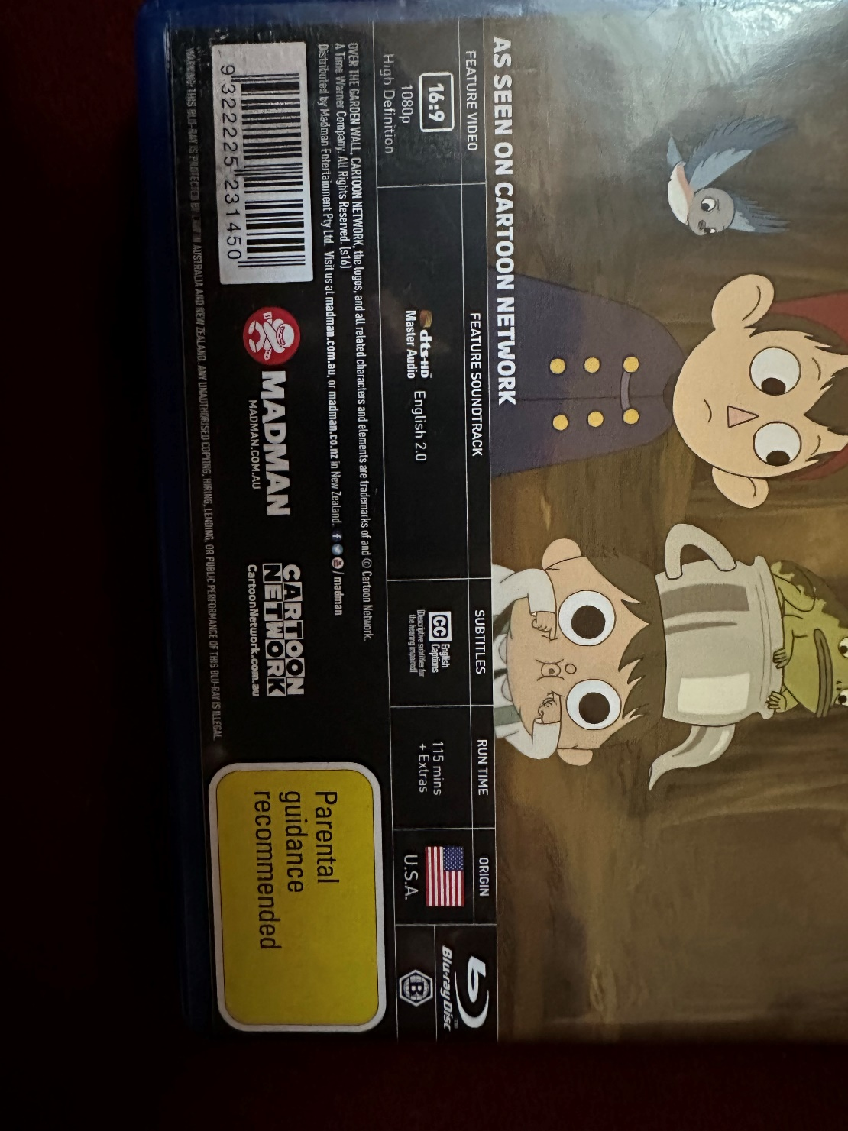
Container back close-up
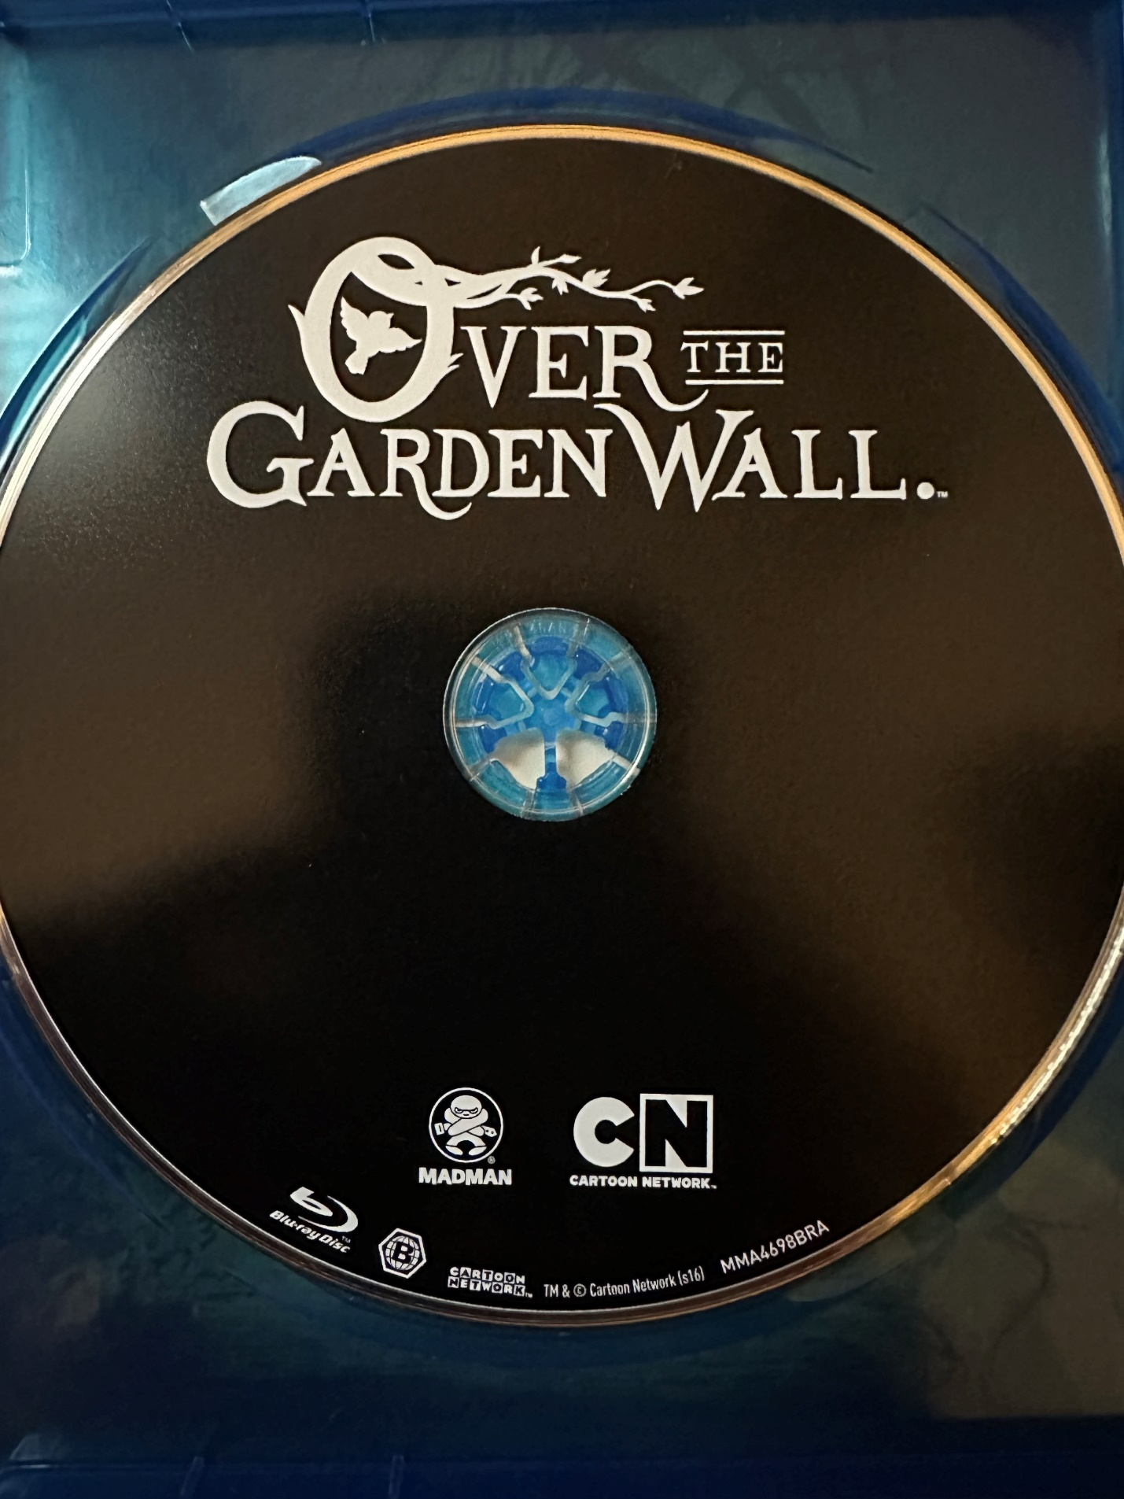
Disc label
Contents list (From container insert):
The Old Grist Mill
Hard Times at the Huskin’ Bee
Schooltown Follies
Songs of the Dark Lantern
Mad Love
Lullaby in Frogland
The Ringing of the Bell
Babes in the Wood
Into the Unknown
The Unknown

Listing from eBay for this same item:
Over the Garden Wall Blu Ray 2014 RARE OOP Cartoon Network Madman REGION FREE | eBay
This has similar pictures, but it might be easier to zoom

