Barcoding in Leap
Leap is available at Leap.illinoisheartland.org. Type the domain name SHARE back slash (\) and your username to get started, then add your Polaris password and click Sign In.
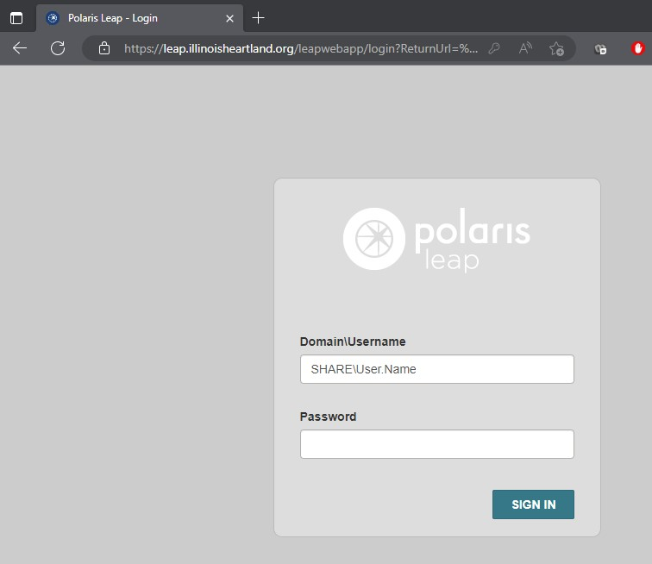
Next select your branch, if applicable and your workstation. Click Continue.
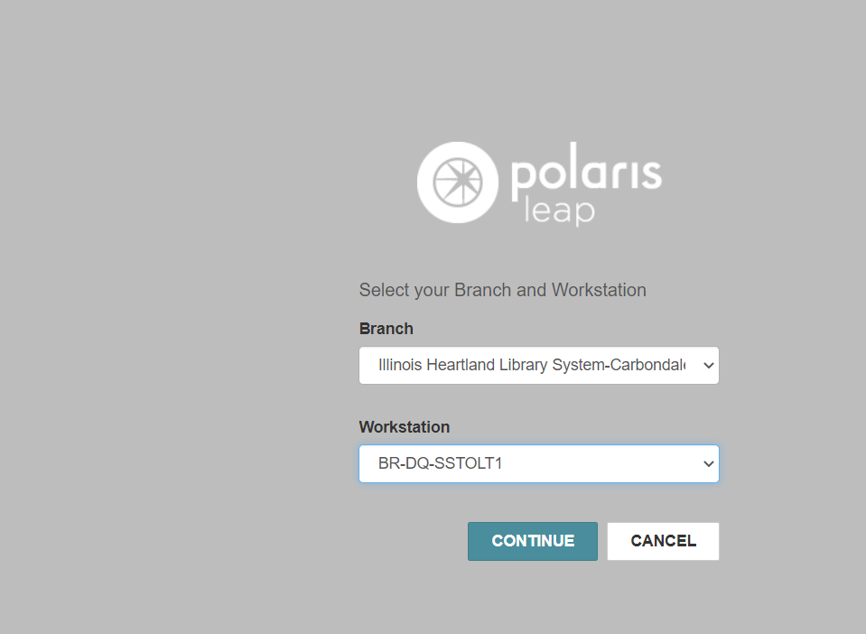
The opening screen of Leap is rather plain. As you can see, this product is circulation driven. The only options are Check In or New Patron. The search box defaults to a patron search. Instead of using the search box, click Find.
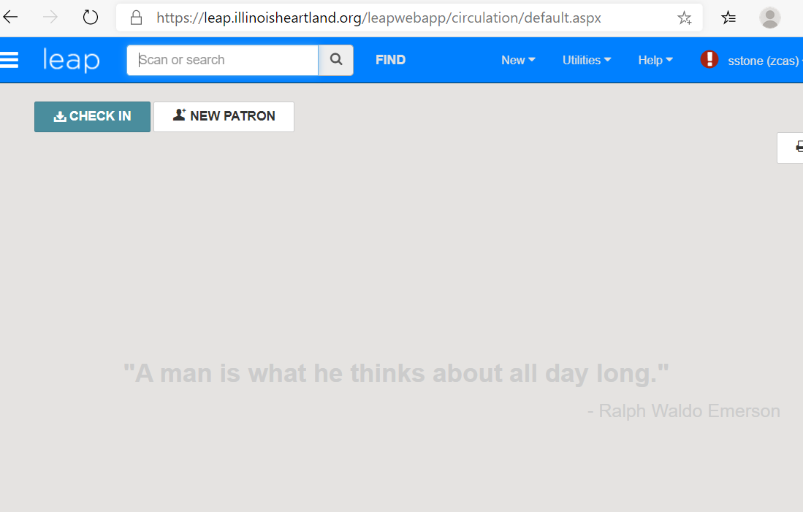

This opens a Find Tool search for the default, which is Patron.
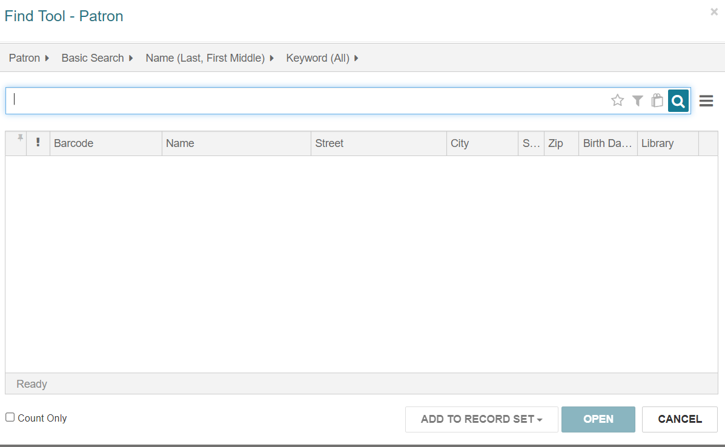
Next, click on Patron and change the search to Bibliographic Record. You can click the yellow star to save that as your default search.
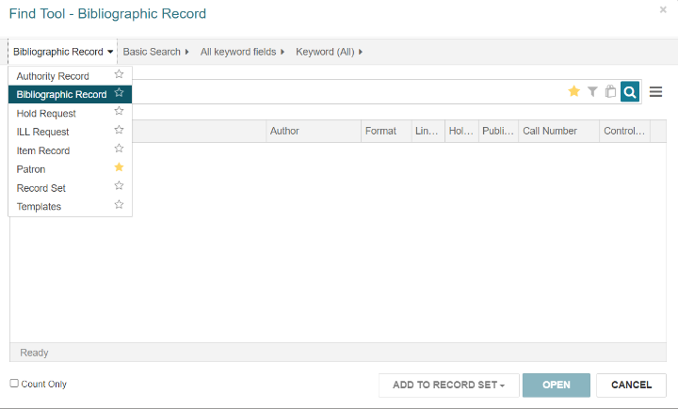
Change All Keyword Fields to ISBN, as well. You may choose anything you want to search by here, including title, ISBN, author, control number, etc. ISBN is usually the best place to start.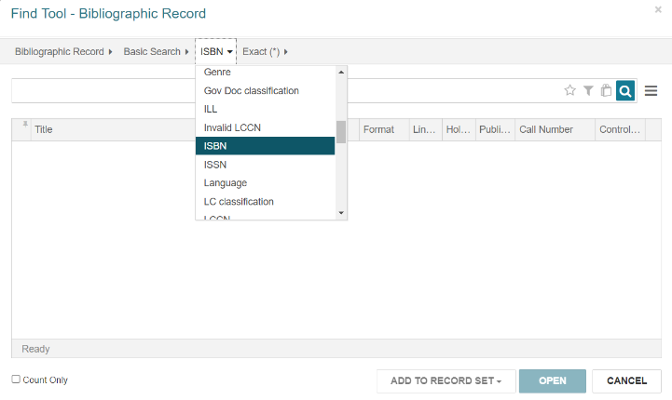
Scan or type an ISBN number in to find a bibliographic record. Search as usual until you find a possible matching record. Click the check box to highlight the record, then click Open.
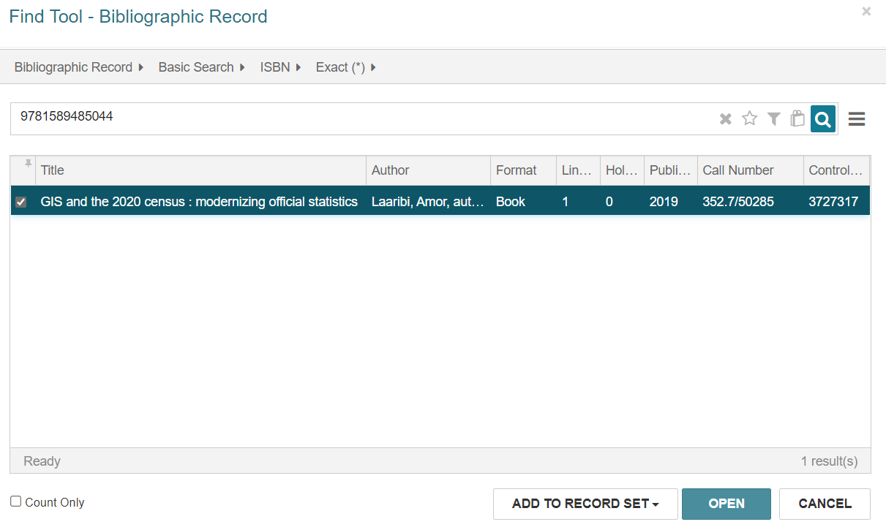
This will give you the preview display.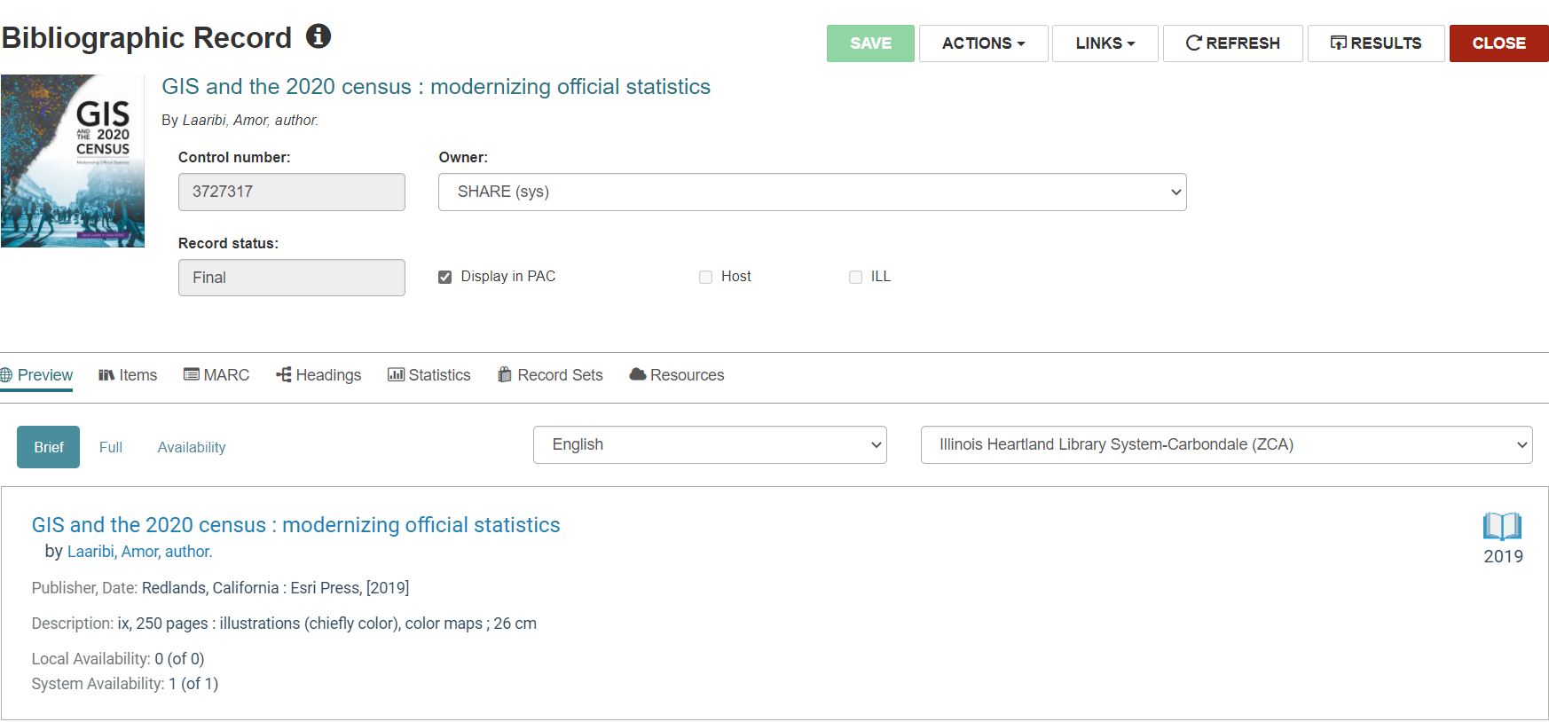
In order to verify all match points, click on MARC to see the full MARC record.
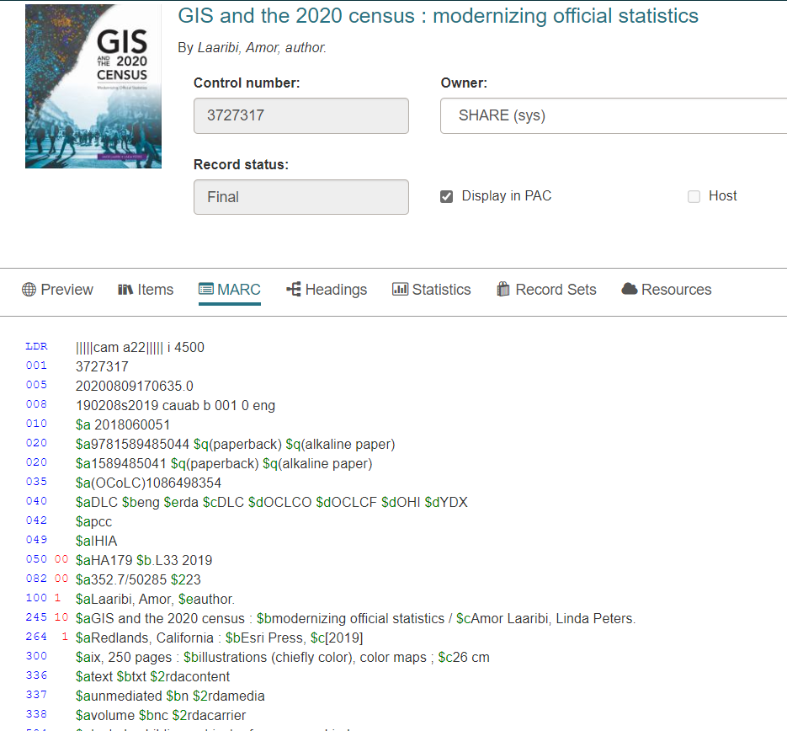
After verifying that this bib record matches the item in your hand, click Actions and then Create Item.
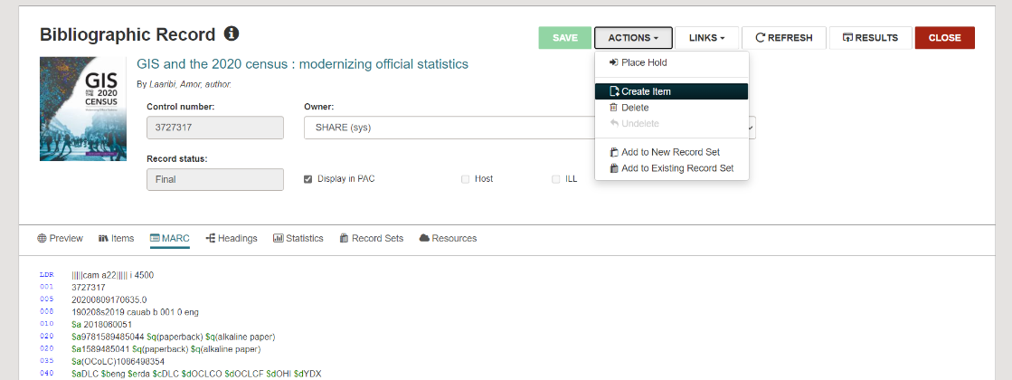
The item record will appear. The area you are working on will appear with a blue border. The Barcode space will be seen that way when the item record first appears on the screen, prompting you to enter a barcode. Scan your barcode.
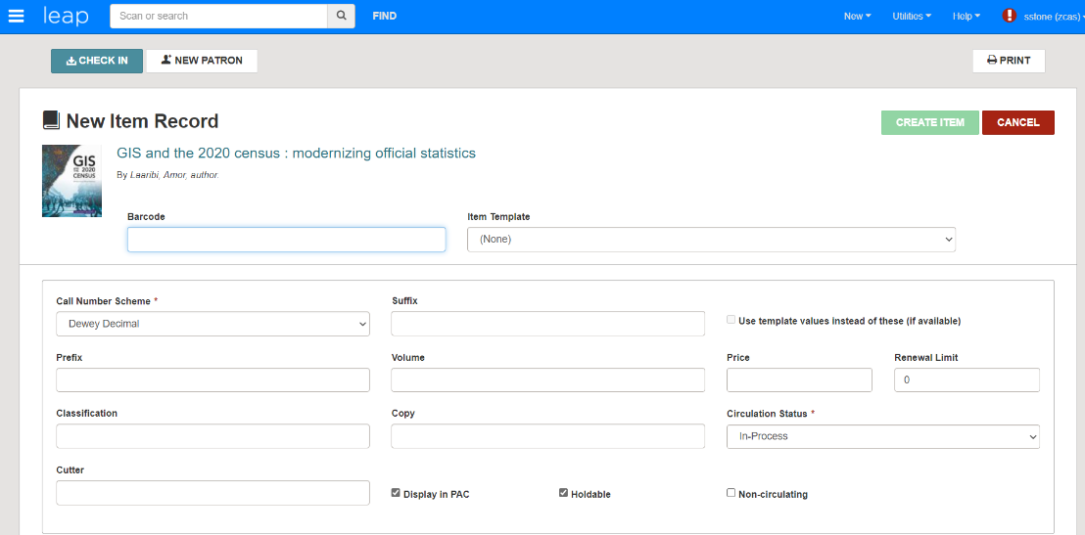
Next, click on the Item Template line and select the correct item template for the type of material in hand. In this case, it is a non-fiction book. You will only see your own item templates. After choosing an item template, information from that template will fill in at the bottom of the screen.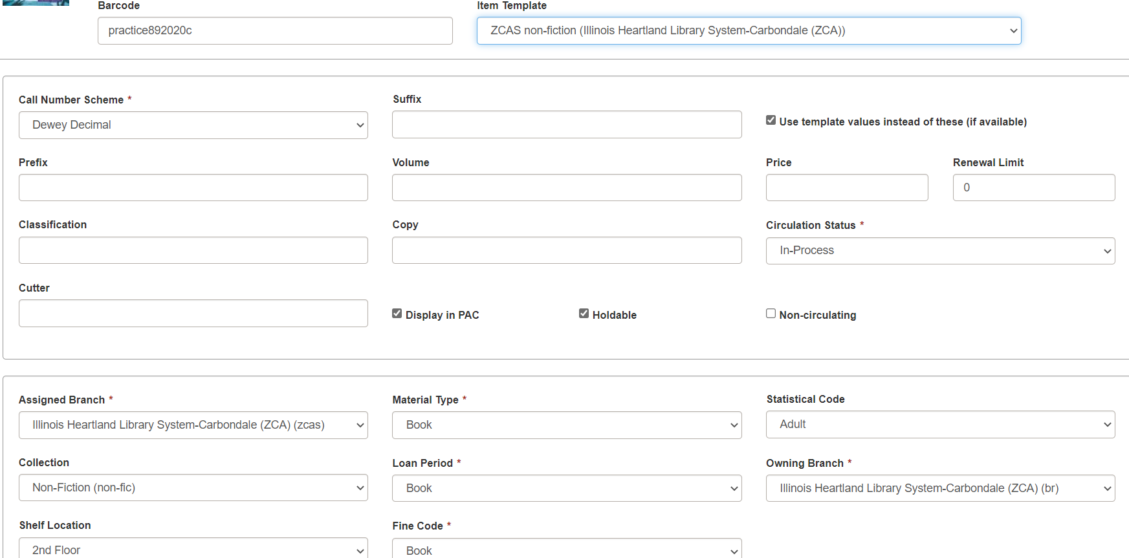
Fill in the Call Number area as needed. This one will need a classification number and cutter since it is non-fiction. Note the check box which says Use template values instead of these (if available). This means values from the template will override what you type in, if this box is checked. For instance, if the template has a default price of $25 and nothing is entered in the Price field of the item record, or a different price is entered there, the price will say $25 after creating the item with the template.
If you need to make special restrictions for loaning the material, click on Controls in the center of the page.
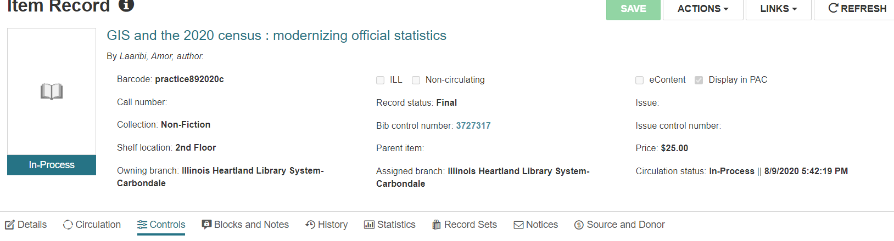
You will see the usual check mark boxes at the bottom of the screen.
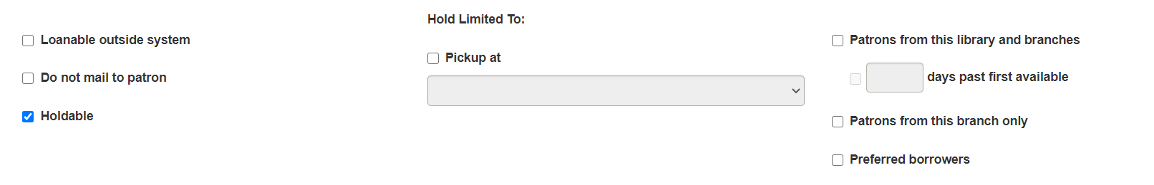
Click on Blocks and Notes to add any notes. These are the same as the notes fields in the staff client. Generic choices can be found under Library Assigned Block or you can create your own under Free Text Block. The Free Text Block is a good place to add the number of CDs or DVDs included in a container. Blocks will appear on the screen when an item is checked in. A Free Text Block, such as 5 discs, will remind the staff member to check that all discs are present before continuing to check in the item. The Public Note will appear in the PAC display and the Non-Public Note will appear in the staff display. If you add a block or a note, click Save.
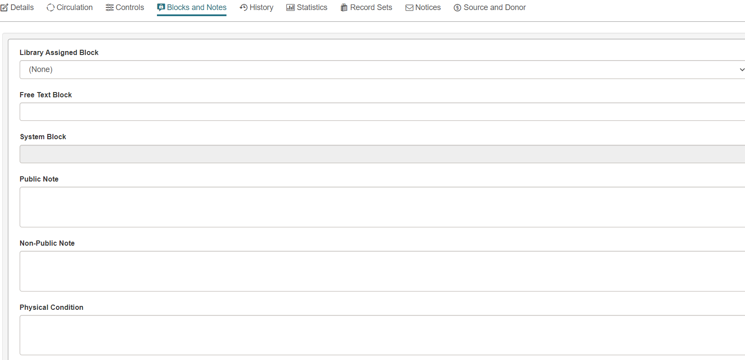

If you have a second copy of the same item, click Actions and then Copy to start a new item record. Edit information on the item record, as needed, and then save the new item record.

