Barcoding in Leap

Accessing Leap
- Visit: https://leap.illinoisheartland.org/leapwebapp/login.
  - Domain name: SHARE backslash (\) and your username (firstname.lastname)
  - Password: Your Polaris password
- Select “SIGN IN”
- Select your branch, if applicable, and your workstation.
- Click Continue.
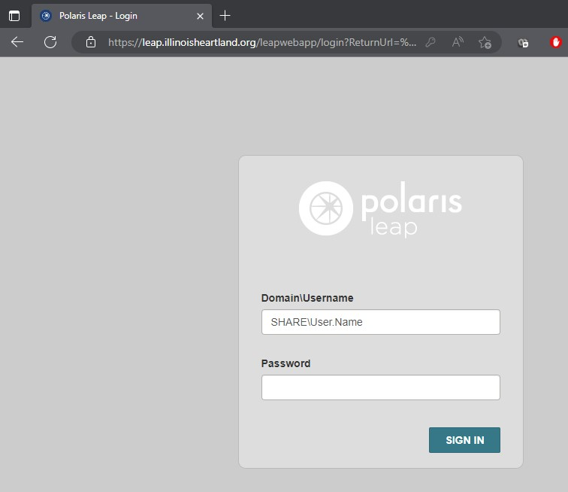

Enter your Polaris username here, in the format shown below:
SHARE\John.Doe

Enter your Polaris password here.

Select “SIGN IN”

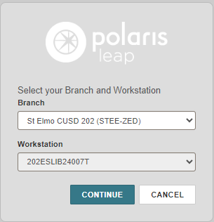
Select “CONTINUE.”
Select your workstation.
Select your branch (if applicable).

Searching for a Bibliographic Record
- On the opening screen, select “FIND”

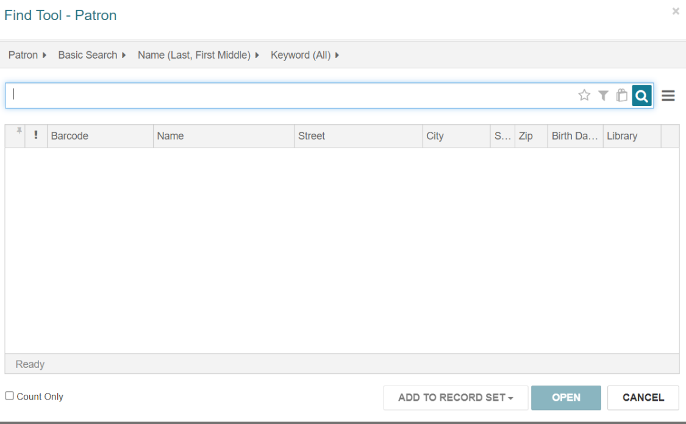
This opens a Find Tool search for the default, which is Patron.

- Next, click on Patron and change the search to Bibliographic Record. You can click the yellow star to save that as your default search.
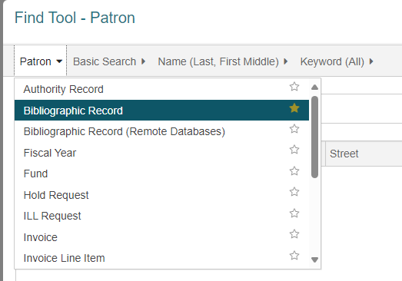

- Change All Keyword Fields to ISBN, as well. You may choose anything you want to search by here, including title, ISBN, author, control number, etc. ISBN is usually the best place to start.

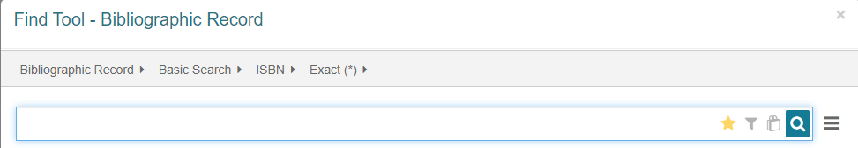

Select this star also if you want the search box to automatically default to this search.

- Scan or type an ISBN number in the search box to find a bibliographic record. You may also have to search by title and/or author to find a potential matching record.
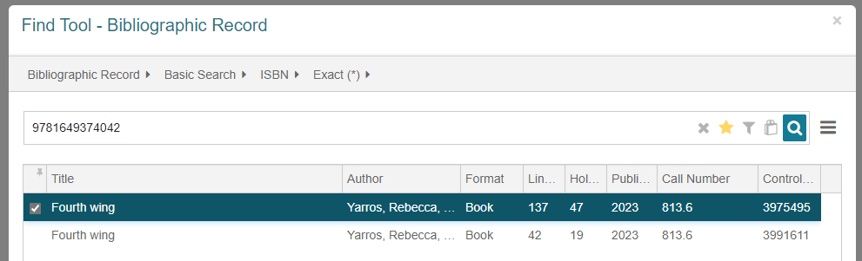
ISBN Search

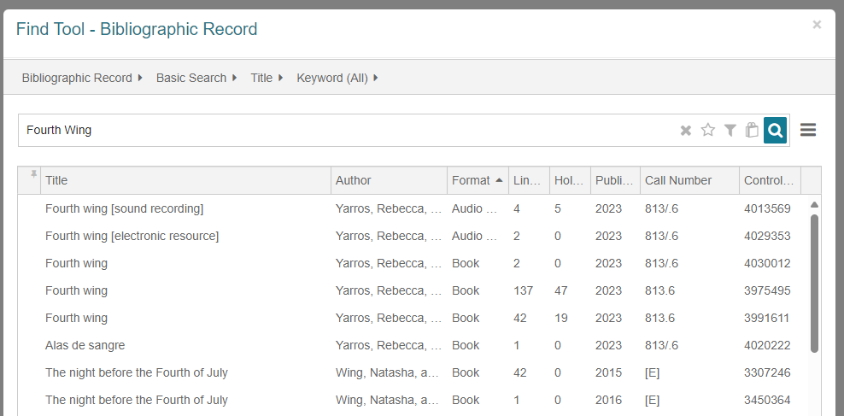

Title Search

- Click the check box to highlight the record, then click Open.
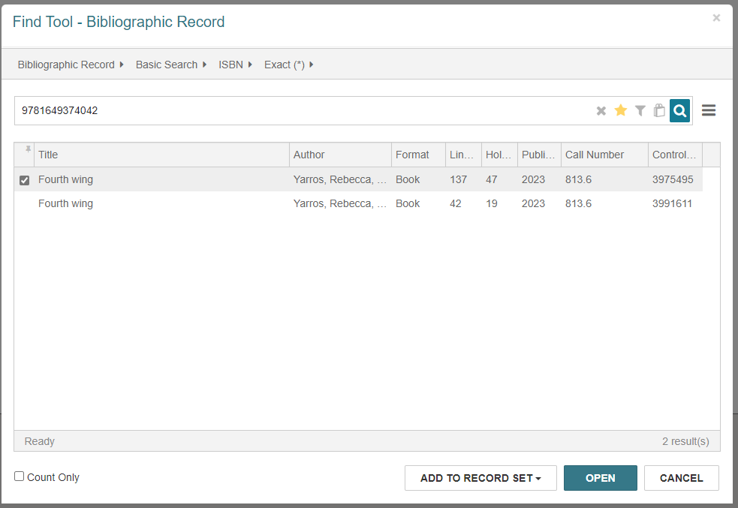
Click here

And then click here.

Matching your Item
- This will give you the preview display.
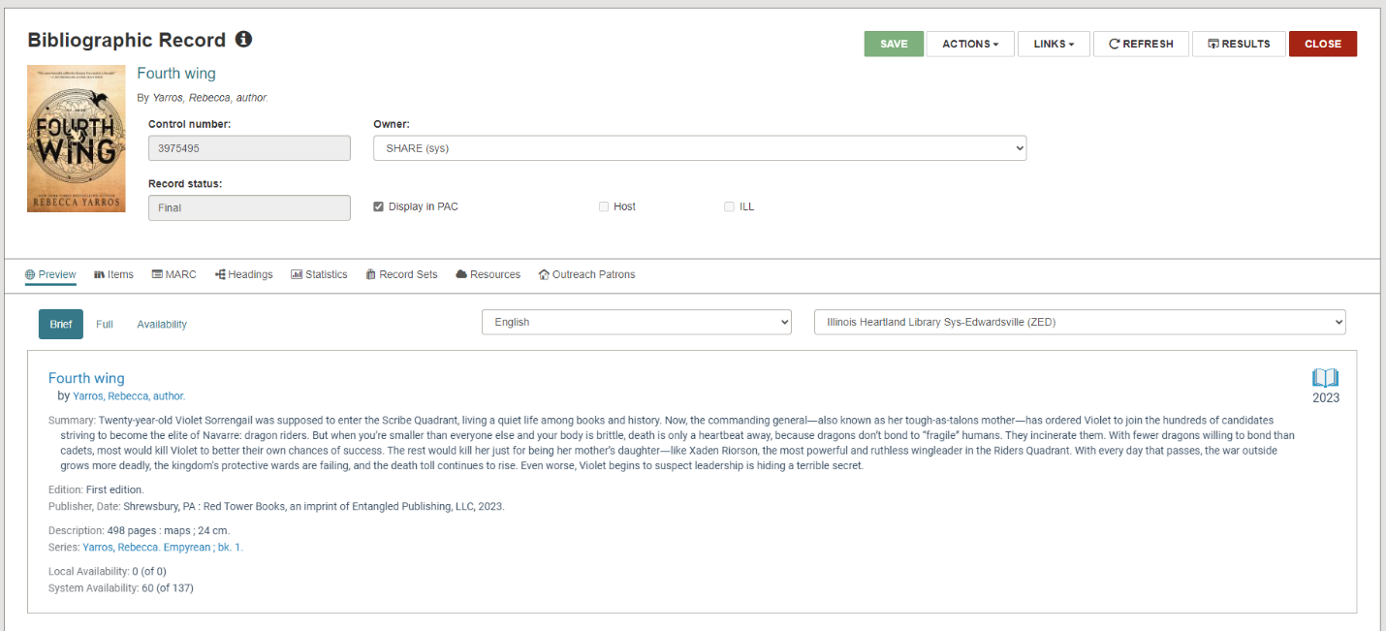

- To verify all match points, click the MARC tab to see the full MARC record.
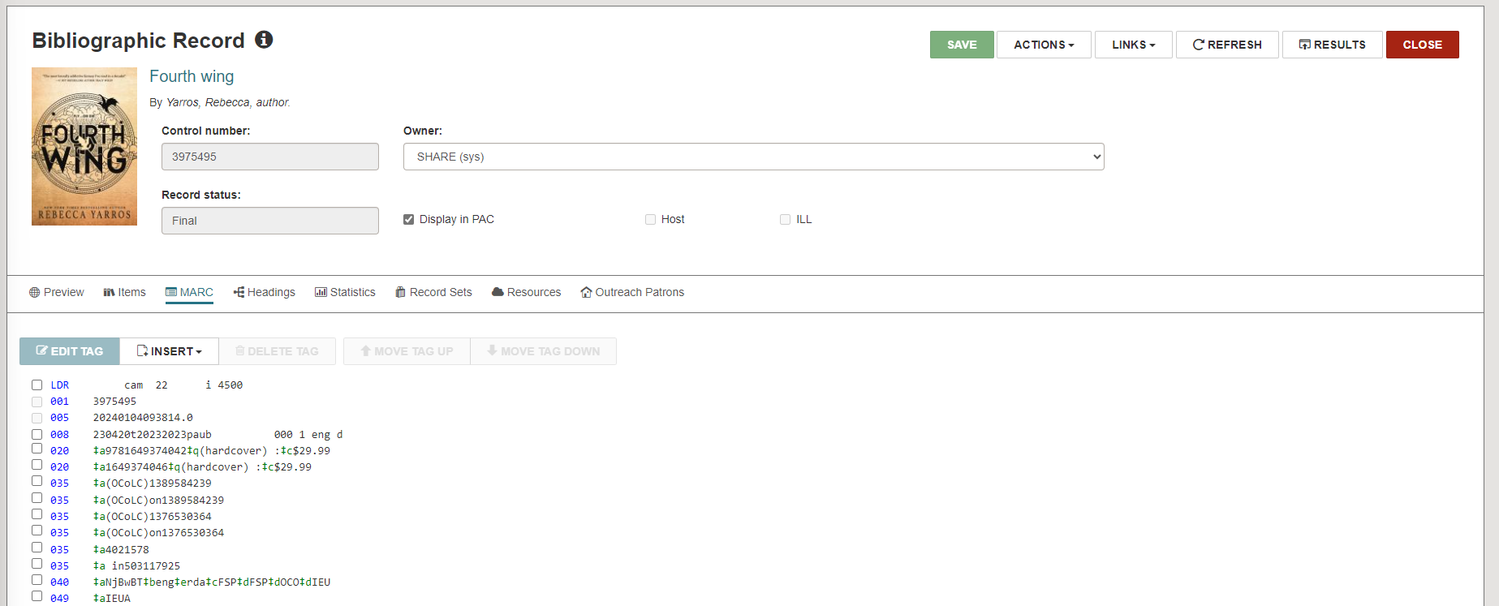

Creating an Item Record
- After verifying that this bib record matches the item in your hand, click “Actions” and then “Create Item.”
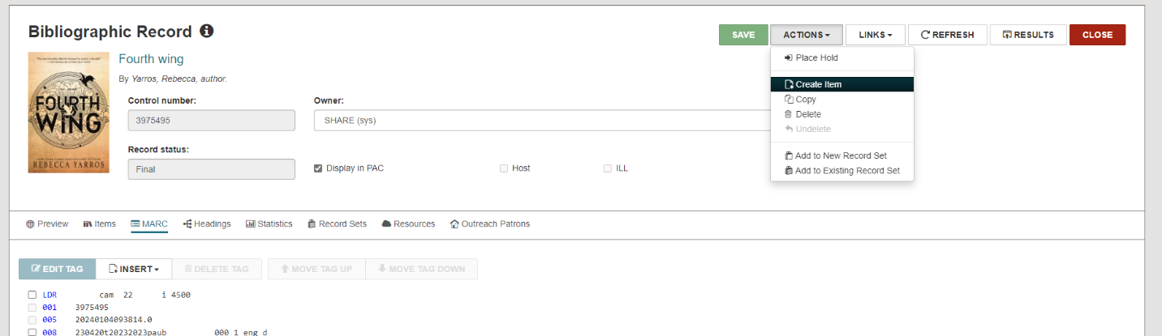
- The item record will appear. The area you are working on will appear with a blue border. Enter your item’s barcode in the barcode box, either by scanning or typing it.
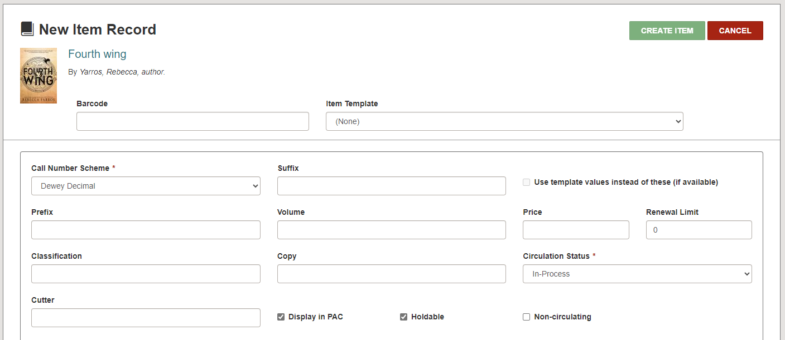
- Next, click on the Item Template line and select the correct item template for the type of material in hand. You will only see your own item templates. After choosing an item template, information from that template will be filled in at the bottom of the screen.
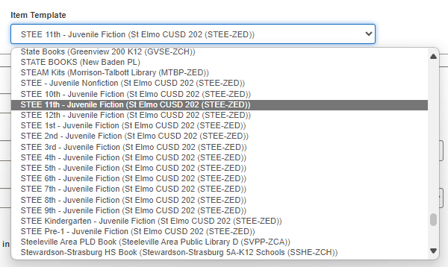

- Fill in the Call Number area as needed. Note the check box which says Use template values instead of these (if available). This means values from the template will override what you type if this box is checked. Some of the fields that are a part of the template will not show up in this view. Once you save the item record, they will appear.
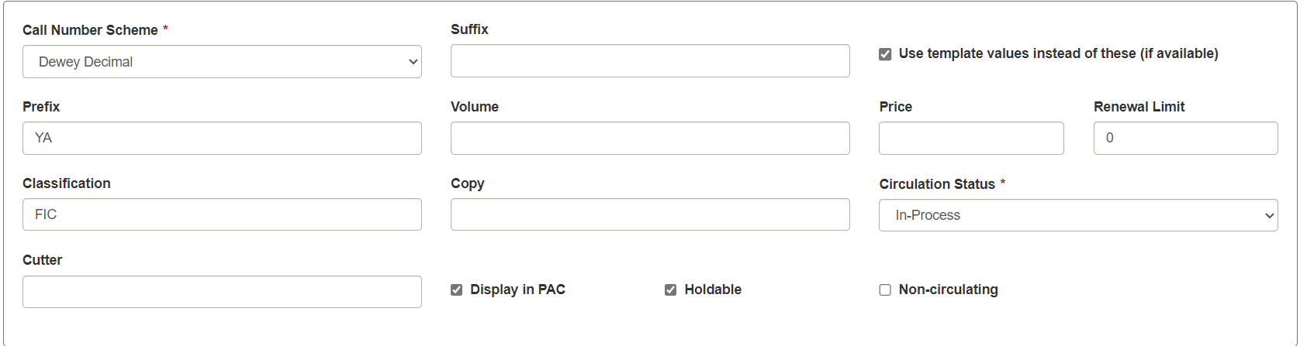

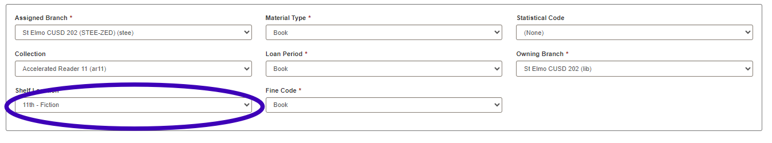

- Select Create Item.
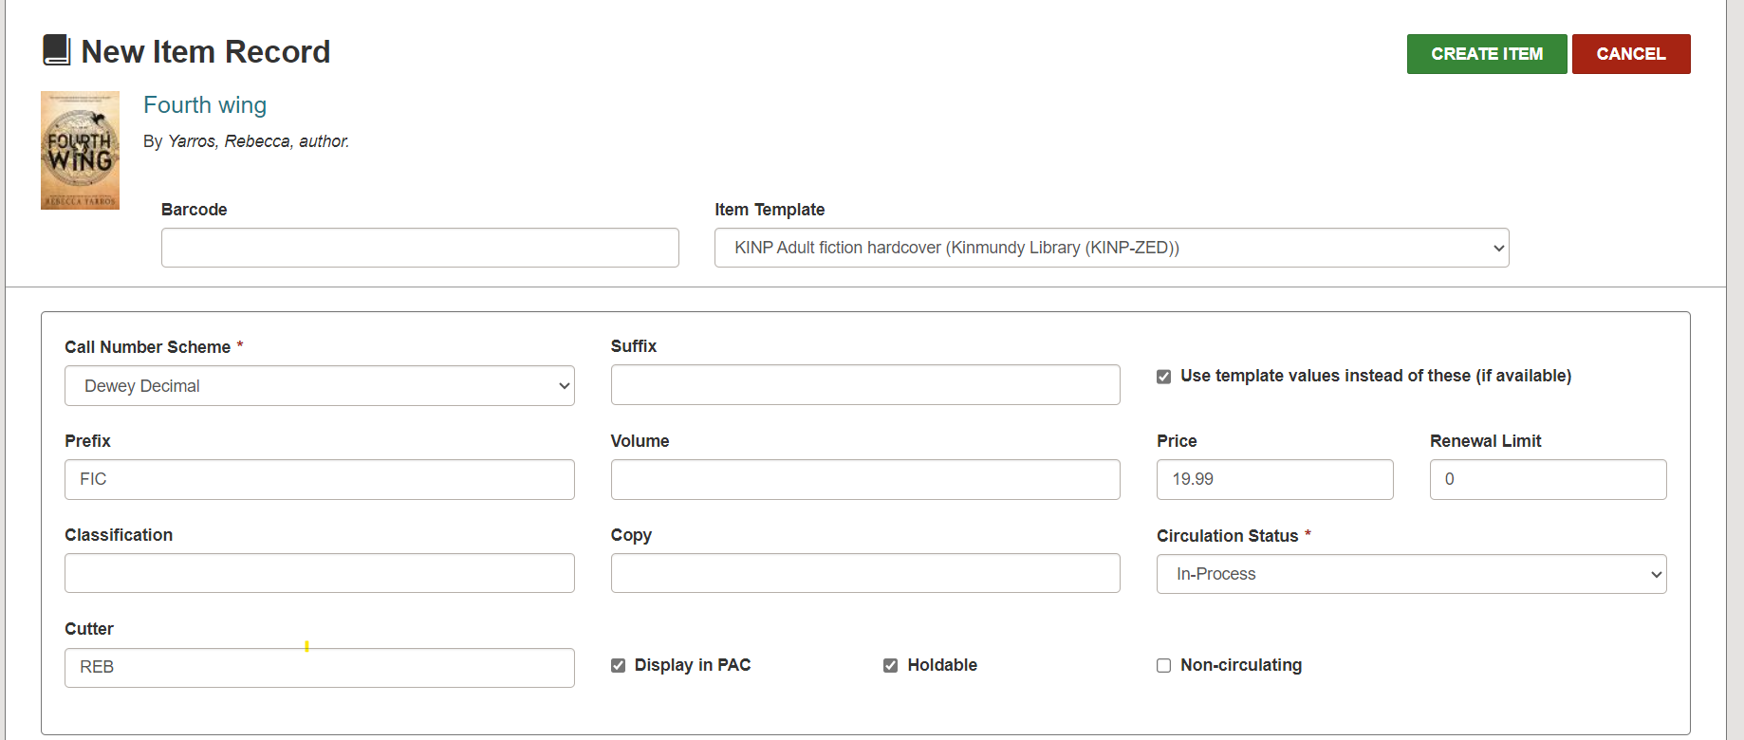

- Additional steps if necessary:

If you need to make special restrictions for loaning the material, click “Details” and scroll to the bottom of the page. You can select and unselect circulation options here. These options do not show up in Leap when you are creating the item record, but they can be predetermined by your item template if it’s set up in a particular way.
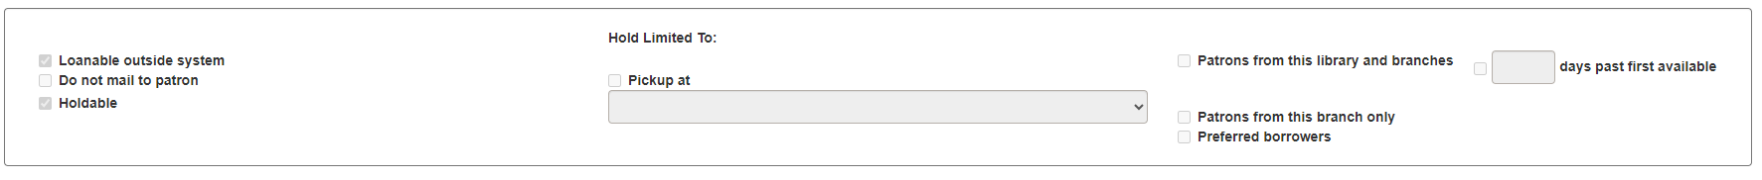

Click on Blocks and Notes to add any notes. These are the same as the notes fields in the staff client. Generic choices can be found under Library Assigned Block, or you can create your own under Free Text Block.
The Free Text Block is a good place to add the number of CDs or DVDs included in a container. Blocks will appear on the screen when an item is checked in. A Free Text Block, such as 5 discs, will remind the staff member to check that all discs are present before continuing to check in the item.
The Public Note will appear in the PAC display and the Non-Public Note will appear in the staff display. If you add a block or a note, click Save.
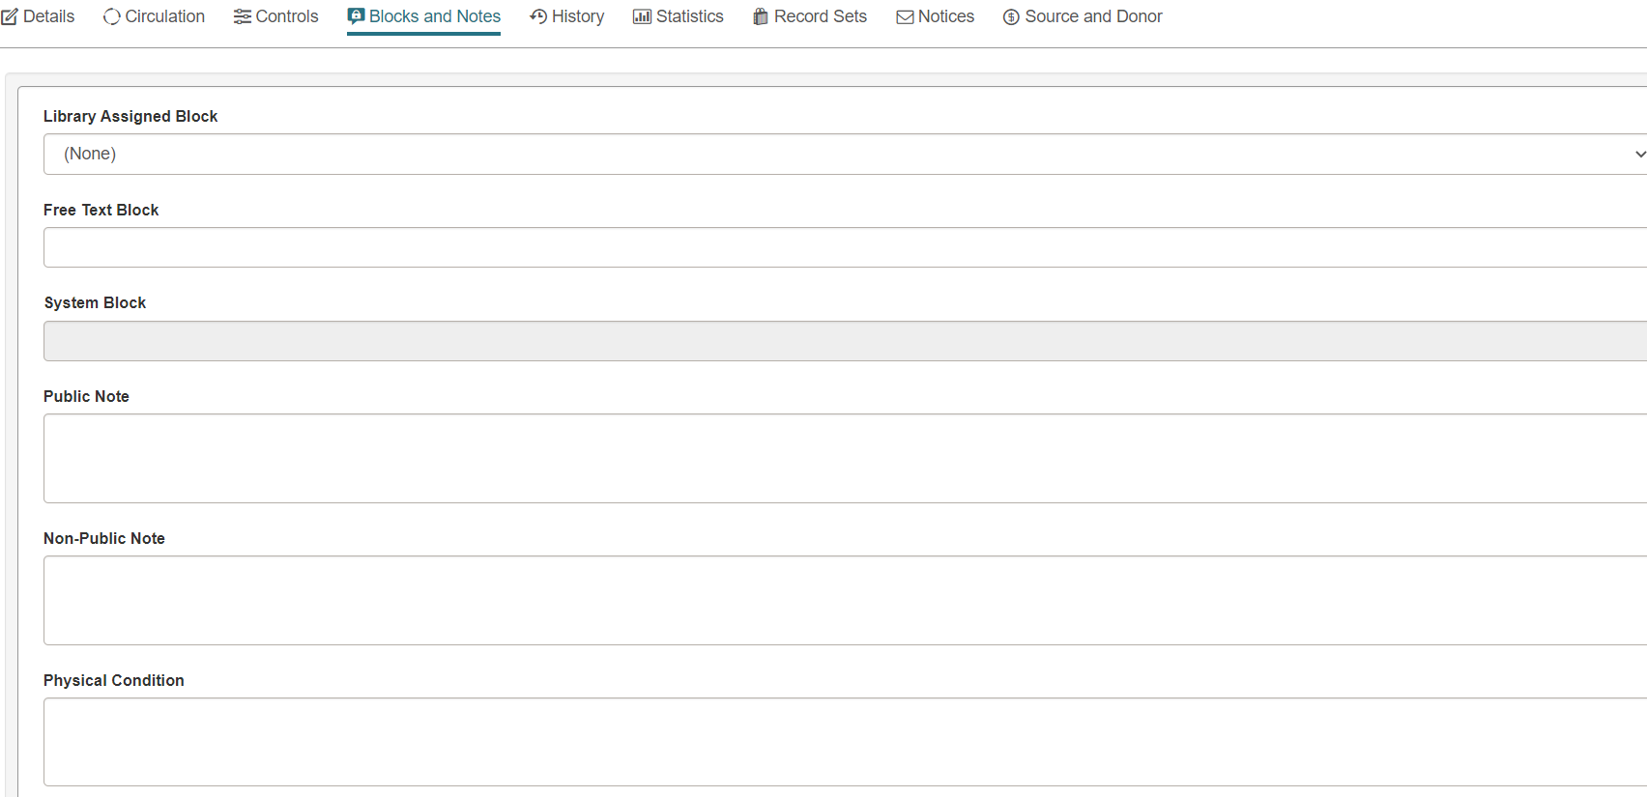

If you have a second copy of the same item, click “Actions” and then “Copy” to start a new item record. Edit information on the item record as needed, and then save the new item record.
