Cataloging in Leap

Accessing Leap
- Visit: https://leap.illinoisheartland.org/leapwebapp/login
  - Domain name: SHARE backslash (\) and your username (firstname.lastname)
  - Password: Your Polaris password
- Select “sign in”
- Select your branch, if applicable, and your workstation
- Click continue
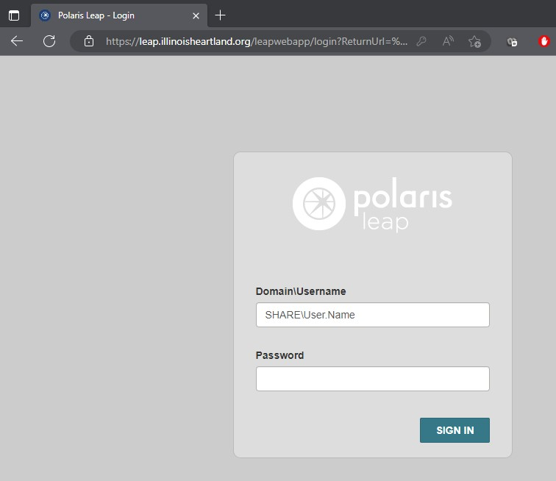

Enter your Polaris username here, in the format shown below:
SHARE\John.Doe

Enter your Polaris password here.

Select “SIGN IN”

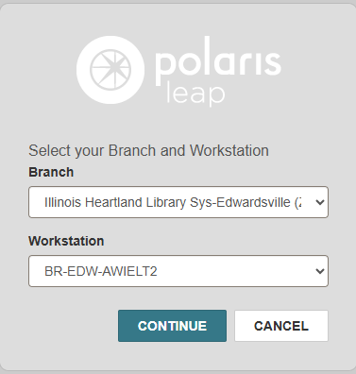
Select “CONTINUE”
Select your branch (if applicable)
Select your workstation

Editing a Bibliographic Record
- Find the bibliographic record that you want to edit. If you need help with this process, see the “Barcoding in Leap” document for further information.
- Switch the view to MARC view
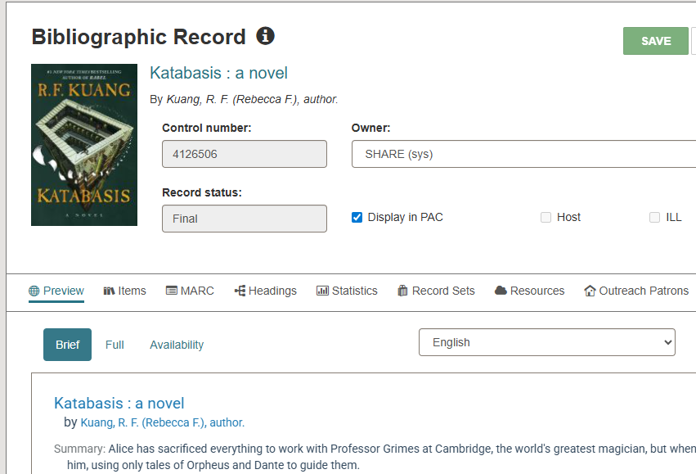
- People with cataloging permissions can see the arrows on the left-hand side of the screen in MARC view. These are for moving the fields up and down within the record. On the right-hand side, the plus sign will insert a blank field below wherever you click. The minus sign will delete the selected field.
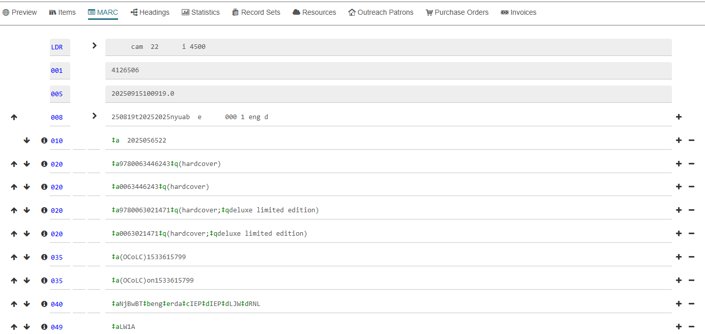
- Macros in Leap don’t currently function. If you need to use Macros you will need to login to Polaris staff client.
- Some of the function keys are the same as in the staff client and some are different.
  - To insert a delimiter symbol, press Ctrl + Q (same in both)
  - Ctrl + D in Leap will delete the selected field. In staff client, it will show a pop-up asking if you want to delete the entire record.
  - Alt + D will not bring up the diacritic editor in Leap.
- Many functions within bibliographic records can be found under the Actions tab.
  - Checking for duplicates
  - Deleting the bibliographic record
  - “Comparing” records—this will allow you to view two bibliographic records side by side. Select “Compare” and Leap will bring up a Find tool. Search for the record you want to compare, select it, and either double-click or click Open. This will bring up the two records in side-by-side mode. In this mode you can edit either record or copy selected MARC fields from one record to another with the arrow at the top of either record. When you are done with the comparison mode, hit Close, and Leap will bring you back to the original Bibliographic record.

Creating a New Bibliographic Record
- To create a new bibliographic record, either go to an existing record that you want to copy and go to Actions > Copy, or go to the top of the Leap window to New and select Bibliographic record, which will provide you with a blank workform.
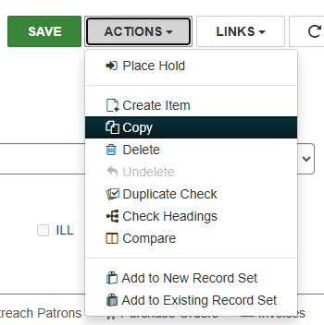
From the Actions menu within an existing bib record
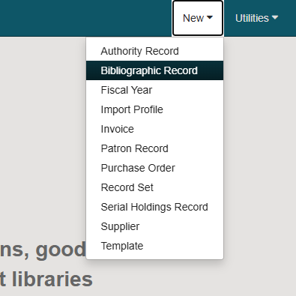
For a new work form
- If creating a new bibliographic record, Leap will ask if you want to select a template. Select the desired template from the drop-down menu, or select “none” and create a record from scratch.

Importing Records in Leap
- Importing records in Leap is the same process as in Polaris staff client.
- Go to Utilities > Marc Import and select the same import profile that you normally use.
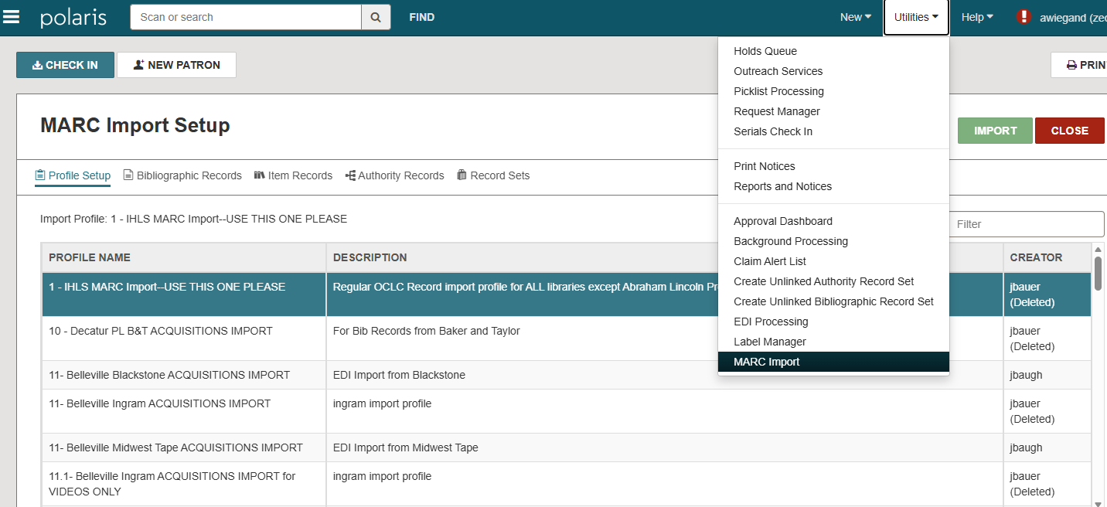
Select your import profile
Utilities, Marc import
- Scroll down within the screen and choose the “Select file” button on the lower right-hand side.
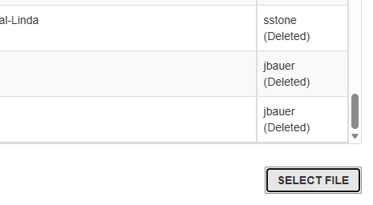
- A box will pop up. Choose “select file” again and find your import file. Choose the import file and hit “Open”. From there, your file will import to Leap.
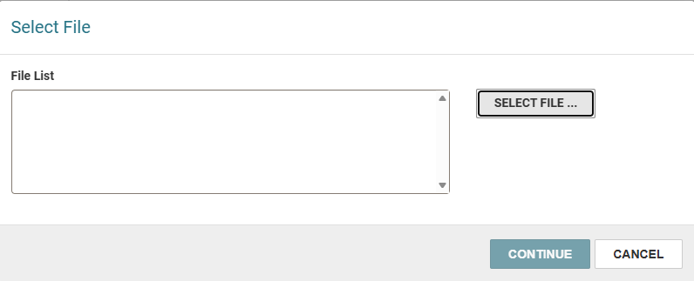
- To find your imported file, use the main Find tool to search for your record set.

If you want more information about cataloging in Leap or Polaris generally, visit the Innovative/Polaris lib guide, which includes videos about different processes: Cataloging - Polaris - support.iii.com at Innovative Interfaces

