Templates and Record Sets in Leap

Accessing Leap
- Visit: https://leap.illinoisheartland.org/leapwebapp/login
  - Domain name: SHARE backslash (\) and your username (firstname.lastname)
  - Password: Your Polaris password
- Select “sign in”
- Select your branch, if applicable, and your workstation
- Click continue
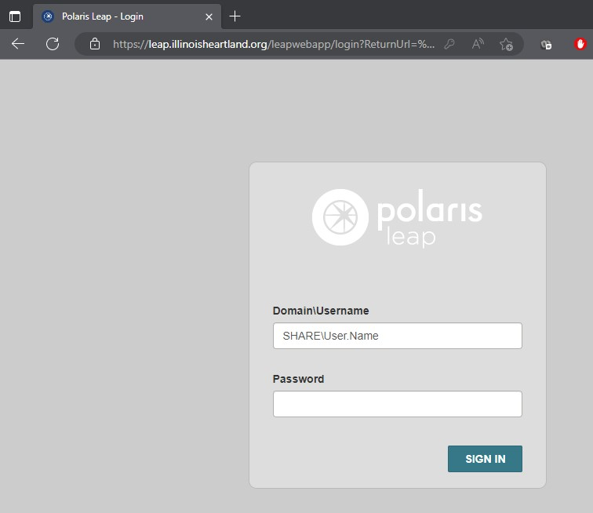

Enter your Polaris username here, in the format shown below:
SHARE\John.Doe

Enter your Polaris password here.

Select “SIGN IN”

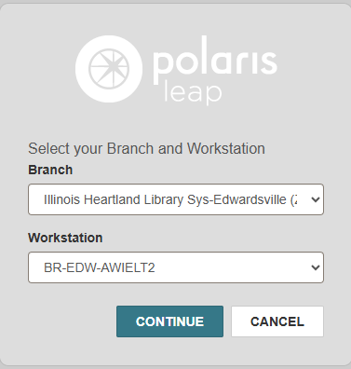
Select “CONTINUE”
Select your branch (if applicable)
Select your workstation

Creating or Editing a Template
It is now possible to create item templates in Leap!
In the upper right corner, select New > Template > Item.
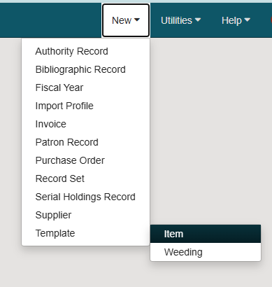
This will bring to you to a blank item template workform. Form there, give your template a name, and make sure the owner is listed as your library rather than your personal account. Add all other applicable fields and click “save.”
The item templates for your library that you can find in Polaris should also be available in Leap.
In order to find an item template, the process is the same as finding a bibliographic record. Go to the “Find” tool and select “Item Template”
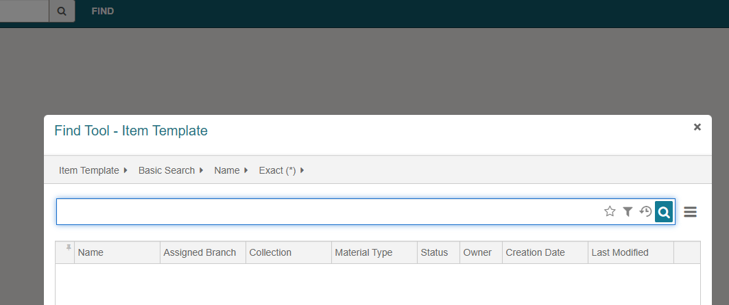
You can copy any item template to create a new item template with the same information filled in by going to Actions > Copy.
Once you have found the correct item template and copied it, make whatever changes are necessary and click “save.”
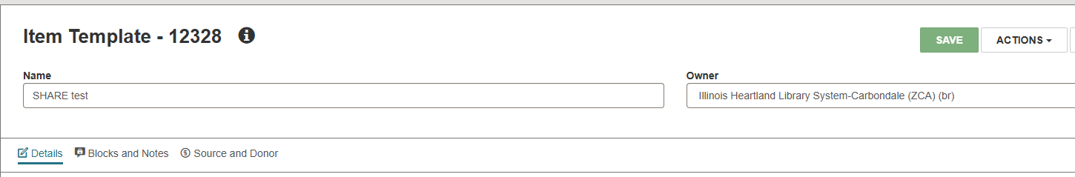

Record Sets
Existing record sets can be found with the same “Find tool.”
New record sets can be created under the “New” tab. When you select “record set,” select which record type you want.
Once the new record set is created, give it a name and change the Owner to your library if you want others to be able to search for it.
Add items to the record set by scanning in barcodes, or by using the Find tool.
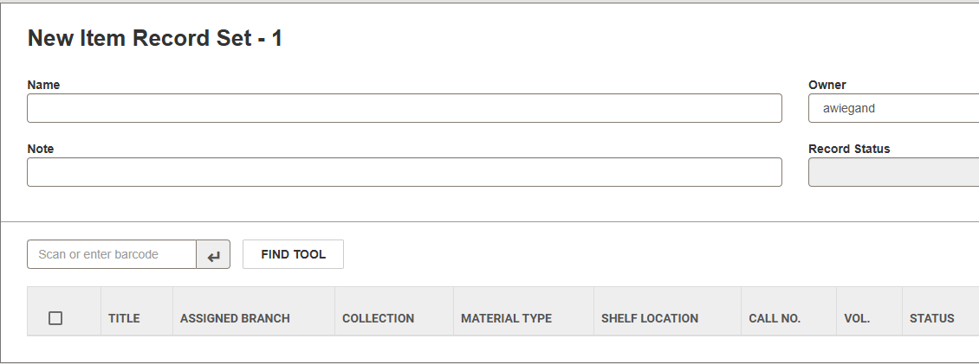
Add items to your record set with one of these tools.
Owner must me set to the library’s name for others in your library to be able to access it.

